Table of Contents

I. Introduction 5

1. Technology: 7

II. Requirement: 7

1. Functional 8

2. Non-functional 8

III. Database: 8

1. ERD 8

IV. Design: 10

1. Sitemap: 10

2. Wireframe 12

2.1 Login 12

2.2 Personal information 13

2.3 Upload file 14

2.4 Message 17

2.5 All faculty 18

2.6 Set time 20

2.7 View and evaluate 21

3. Interface 22

3.1 Login 22

3.2 Personal information 24

3.3 Upload file 25

3.4 Massage 28

3.5 All faculty 30

3.6 View bar chart 33

3.7 Set time 34

3.8 View and evaluate 35

4. Usability 37

5. Accessibility 37

V. Implementation (Functionality): 37

1. Use case Diagram: 37

2. Activity Diagram: 43

3. Function 55

3.1 Data security 55

3.2 Data validation 57

3.3 Main function in requirement 58

VI. Testing: 68

1. Test plan 69

1.1 Function requirement 69

1.2 Targeted users 69

1.3 Purpose of the test 69

1.4 Testing implementation plan ( Test strategy ) 69

1.5 Potential risks 71

2. Test case 72

3. Test evident 84

VII. Agile: 105

1. Product backlog 106

2. Sprints, burndown chart, meeting 106

2.1 Sprint 1 (22/2/2021- 2/3/2021) 106

2.2 Sprint 2 (3/3/2021- 11/3/2021) 108

2.3 Sprint 3 (12/3/2021- 20/3/2021) 111

2.4 Sprint 4 (21/3/2021- 29/3/2021) 113

VIII. Conclusion 114

Table of Figure

Figure 1: Functional 8

Figure 2: Non-functional 8

Figure 3:ERD 9

**Figure 4: Sitemap admin** 10

**Figure 5:Sitemap marketing manager** 10

**Figure 6:Sitemap guest** 11

**Figure 7:Sitemap marketing coordinator** 11

**Figure 8:Sitemap student** 11

Figure 9:Wireframe login of computer and mobile 12

Figure 10:Wireframe home page of student 13

Figure 11:Wireframe home page of student mobile 13

Figure 12:Wireframe popup terms 14

Figure 13:Wireframe upload file 15

Figure 14:Wireframe upload file mobile 15

Figure 15:Wireframe file submitted 16

Figure 16:Wireframe file submitted mobile 16

Figure 17: Wireframe chat box of Student and marketing coordinator 17

Figure 18: Wireframe chat box of Student and marketing coordinator mobile 17

Figure 19:Wireframe all faculty of admin 18

Figure 20:Wireframe all faculty of admin mobile 19

Figure 21:Wireframe all guest of admin 19

Figure 22:Wireframe all guest of admin mobile 20

Figure 23:Wireframe set time of marketing manager 20

Figure 24:Wireframe set time of marketing manager mobile 21

Figure 25:Wireframe view and evaluate of marketing coordinator 21

Figure 26:Wireframe view and evaluate of marketing coordinator mobile 22

Figure 27:Login 23

Figure 28:Login mobile 23

Figure 29:home page student 24

Figure 30:homepage student mobile 25

Figure 31:popup terms desktop 25

Figure 32:upload file 26

Figure 33:Upload file mobile 26

Figure 34:File submitted 27

Figure 35:File submitted mobile 28

Figure 36:chat box of Student and marketing coordinator 29

Figure 37:chat box of Student and marketing coordinator mobile 29

Figure 38:All faculty of admin 30

Figure 39:all faculty of admin mobile 31

Figure 40:all guest of admin 32

Figure 41:all guest of admin mobile 32

Figure 42:bar chart 33

Figure 43:bar chart mobile 34

Figure 44:set time of marketing manager 34

Figure 45:set time of marketing manager mobile 35

Figure 46:View and evaluate of marketing coordinator 36

Figure 47:View and evaluate of marketing coordinator mobile 36

Figure 48 Guest use case diagram 38

Figure 49 Administrator use case diagram 39

Figure 50 Marketing coordinator use case diagram 40

Figure 51 Student use case diagram 41

Figure 52 Marketing manager use case diagram 42

Figure 53 Create faculty activity diagram 43

Figure 54 Create teacher activity diagram 44

Figure 55 Chat box activity diagram 45

Figure 56 Delete/Update article activity diagram 46

Figure 57 Login activity diagram 47

Figure 58 Upload activity diagram 48

Figure 59 Add student activity diagram 49

Figure 60 Dashboard activity diagram 50

Figure 61 Download activity diagram 51

Figure 62 Comment activity diagram 52

Figure 63 Set time activity diagram 53

Figure 64 View article activity diagram 54

Figure 65: Data security 55

Figure 66: Data security 55

Figure 67: Data security 56

Figure 68: Data security 56

Figure 69: Validate email 57

Figure 70: Validate name 57

Figure 71: Validate birthday 57

Figure 72: Validate phone 58

Figure 73: Validate Faculty name 58

Figure 74: Validate password 58

Figure 75: Authorize code 59

Figure 76: check Auth code 60

Figure 77: Home account 60

Figure 78: Upload file and images 60

Figure 79:Case upload 1 file code 61

Figure 80:Case upload 2 file code 62

Figure 81:Case upload 2 file code 63

Figure 82: View the selected reports code. 63

Figure 83: Set mail sever 64

Figure 84: Turn on less secure app access 64

Figure 85:Enable IMAP 64

Figure 86: Send email to student code 65

Figure 87: Send email to Marketing coordinator code 65

Figure 88: Make a comment code 66

Figure 89: Make a comment code 66

Figure 90: Download article as zip code 67

Figure 91: Chat box code 68

Figure 92: Chat box code 68

Figure 93:Login as admin 84

Figure 94: Log in successful 85

Figure 95:Logout by pressing the “X” button 85

Figure 96:Login fail ( wrong password) 86

Figure 97:Faculty list before create a new one 86

Figure 98: Creating a new faculty 87

Figure 99: Create faculty successful 87

Figure 100: Update or delete button of faculty 88

Figure 101: Changing subject name to Python 88

Figure 102:Faculty display after update 89

Figure 103: Faculty display after delete 89

Figure 104: Search function of the system 90

Figure 105: Marketing coordinator list before create a new one 90

Figure 106: Creating a new Marketing coordinator 91

Figure 107: Create new marketing coordinator successful 91

Figure 108: Update teacher email to teacher1@gmail.com 92

Figure 109: Update teacher successful 92

Figure 110: Delete marketing coordinator button 93

Figure 111: Delete successful 93

Figure 112: Display faculty list and view statistic button 94

Figure 113: Statistic view and can see detail information when hover your cursor on the chart 94

Figure 114: Display faculty list and view contribution button 95

Figure 115: Submission list of that faculty 95

Figure 116: Click on download contribution and see the faculty list 97

Figure 117: Select submission and download successful 97

Figure 118: Click on set time button 98

Figure 119: Set time successful 98

Figure 120: Grading and comment box after click on view submission 99

Figure 121: Grading successful 99

Figure 122: Adding people to chat box 100

Figure 123: Using chat box 100

Figure 124: Interaction in chat box between Coordinator and Student 101

Figure 125: Uploading file 101

Figure 126: Uploading successful 102

Figure 127: Display submission graded with comment 102

Figure 128: Update file success 103

Figure 129:All faculty as guest perspective 103

Figure 130: All submission in selected faculty 104

Figure 131: Submission being viewed by guest 104

Figure 132:Technical 105

Figure 133:Product backlog 106

Figure 134: Sprint 1 106

Figure 135: Burndown chart Sprint 1 107

Figure 136: Sprint 2 108

Figure 137: Burndown chart Sprint 2 109

Figure 138: Sprint 3 111

Figure 139: Burndown chart Sprint 3 111

Figure 140: Sprint 4 113

Figure 141: Burndown chart Sprint 4 113

# Introduction

|  |  |  |
| --- | --- | --- |
| **Role** | **Task** | **Member** |
| Product owner | Evaluate requirement | Bui Chi Huong |
| Database designer | Design database | Son, Minh |
| Interface designer | Design Interface | Tuan |
| Tester | Test | Bui Chi Huong, Khang |
| Scrum master | Make plan, Track project progress, Division of work. | Sơn |
| Developer | Front-end | Tuan |
| Back-end | Son, Minh |

* URL Source code of website:
* URL Functional demo video:
* URL Group repository:
* URL Documentation:
* URL Site:

## Technology:

**Reasons choose NodeJs:**

Node.js is a very strong foundation, our project is to build a student management website so it's very important because we are trying to make a big product and we want to make sure it can. It expands rapidly and fully responds to a large number of users as the website grows.

Node.js is capable of handling multiple connections at once, while PHP does not. So in addition to the performance and scalability benefits, we can also learn a little more about JavaScript, so it's easy to learn and learn a whole new language.

**Reasons choose Mongo:**

MongoDB uses to store data in the form of JSON Document, so each collection will have flexible sizes and documents, this flexibility is very good in storing data, so whatever we want, please insert it freely. .

Data in MongoDB has no mutual binding, no join as in RDBMS, so when inserting, deleting or updating it does not need to take time to check whether data constraints like in RDBMS are satisfied.

MongoDB is very extensible.

High performance: MongoDB's query speed (find, update, insert, delete) is much faster than other relational database management systems. With a large enough data, the test shows that MongoDB's insert speed can be faster than other candidates.

**Reasons choose Heroku:**

Provide the best user experience.

A service ecosystem.

Support to connect to salesforce.

# Requirement:

## Functional

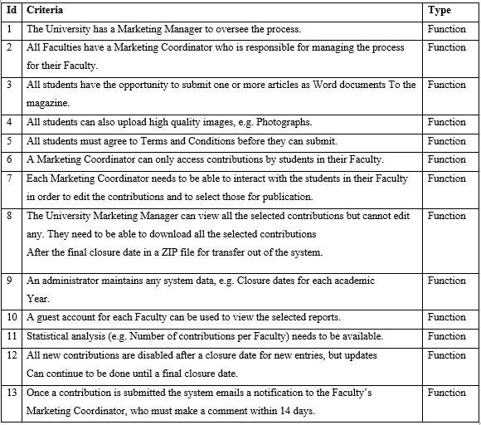

Figure 1: Functional

## Non-functional



Figure 2: Non-functional

# Database:

## ERD

We use MongoDB to store one-to-many data and models, the data from the collection can be compared to the data in another collection.

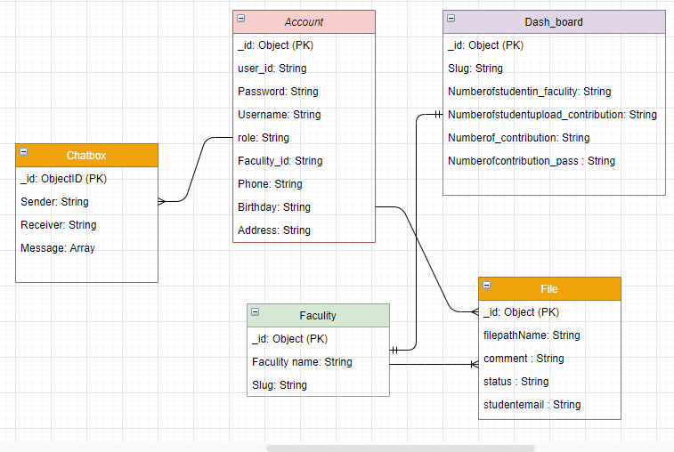

Figure 3:ERD

To meet the project requirements, we have designed 5 collections included:

_The account collection will contain attributes of the user, such as name, age, email, password, phone number, address, date of birth. The slug field we created is for the purpose of referencing other collections in the database. If the account role is student then a student can submit multiple files to the system.

_The faculty collection will contain the name and slug of the faculty. We use the slug to reference the student and the marketing coordinators available in that faculty. One faculty will have many students and only one marketing coordinator

_The chat collection will contain recipient's email name and sender's email and message. The message field is an array, the data will be pushed when users chat with each other. One faculty will have many students and only one marketing coordinator. If the account's role is a student, then 1 student will only be able to chat with one marketing coordinator. If the account's role is the marketing coordinator, the marketing coordinator can chat with all students in the faculty

_ The dashboar collection will include the following properties: slug, the number of students in the department, the total number of students paid in the department, the total contribution paid and the total number of contributions passed. The slug field will refer to the faculty in the collection faculty in the database. Each 1 dashboar will be associated with 1 faculty and vice versa

_ The file collection will include: the path of the file, the file name and the student's email. The path of file field will be the path to upload the file to the server and the email field will reference the account collection to identify who uploaded the file.

# Design:

## Sitemap:

Following are the links from the main page to the smaller pages of each role.

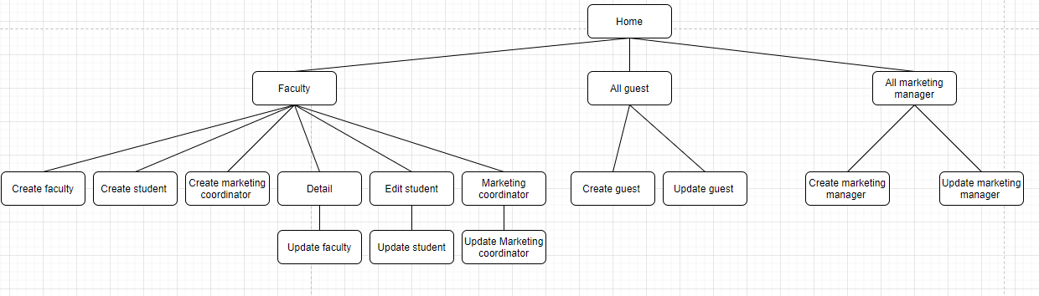

**Figure 4: Sitemap admin**

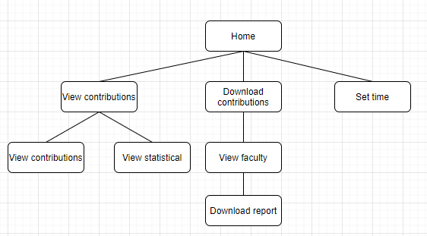

**Figure 5:Sitemap marketing manager**

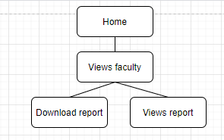

**Figure 6:Sitemap guest**

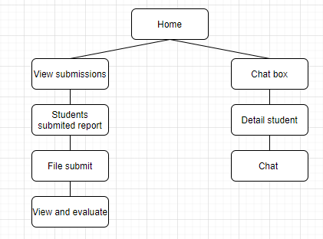

**Figure 7:Sitemap marketing coordinator**

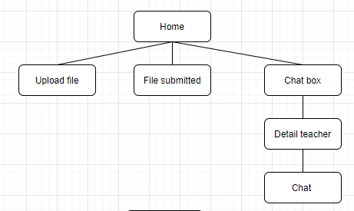

**Figure 8:Sitemap student**

## Wireframe

According to the requirements of customers, we have to design interfaces for 5 different objects: administrator, Student, Marketing coordinator, Marketing manager, and Guest. For each object, we will design a separate interface, interface. The interface will be designed optimally and suitable for devices such as computers, mobile phones, ...

### Login

First, when a user visits the website, the login page will be displayed first. Login is designed with a header in h tag with large clear font. Both the username and password fields are displayed in the text in the input area, making it easy for users to understand.

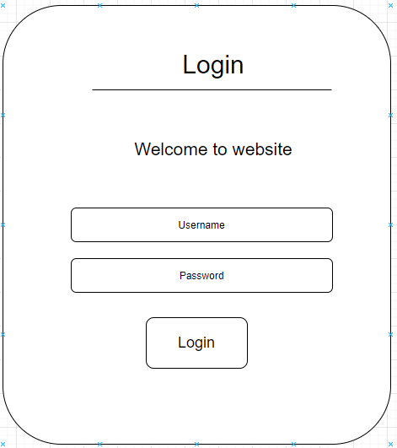

Figure 9:Wireframe login of computer and mobile

The layout of the interface is divided into 4 main parts: the header contains the "X" button to logout, the menu contains the functions that the user can use and it is displayed on the left-hand side, the content contains the content, the Finally, the footer.

When entering the student interface, the menu will display student functions such as home, upload file, submitted file, and chat box. Content will display personal information of students including user name, email, faculty, Phone, Birthday, and address. Information will be included in the table to make it easier for the user to observe. The title section uses h-tags and large fonts so that users can better understand the website they use. Pages displaying personal information are of the same structure.

### Personal information

**Desktop, laptop, pc:**

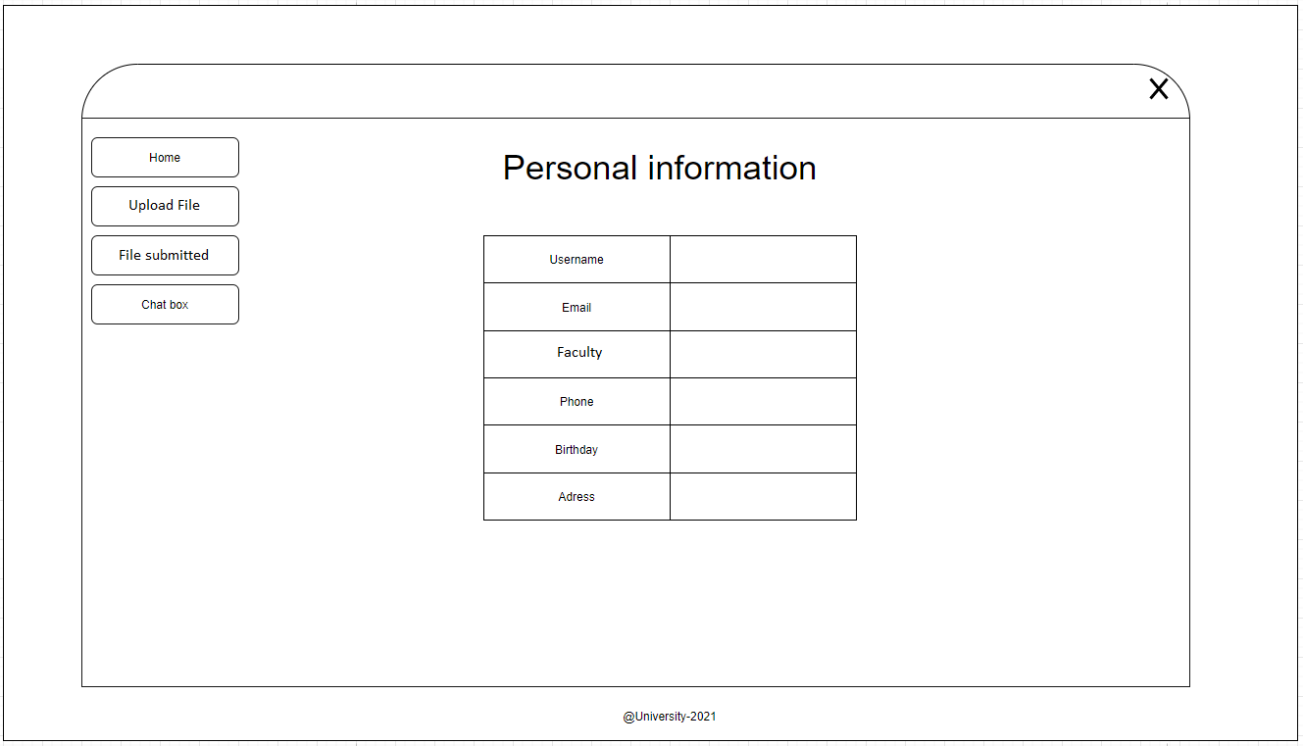

Figure 10:Wireframe home page of student

**Mobile:**

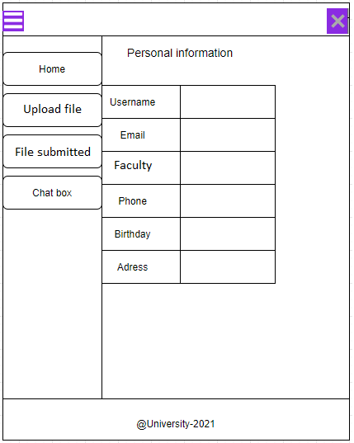

Figure 11:Wireframe home page of student mobile

To accommodate mobile devices, the menu section is hidden and shows an icon for the menu on the left to save space for mobile devices. When you need to use the menu, just click on the icon of the menu, the menu will appear and when the user clicks on the icon of the menu, the menu will be hidden.

### Upload file

**Desktop, laptop, pc:**

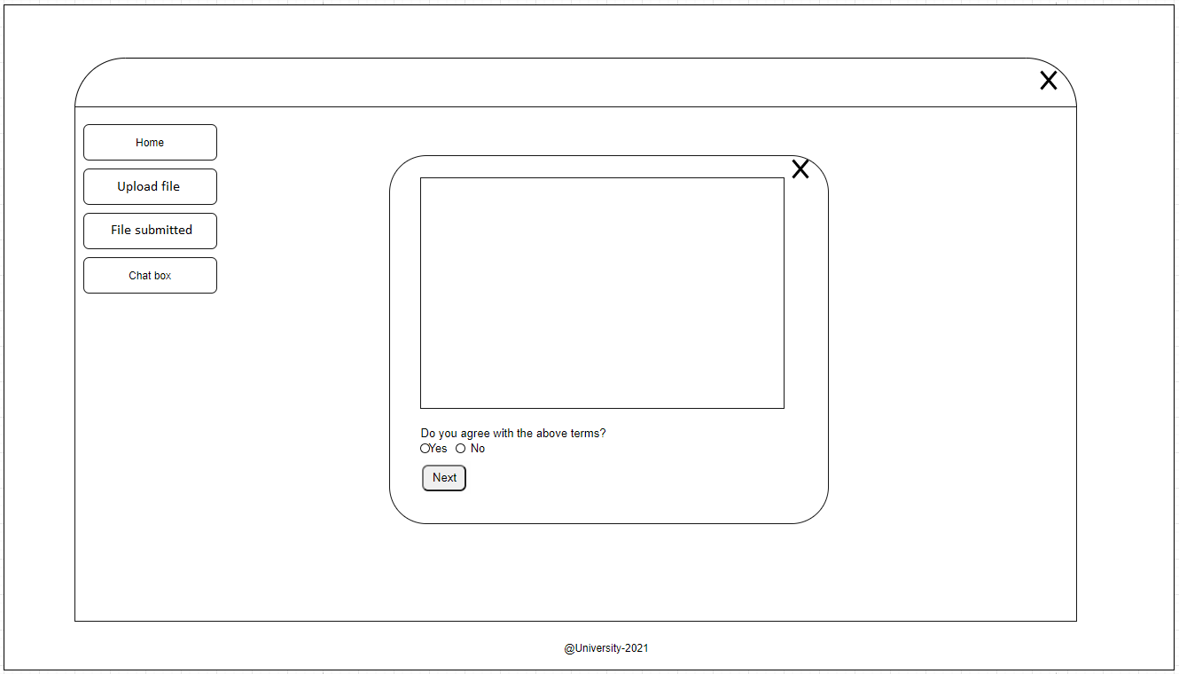

Figure 12:Wireframe popup terms

The terms display will use a popup to show the student's terms when trying to upload files.

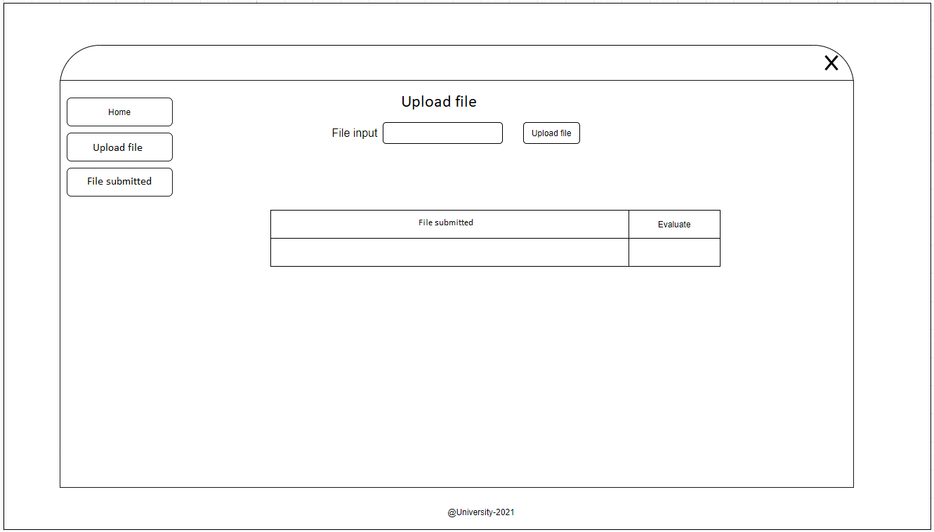

Figure 13:Wireframe upload file

**Mobile:**

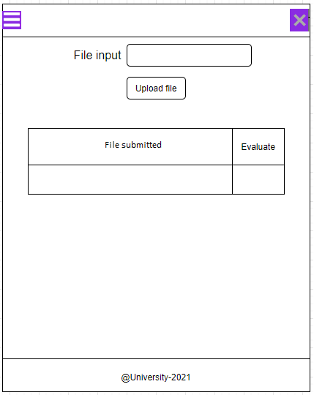

Figure 14:Wireframe upload file mobile

Using the input file header right before the file upload area will help users know the part they can upload files and the file upload button is located next to the user so that users can enter files and easily upload files.

The submitted files are placed in tables for easier viewing and management by users.

**Desktop, laptop, pc:**

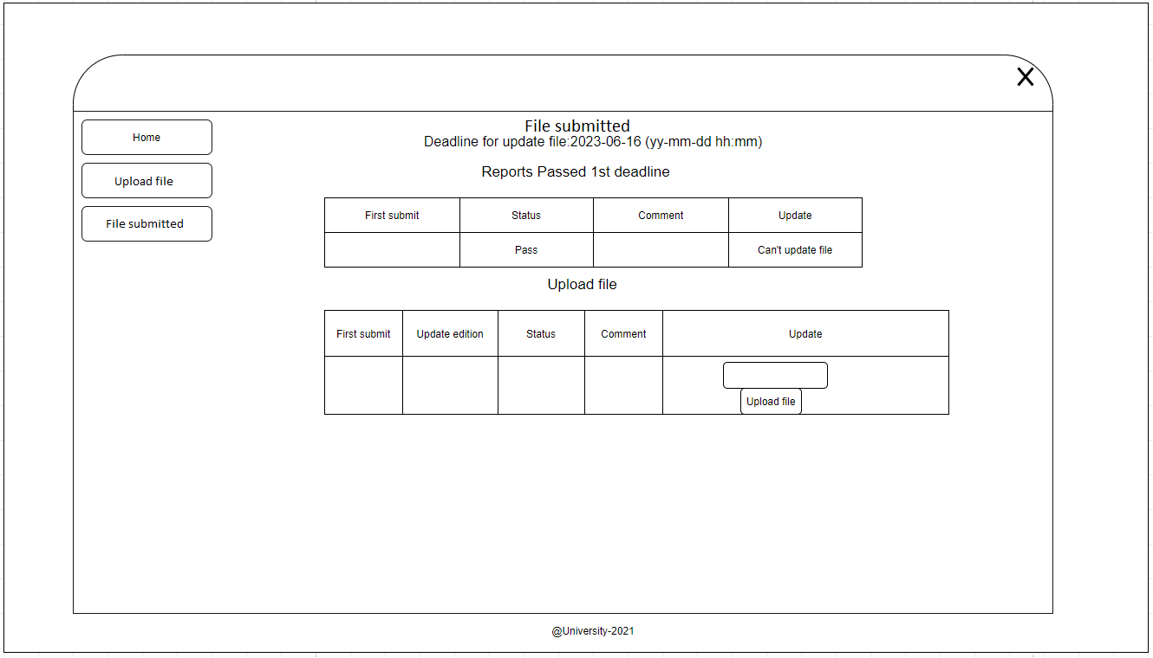

Figure 15:Wireframe file submitted

**Mobile:**

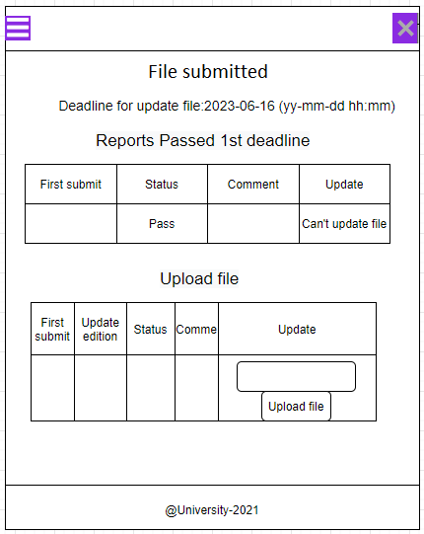

Figure 16:Wireframe file submitted mobile

It shows the deadline for the report, table 1 shows the reports that have passed and the file could not be uploaded. Table 2 shows the reports that have not been graded or failed. If there is a deadline, users can upload another file.

### Message

**Desktop, laptop, pc:**

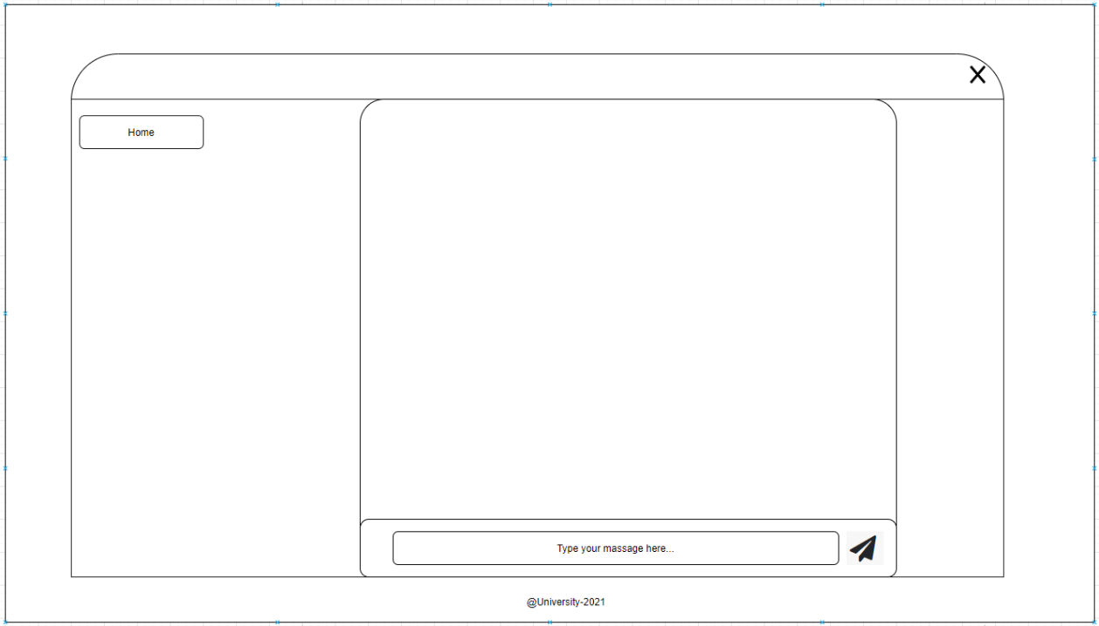

Figure 17: Wireframe chat box of Student and marketing coordinator

**Mobile:**

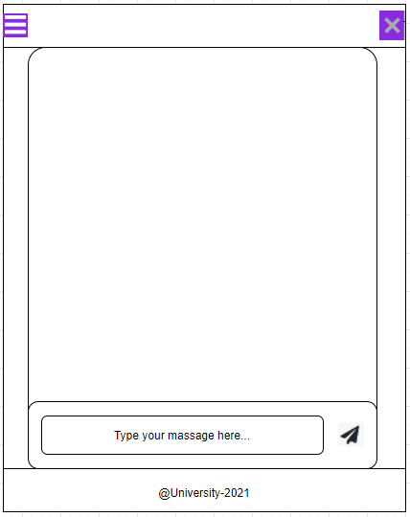

Figure 18: Wireframe chat box of Student and marketing coordinator mobile

Students and coordinators can contact each other through the chat box. The text chat section has: type your massage here to help users know where to write the chat box. Next to it is an icon for the button to send the message.

### All faculty

**Desktop, laptop, pc:**

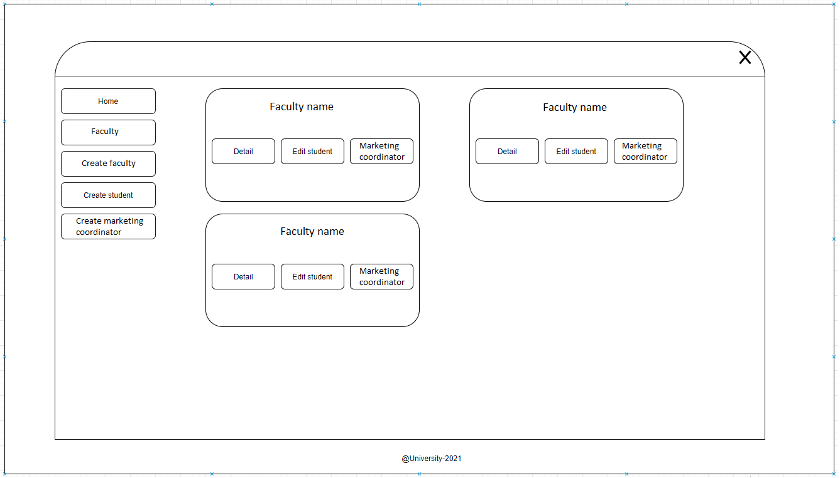

Figure 19:Wireframe all faculty of admin

**Mobile:**

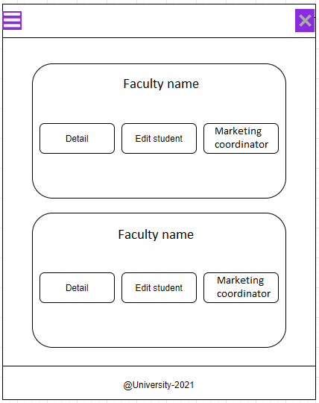

Figure 20:Wireframe all faculty of admin mobile

In faculty, it will display the faculty. The faculty will be wrapped into a frame and functions are placed in the button so that the user can observe and understand its usage and functions.

**Desktop, laptop, pc:**

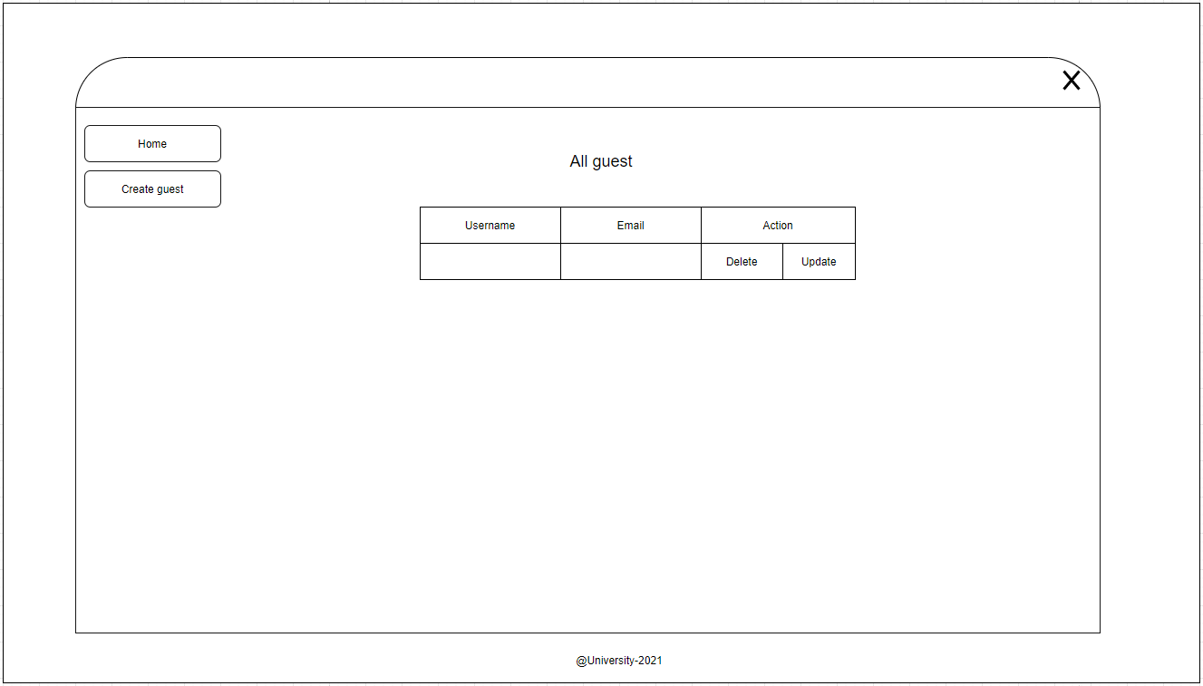

Figure 21:Wireframe all guest of admin

**Mobile:**

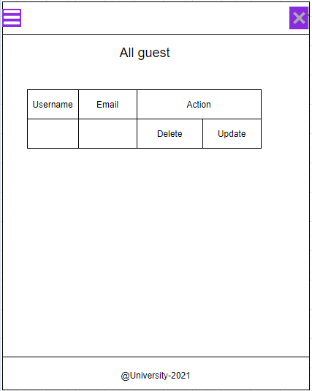

Figure 22:Wireframe all guest of admin mobile

Show all guest and marketing managers are included in the table for easier management.

### Set time

**Desktop, laptop, pc:**

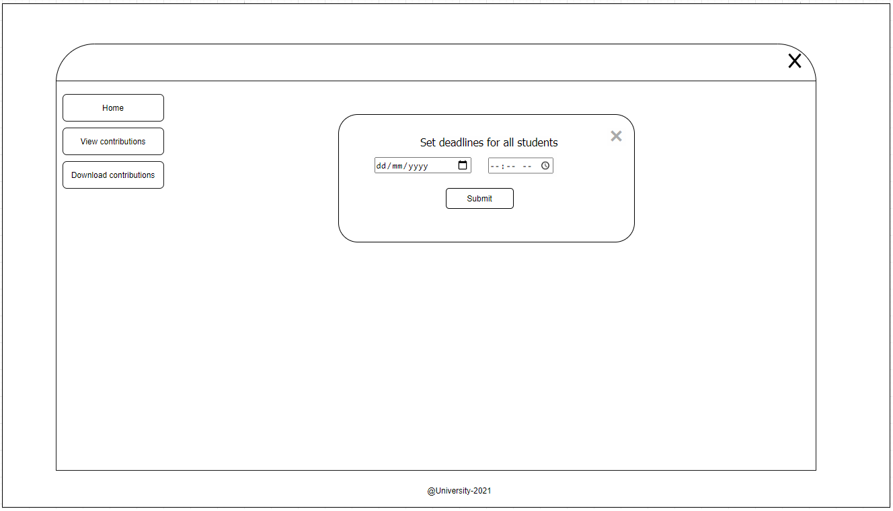

Figure 23:Wireframe set time of marketing manager

**Mobile:**

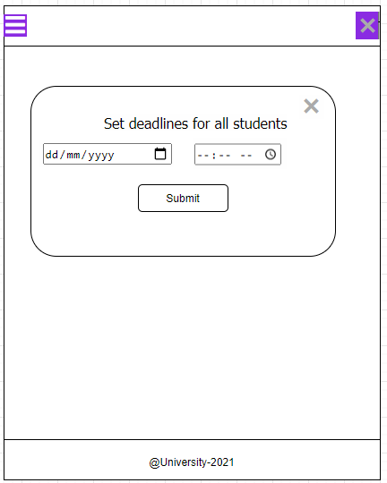

Figure 24:Wireframe set time of marketing manager mobile

The marketing manager can set a time for the report. The date entry uses the date tag input for users to easily enter the correct category. The set time is also designed in a popup format that is both easy to use and saves an area.

### View and evaluate

**Desktop, laptop, pc:**

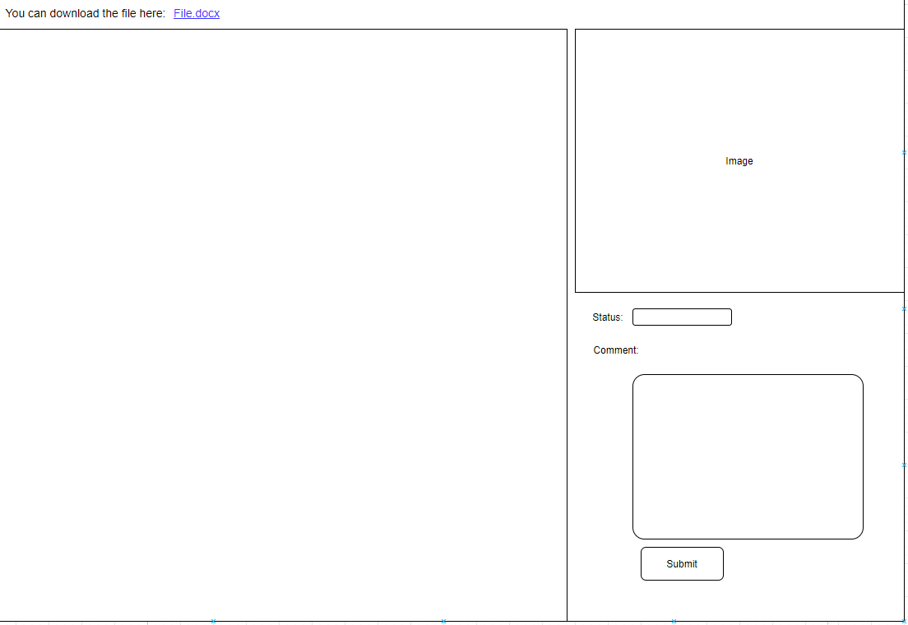

Figure 25:Wireframe view and evaluate of marketing coordinator

**Mobile:**

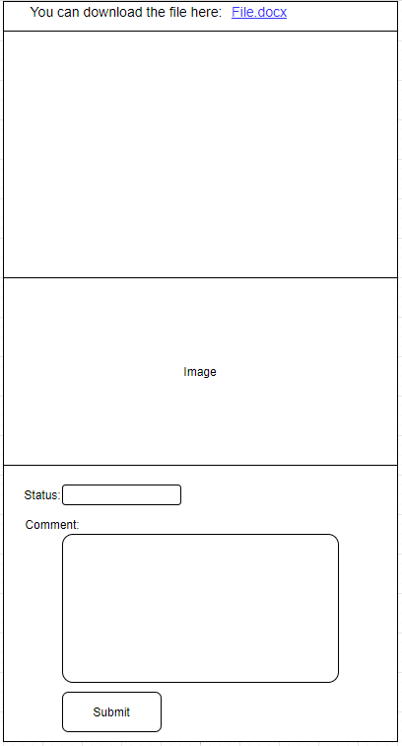

Figure 26:Wireframe view and evaluate of marketing coordinator mobile

The Marketing coordinator can view the student's uploaded files and rate them. The rating: status shows the current score and can choose the point to change without having to manually enter.

## Interface

The colors used on the web interface are all light and gentle colors that do not cause inhibition.

When switching from desktop to mobile the menu is hidden to save screen space. The fonts have all been adjusted to suit the phone.

Buttons will add effects.

### Login

First, when a user visits the website, the login page will be displayed first. Then the user will enter the username and password, the system will check the username and password to provide an interface for each object above. It is suitable for both computers and mobile.

**Desktop, laptop, pc:**

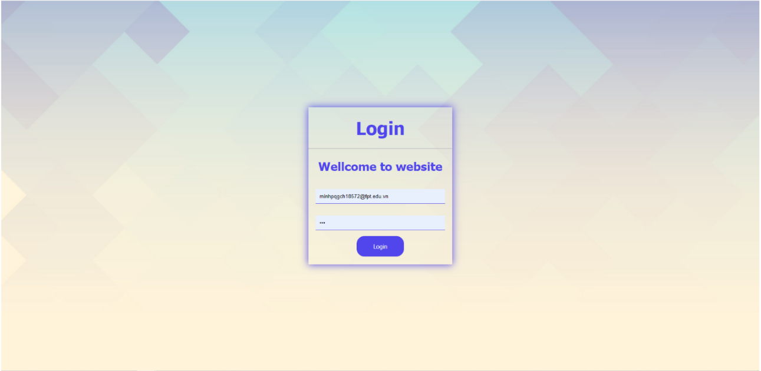

Figure 27:Login

**Mobile:**

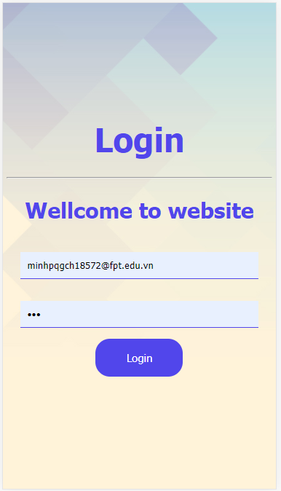

Figure 28:Login mobile

The layout of the interface is divided into 4 main parts: the header contains the "X" button to logout, the menu contains the functions that students can use and it is displayed on the left-hand side, the content contains the content, the last part. the same is the footer.

When entering the student interface, the menu will display student functions such as home, upload file, submitted file, and chat box. Content will display personal information of students including user name, email, faculty, Phone, Birthday, and address.

### Personal information

**Desktop, laptop, pc:**

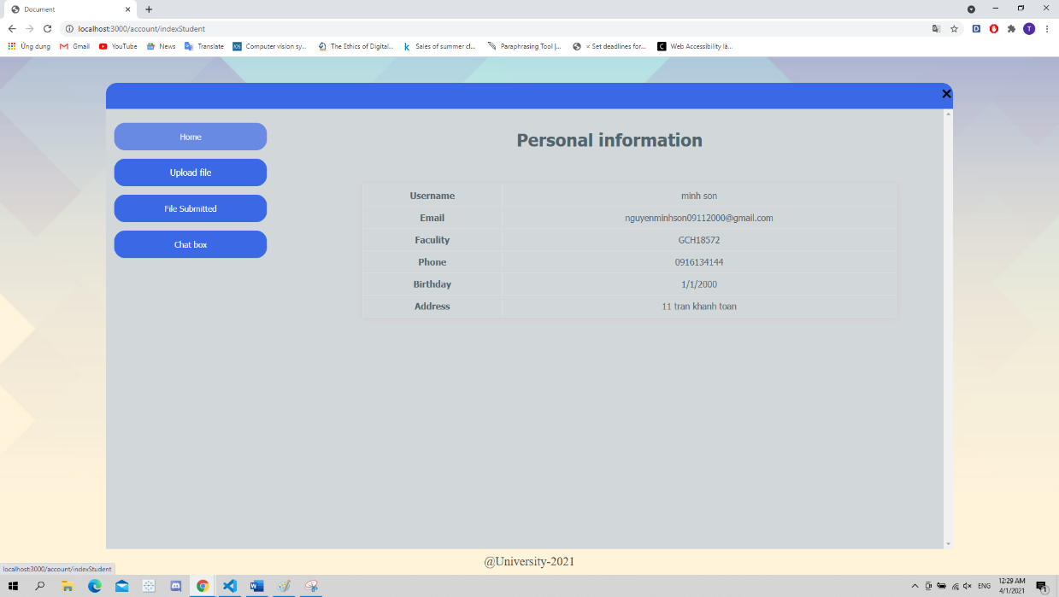

Figure 29:home page student

**Mobile:**

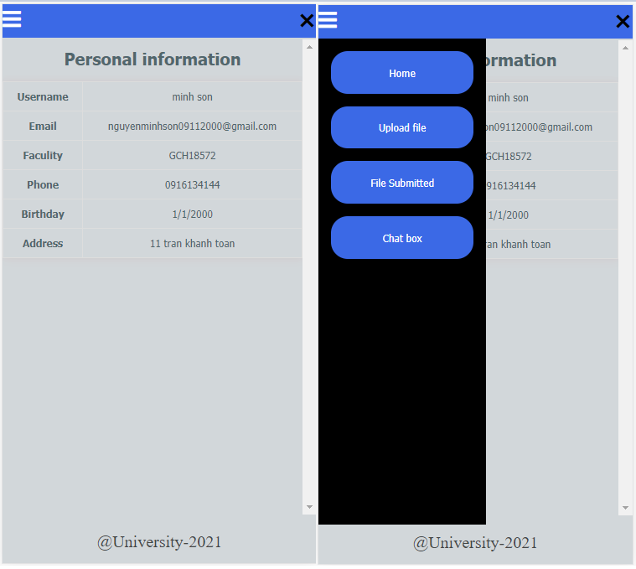

Figure 30:homepage student mobile

To be suitable for mobile, the menu section will be hidden and display an icon for the left-hand menu to save space for the mobile device. When you need to use the menu, just press on the icon for the menu, the menu will appear and when the user presses the icon of the menu, the menu will be hidden.

### Upload file

**Desktop, laptop, pc:**

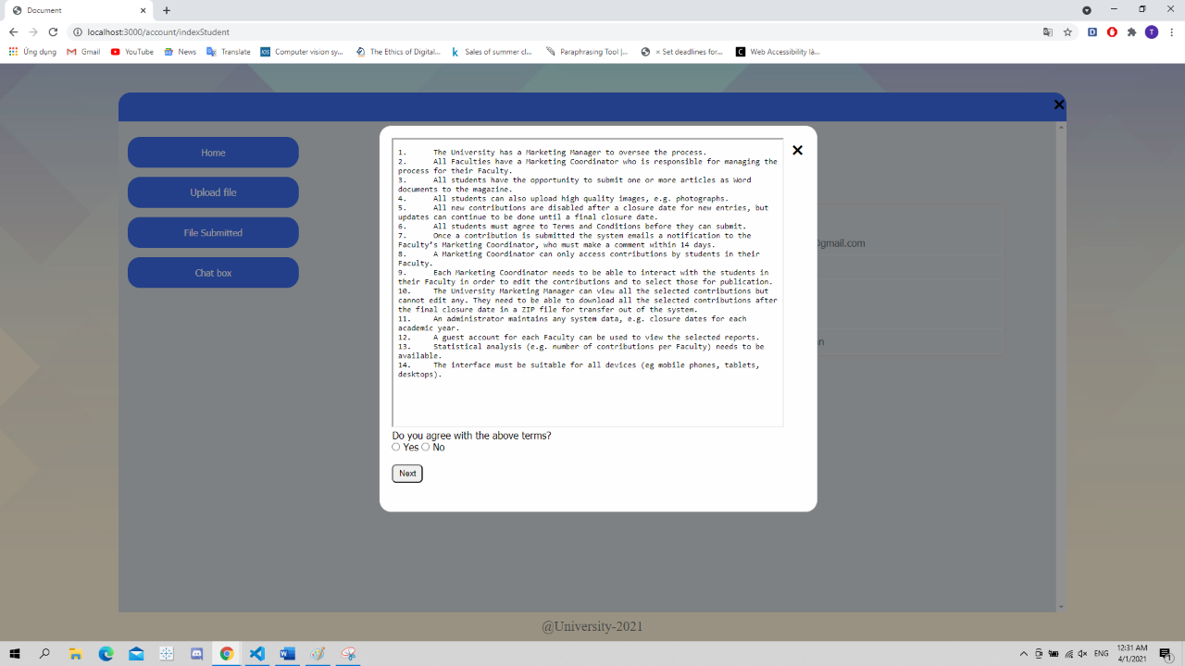

Figure 31:popup terms desktop

After clicking to Upload file, it will display the terms and students need to agree with the terms before they can access the updated files.

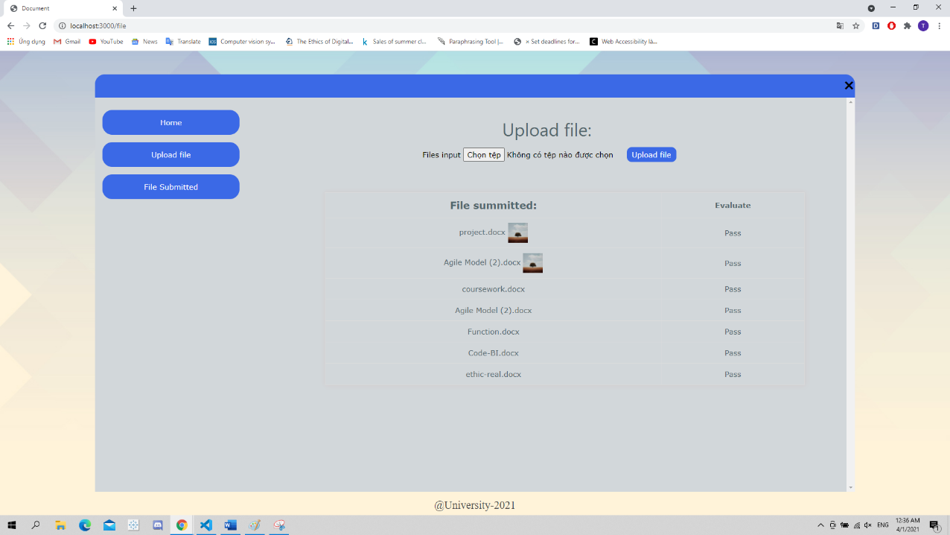

Figure 32:upload file

**Mobile:**

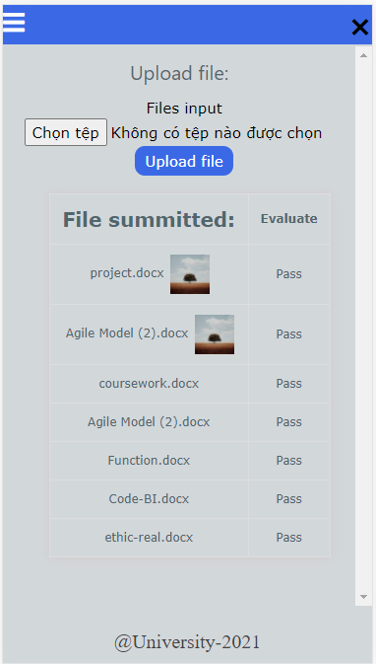

Figure 33:Upload file mobile

The input file section is for the user to import the files and images to upload the file. The table below shows the files that the user has uploaded. The content uses scroll, so the user can scroll down to see the content if the content is long.

**Desktop, laptop, pc:**

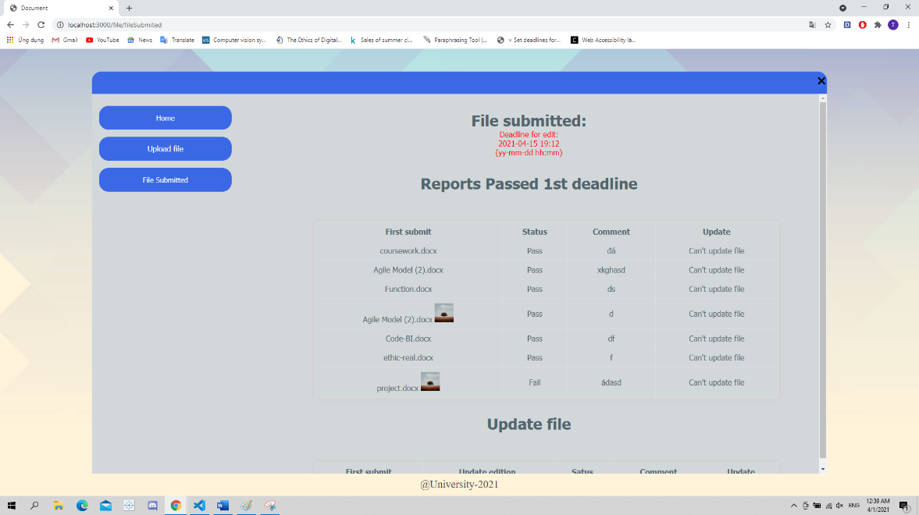

Figure 34:File submitted

**Mobile:**

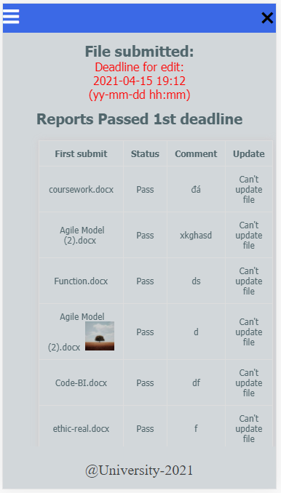

Figure 35:File submitted mobile

It shows the deadline for the report, table 1 shows the reports that have passed and the file could not be uploaded. Table 2 shows the reports that have not been graded or failed. If there is a deadline, users can upload another file.

### Massage

**Desktop, laptop, pc:**

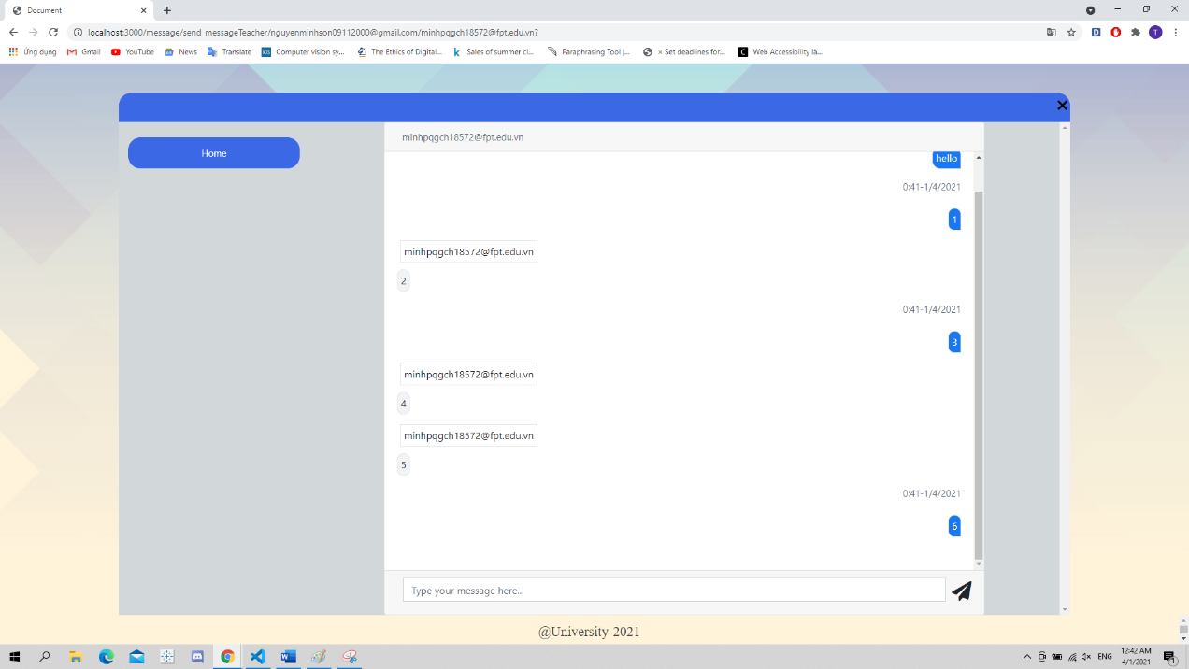

Figure 36:chat box of Student and marketing coordinator

**Mobile:**

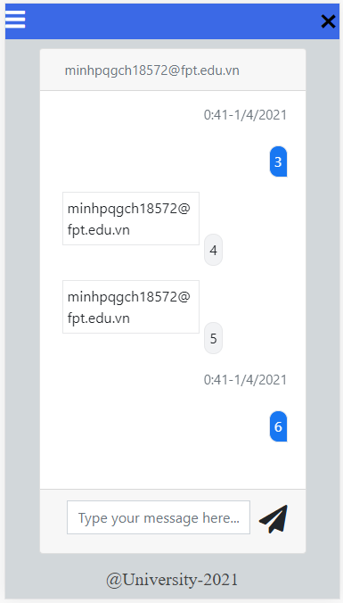

Figure 37:chat box of Student and marketing coordinator mobile

Students and coordinators can contact each other through the chat box.

### All faculty

**Desktop, laptop, pc:**

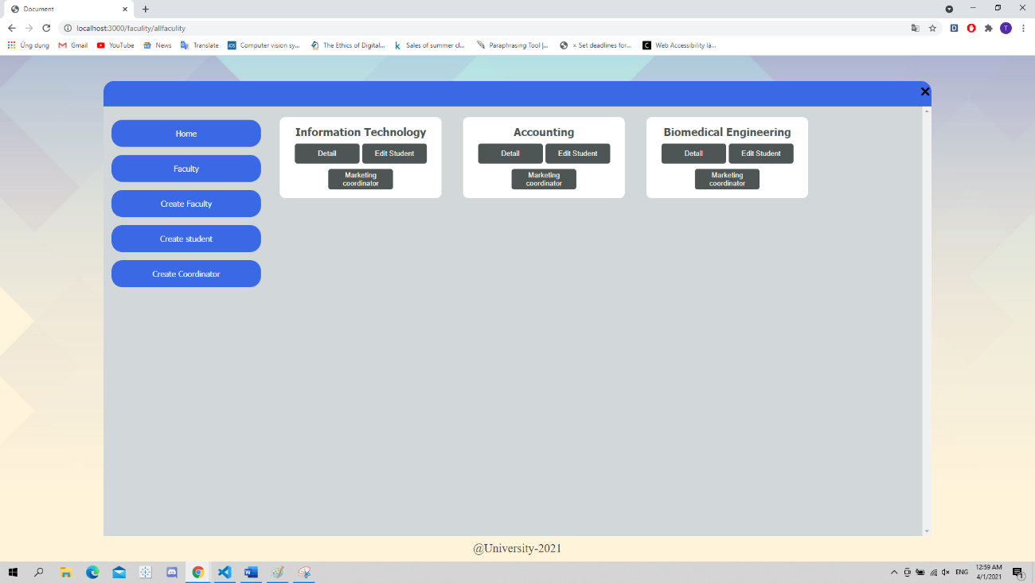

Figure 38:All faculty of admin

**Mobile:**

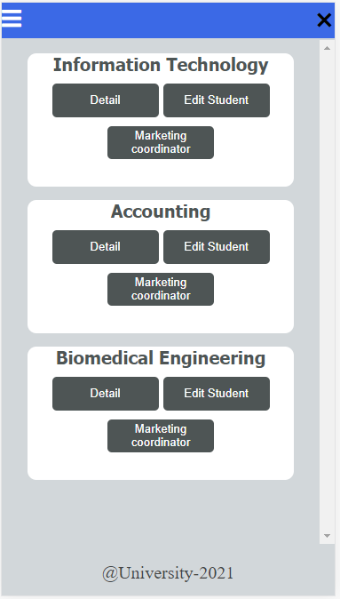

Figure 39:all faculty of admin mobile

In faculty, it will have the functions: create faculty, create student and create marketing coordinator. Content will display the Faculty name and can be edited by "Detail", can view the students in the department, can view the marketing coordinator of that department.

**Desktop, laptop, pc:**

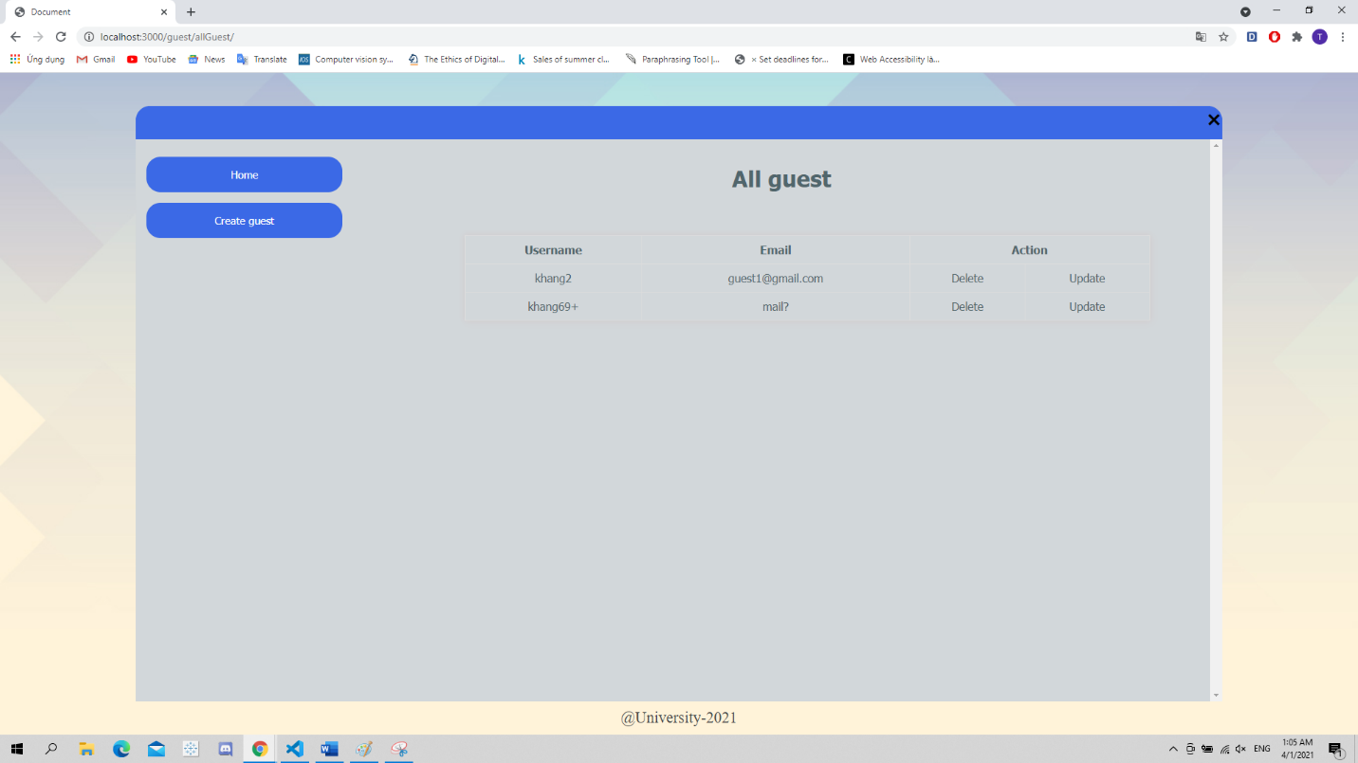

Figure 40:all guest of admin

**Mobile:**

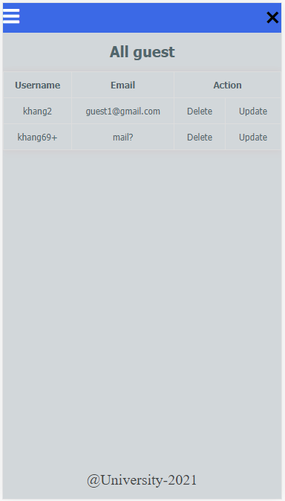

Figure 41:all guest of admin mobile

Show all guest and marketing managers. Admin can create guest and marketing coordinator, manage them.

### View bar chart

**Desktop, laptop, pc:**

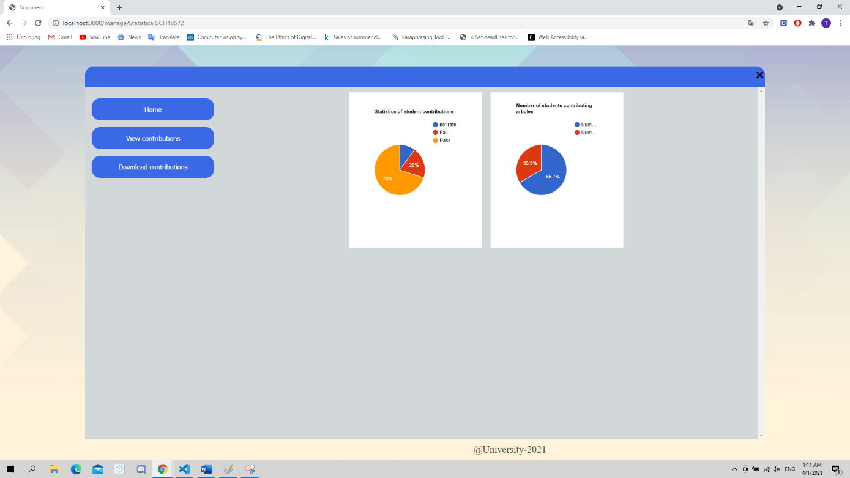

Figure 42:bar chart

**Mobile:**

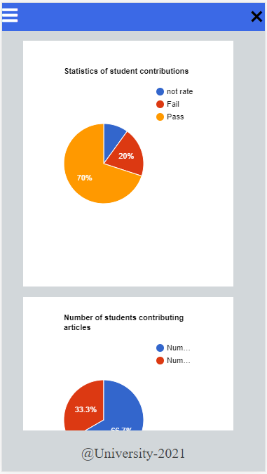

Figure 43:bar chart mobile

### Set time

**Desktop, laptop, pc:**

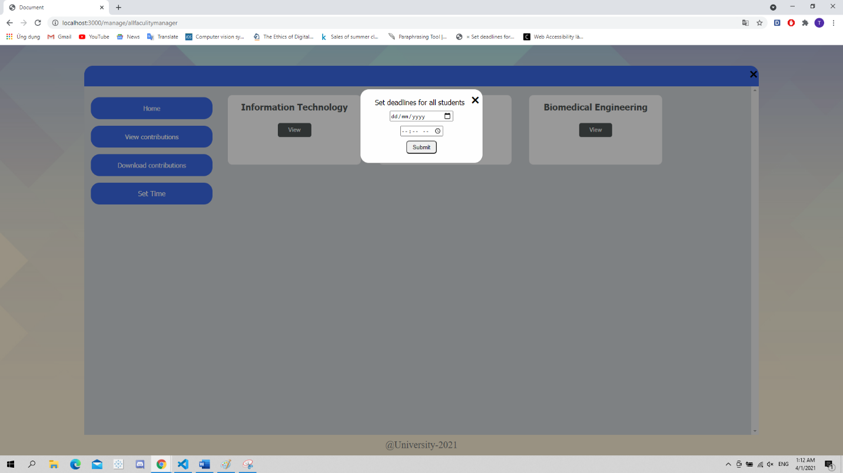

Figure 44:set time of marketing manager

**Mobile:**

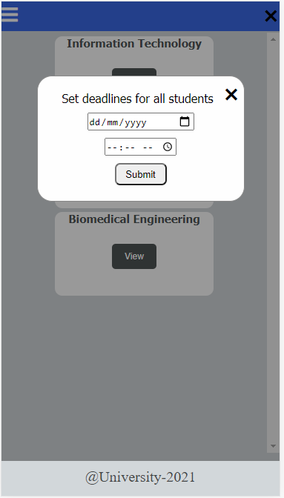

Figure 45:set time of marketing manager mobile

A marketing manager can set a time for the report of students.

### View and evaluate

The Marketing coordinator can view the student's uploaded files and rate them.

**Desktop, laptop, pc:**

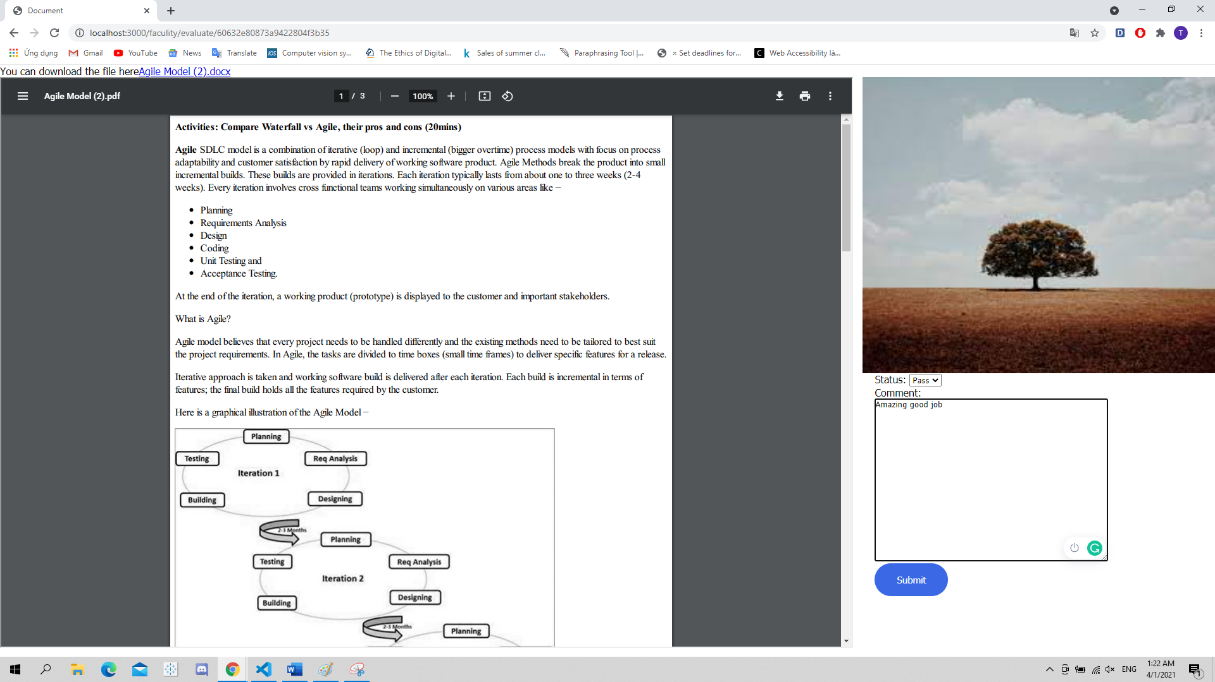

Figure 46:View and evaluate of marketing coordinator

**Mobile:**

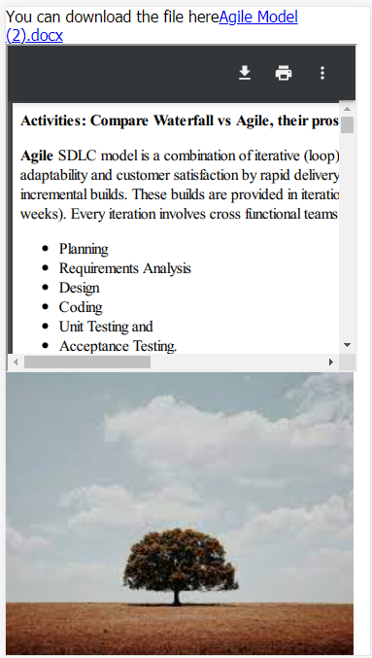

Figure 47:View and evaluate of marketing coordinator mobile

The interface uses bright colors, good-looking and does not cause inhibition for the viewer. Buttons are added effects to let the user see where they are clicking and create an interesting feeling for the user. The clearly displayed functions make it easy to remember and use at the same time.

## Usability

The website's interface is easy to recognize and easy to use functions:

* The menu is fixed on the right-hand side and all functions are displayed in the menu bar so the user can use it easily.
* When using on the phone, the menu is hidden and displays the menu icon so the user can click on it to display the menu. The fonts will also be adjusted to suit the phone screen size.
* The website has headers for the user to see what function they are using.
* Naming functions are quite simple so users can remember the functions in the website easily.
* When entering incorrect data, the types of data to be entered will be printed out so that the user can easily recognize and modify.
* The interface is used in creative colors that is comfortable and does not cause inhibition to the viewer.

## Accessibility

* The headings use h-tags and are bold, large font easy to see for everyone to see.
* Display the correct data format when input is incorrect.
* Not only using the mouse to navigate and use the website, but the keyboard can also use those functions.

Img tags all have an alt attribute.

# Implementation (Functionality):

## Use case Diagram:

Below is an overview Diagram of the whole system. Diagram includes 5 actors that are guest, students, admin, marketing coordinator and marketing manager. They are the people who interact directly with the system. With a clear decentralization, each task and their way of interacting is different on the system. For example, guest can view the selected report but Students do not have permission to do this ...

* 1. Guest use case diagram:

With guest authorization, there are 3 functions allowed to use and interact with the system, namely login / logout, view profile, view the selected reprot.

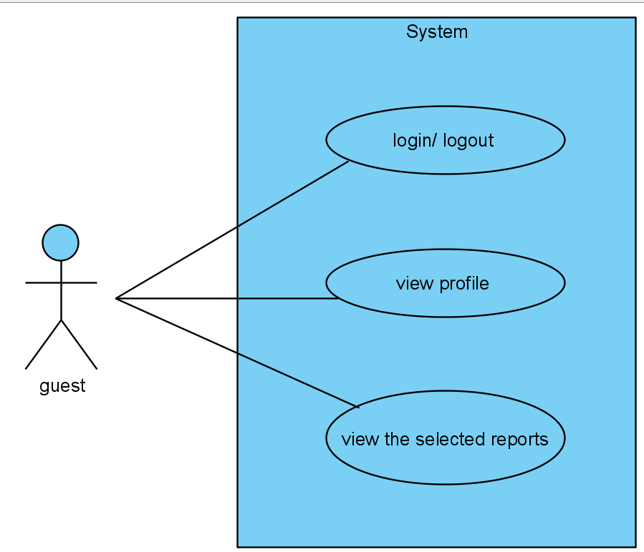

Figure 48 Guest use case diagram

* 1. Administrator use case diagram

With the Administrator decentralization, there are 3 functions allowed to use and interact with the system, they are any system data, Statistical analysis and account management.

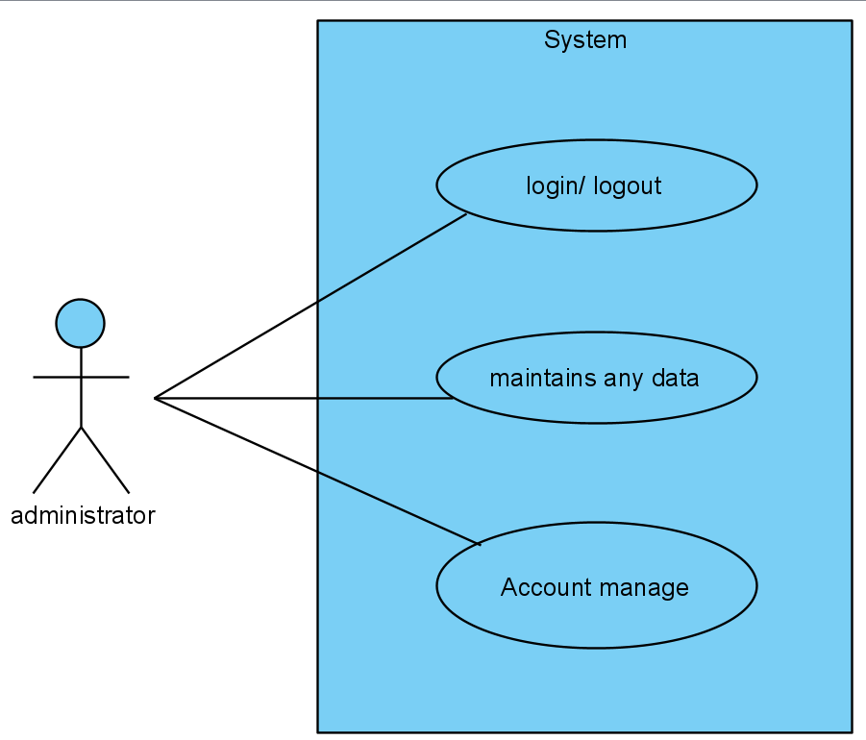

Figure 49 Administrator use case diagram

* 1. Marketing coordinator use case diagram

With Administrator privileges, there are 5 functions allowed to use and interact with the system, namely login / logout, chat box, view the selected reports, give comment, dashboard.

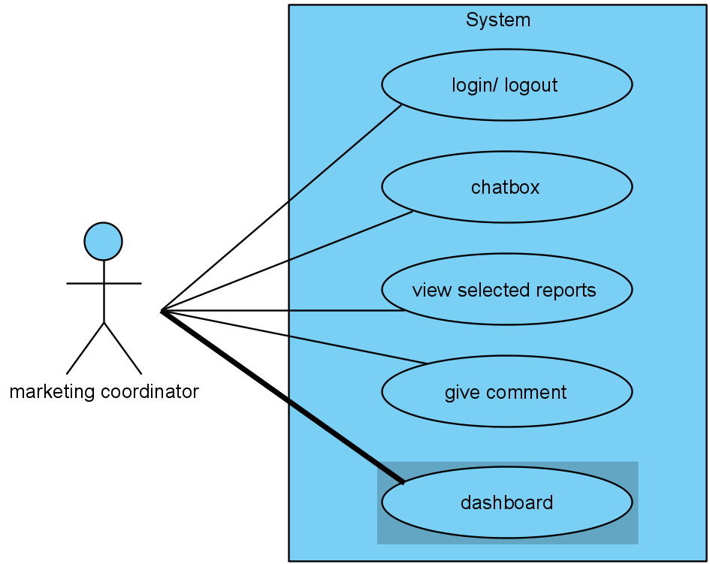

Figure 50 Marketing coordinator use case diagram

* 1. Students use case diagram

With Administrator rights, there are 5 functions that are allowed to use and interact with the system, namely login / logout, chat box, view profile, submit one or more articles as word documents and picture, update articles.

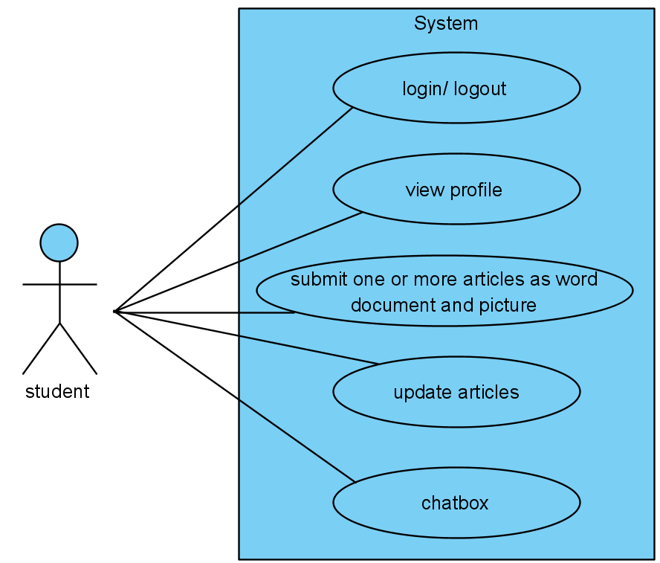

Figure 51 Student use case diagram

* 1. Marketing manager use case diagram

With Administrator privileges there are six functions allowed to use and interact with the system: login / logout, download the selected reports, view profile, view the selected reports, set time, Statistical Analysis.

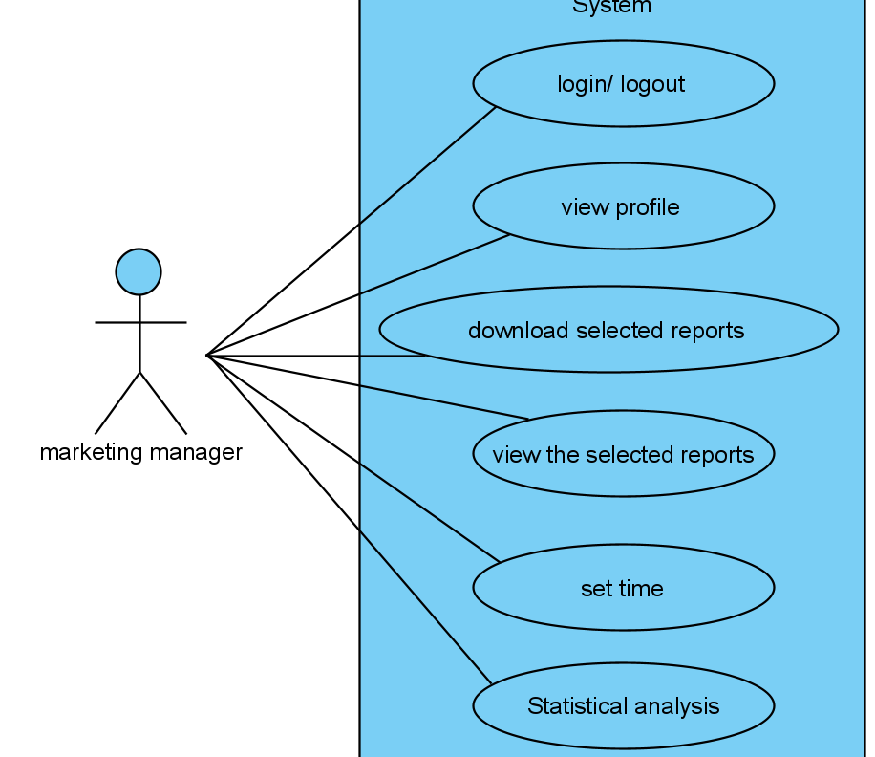

Figure 52 Marketing manager use case diagram

## Activity Diagram:

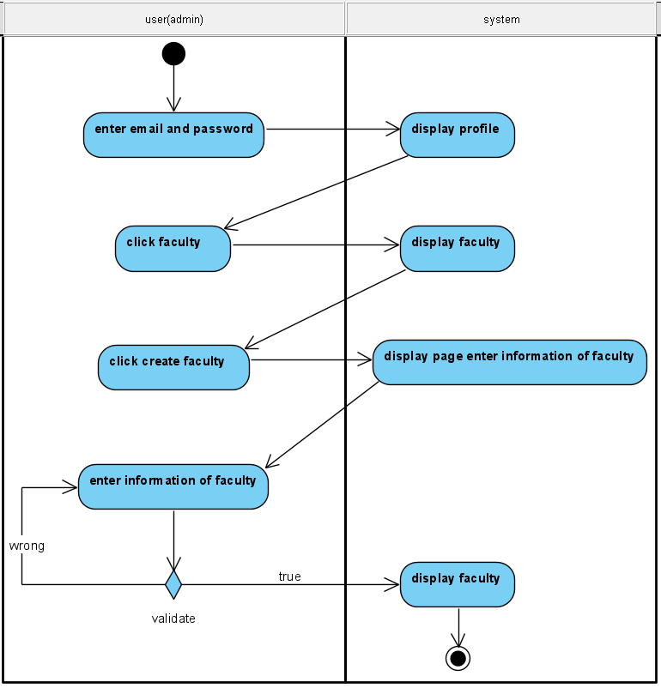

Figure 53 Create faculty activity diagram

Activity create faculty

Creating a new course is admin's right, so the only person interacting with the system here is admin. First, admin log in to his existing account which has been created on the database then the admin information screen appears, click on faculty, the screen displays the faculty page, click on create faculty, the screen displays the page to Enter information for faculty. Then it will divide two cases where an admin filled correctly and enough information, the system will now successfully create the class and send you to the faculty of all, and if wrong, the system will report an error and ask you to correct it. it's correct.

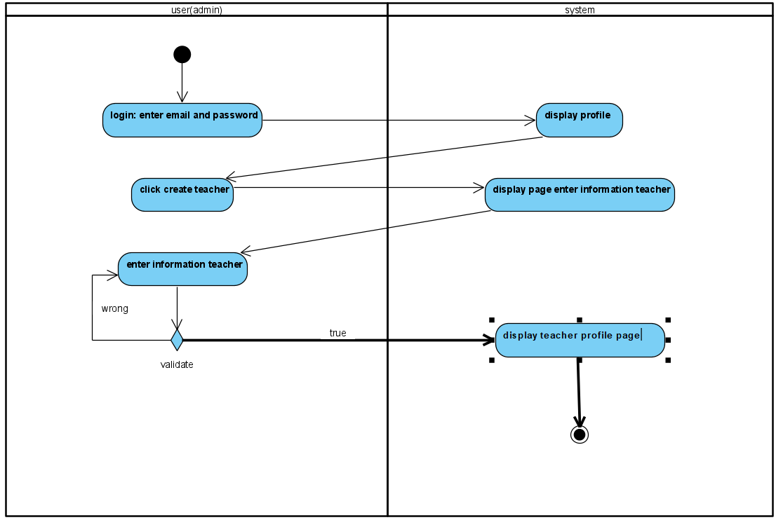

Figure 54 Create teacher activity diagram

Activity create teacher

Creating a teacher account is an admin function, first the admin logs in to an available account exclusively for the admin on the system. The admin information screen appears. Click on create teacher, the screen will display the teacher information page. Here appear two problems, the first problem if entering the correct screen will take us to the account information page of all teachers. Also, if it is wrong, the system will notify you of a mistake and ask to correct the wrong input.

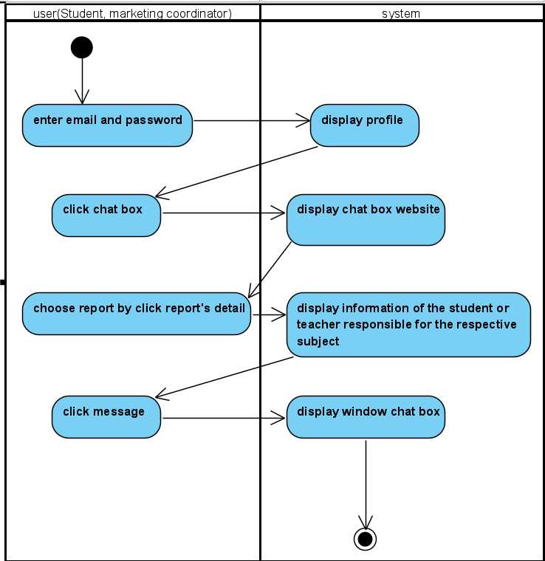

Figure 55 Chat box activity diagram

Activity chat box

For chat box function, we created for two roles: Marketing Coordinator and Student. The way its work is very simple, at the beginning, users logged in the system and go straight to their profile page. After that, user can click on “chat box” button and will be lead to the “chat box display” website. In that page, user can choose to see which chat box they want to discuss between submitter and marker by click on “report’s detail”. By clicking on that button, the system will display information of the individual responsible for that submission. Last thing they need to do is click on “message” and the system will show the chat box for them to interact.

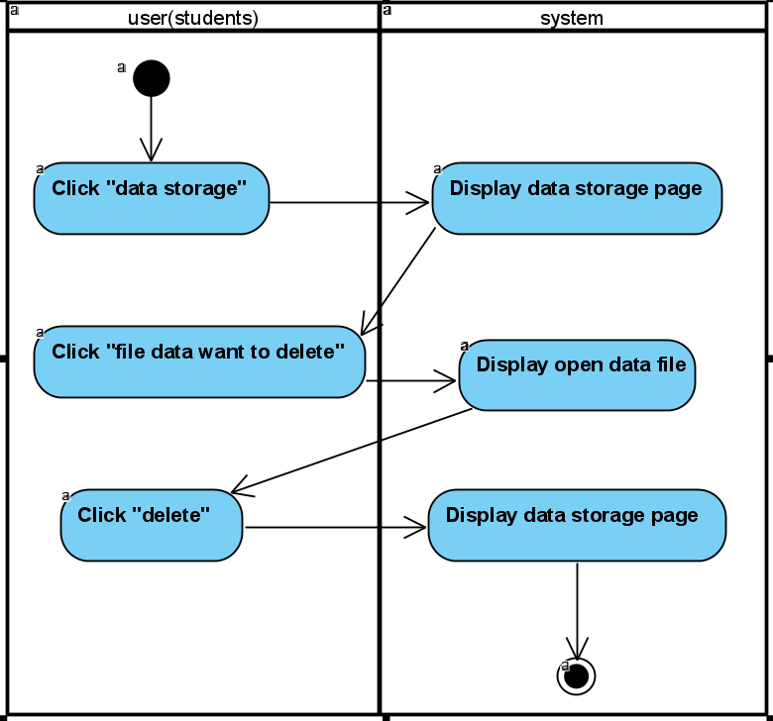

Figure 56 Delete/Update article activity diagram

Activity delete/update articles

This function is for Student only, it is use for student to edit their submission after they submitted it on the web. First, the student need to click on “data storage” to see their submission, the system will display a list of their submission, all they have to do now is click on the article they want to delete/update. after their page finish loading, they can click on update or delete button of the submission they want to update/delete. When they done all of that, the system will return them to the data storage page.

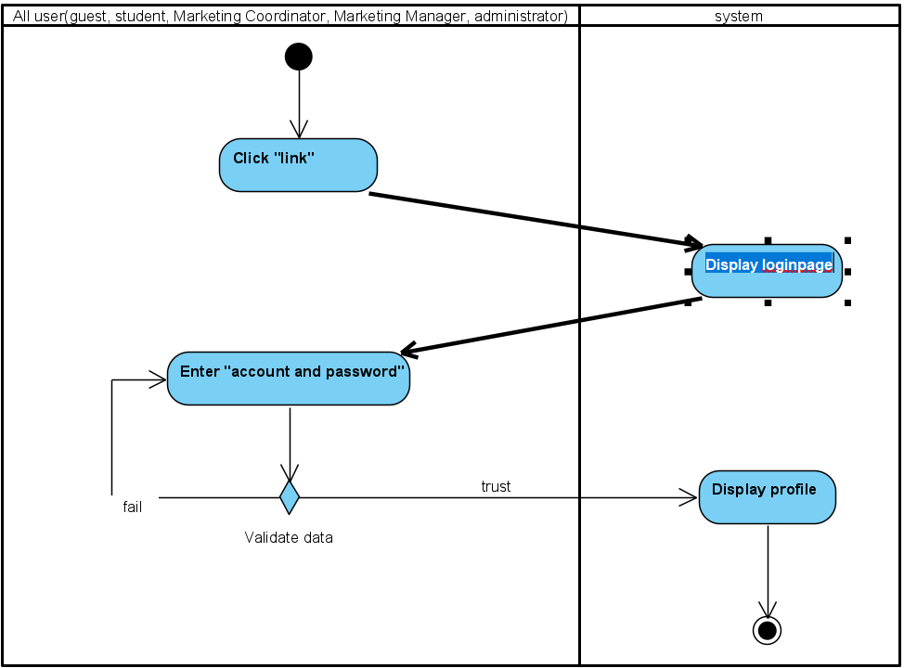

Figure 57 Login activity diagram

Activity login

The login function is created for all users. The purpose is very simple, to distinguish their role. First they need to click on the link which lead to the website, the system will immediately show them the login page. After they put in the correct email and password of their account, the system will let them in the system and show up their profile.

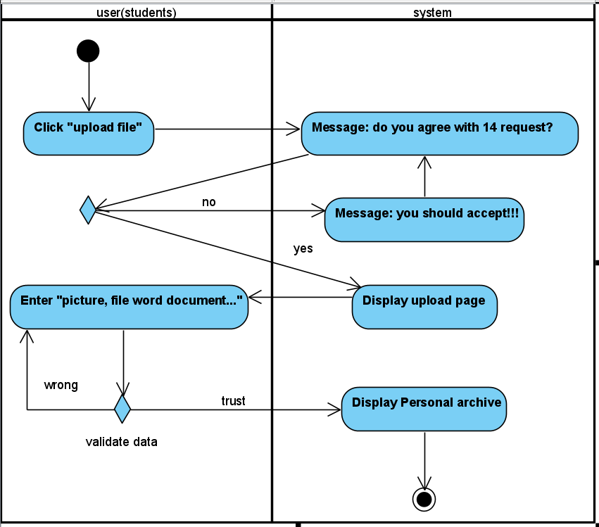

Figure 58 Upload activity diagram

Activity upload file

In this project, only student can upload file to submit their article. Before they can upload their submission, they must agree to the term of the web, if they choose yes, the system will bring them to the submit page. To upload, their file must follow some rule of the web and after the file bypass them all, the file will be up on the web and the system will show their personal archive.

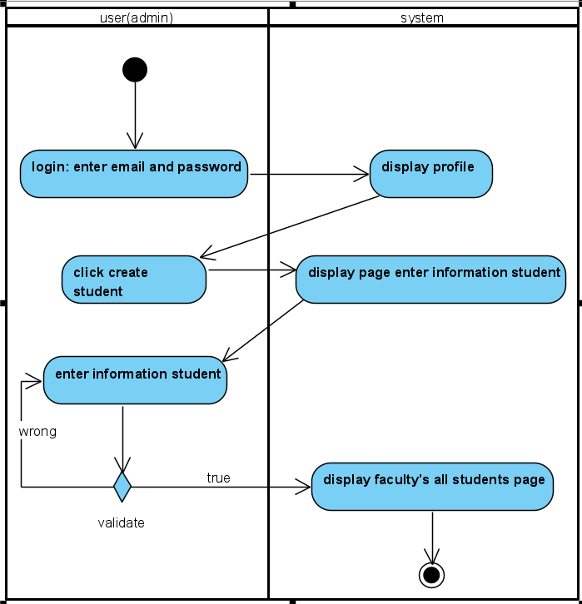

Figure 59 Add student activity diagram

Activity add student to faculty

Except administrator, all other role’s account can be created by admin including student. To do that, user must logged in by an admin account then click on “create student” After being brought to the create student page, they can enter student’s information and click on create, when the system finish validating all the information standard, the account will be create and jump straight to the faculty’s all students page.

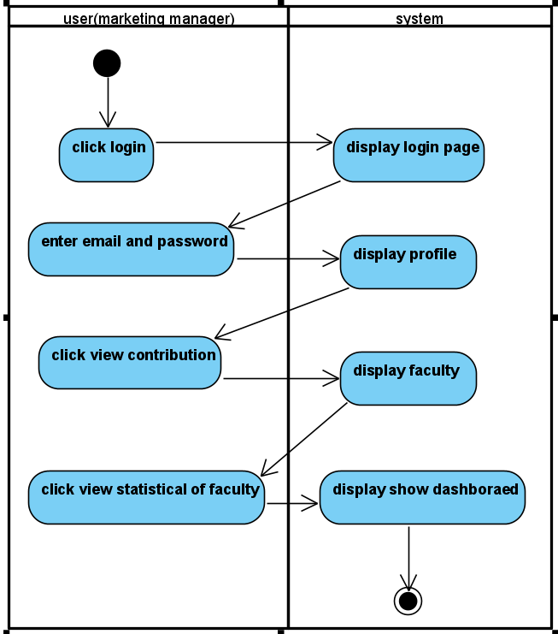

Figure 60 Dashboard activity diagram

Activity Dashboard

The dashboard is one of the function requirement of marketing manager role. After the logged in, they can click on view contribution and the system will bring up all faculty for them to choose, when they click on the button “ view statistical of faculty” the system will display that faculty dashboard for the user.

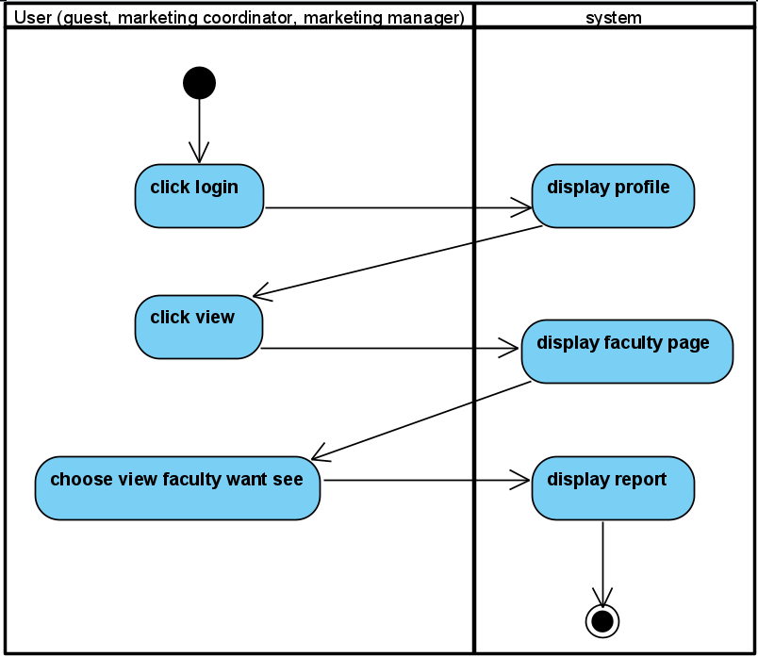

Figure 61 Download activity diagram

Activity download the selected reports

In order to download the selected report, the user must be Marketing manager, marketing coordinator or guest. For Guest and marketing coordinator, they must click on view article so the download button can show up. But with marketing manager, you can click on “download contribution” button, the system will bring you all the faculty. From that, the manager can click on view and selected article to download without have to read it.

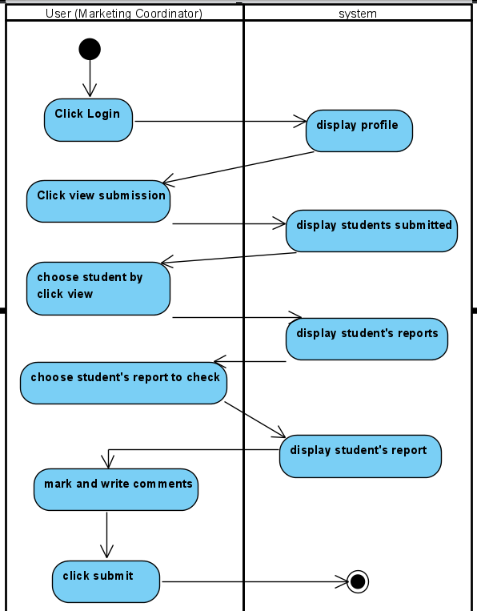

Figure 62 Comment activity diagram

Activity give comments

The comments function is only for marketing coordinator to work on after they logged in and when they are marking a submission. After they click on student, every submission of that student in that faculty will show up, the coordinator can choose one of them to mark. The last activity is when they finish grading, write their comment on the comment section of the article and press submit.

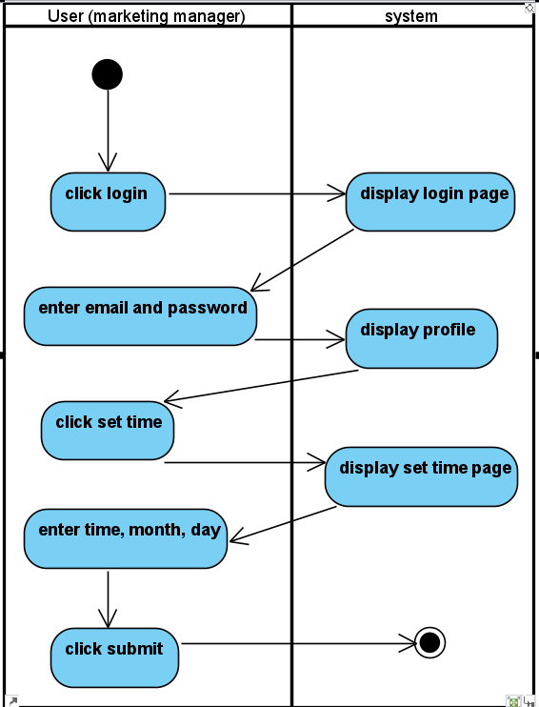

Figure 63 Set time activity diagram

Activity set time

Set time is the activity where only Marketing manager can do. When they finished logging in, they can click on set time and the system will display a Date and Timer for them to set. Entering time, month, day and year, they can click on submit and set that time for all student.

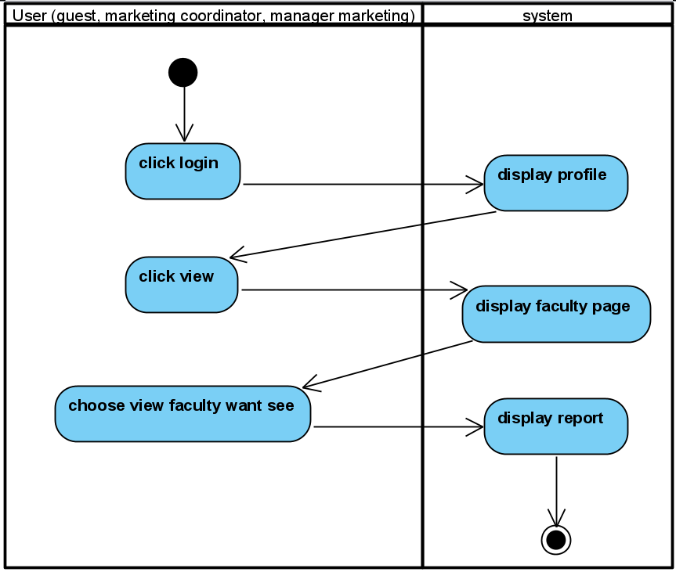

Figure 64 View article activity diagram

Activity view the selected reports

Viewing article can be performed by Marketing manager, marketing coordinator and guest. Just like every other activity, they must login first. After click on view, the system will lead them to the page where it display all faculty. The only thing they have to do left is choose the faculty and click on the article they want to view..

## Function

### Data security

To secure the user's data, we used bcrypt and salt to encrypt information and authenticate. We use the hash () function to convert a value into another. The reason we use the hashing algorithm is because it cannot be decoded or converted back to its value.

The hash () function takes 2 parameter values, which are the data to be encoded and "salt". Salt is added to the hash head to protect the password in case of attack. The value of "Salt" denotes the complexity of the hash function, the higher its value, the longer the password has to be hashed.

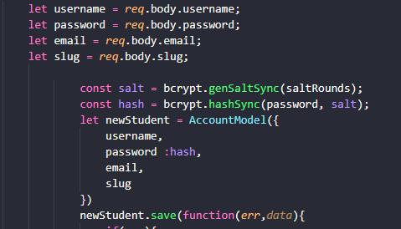

Figure 65: Data security

Upon login, we have turned user information into a token including "_id". Server side will look under _id for authentication, login and authorization. As soon as the token is signed, we use cookies to store the token. Storing information in cookies for too long can present many security risks. That's why we have set "maxAge" of cookies to last for 1 day to avoid hacker attacks



Figure 66: Data security

To ensure cookies are only sent to urls with https addresses, we have used "httpOnly: true" to protect against XSS attacks.

We use a middleware to check the information the user enters upon login. By decompiling the token stored in the cookie to get the user's "_id" for comparison in the database. If the user's account already exists, the server will continue, if not, the server will disallow it and return to the login page.

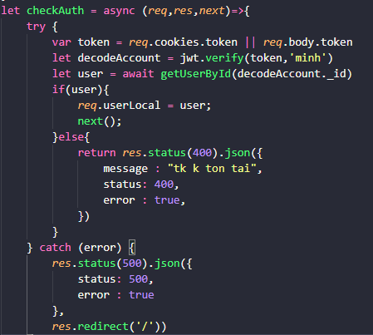

Figure 67: Data security

To prevent a user of this role from being able to access another role's site, we have used an additional middleware to check information on the user cookies.

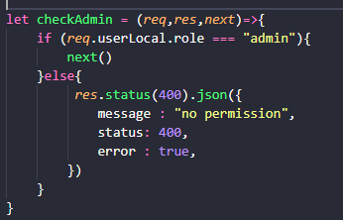

Figure 68: Data security

### Data validation

In order to have actual data and avoid errors in the process of running the project, the system has validated some information of user accounts and information of departments.

Regarding email registration: Admin, when registering an account for a user, will have to enter the correct format for the mail. If not, it will report errors and not allow registration.

Notification: email must contain @ gmail.com, etc



Figure 69: Validate email

About username: The system will check the user name by checking the characters in the name, if the Admin enters a username with special characters or numbers, the system will send an error and prompt the user to enter it correctly. form of name.

Notification: Username shouldn't contain number. e.g. Smith

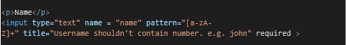

Figure 70: Validate name

About the date of birth of the account: The system will display a calendar for the admin to choose when registering an account for the user. Using the calendar is more accurate and avoids minor errors like stamp, date format, etc

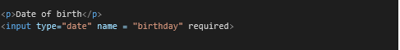

Figure 71: Validate birthday

About phone number information: Phone numbers are formatted as starting with the area code +84 (vietnam) and having at least 8 numbers. If the user enters text or special characters, the system will issue a format error and force the user to re-enter.

Notification:Phone number must not contain letters or any other characters.Phone number must be between 8-10 numbers.

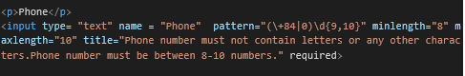

Figure 72: Validate phone

About the faculty name: When the admin creates the faculty name, the faculty name will also have the same format as the username. If the user enters numbers or special characters in the faculty name, the system will also report an error.

Notification: Faculty shouldn't contain number. e.g. Electronic technology

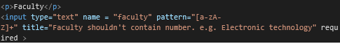

Figure 73: Validate Faculty name

About password: In order for a password to be secure, a password needs to have at least 8 characters and next to it does not contain any special characters. Having special characters can cause difficulty logging in.

Notification: Password needs to be at least 8 characters without special characters (/,?, Etc)

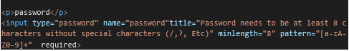

Figure 74: Validate password

### Main function in requirement

In the event that there is data in the database, the server will return the user's token in the cookie and examine that person's role and return it to the homepage with each different role. Since the token can be decoded, to avoid the disclosure of important information, we only store "_id" in the token. When signed token will have a period of 1 day, should not be too long to avoid being hacked.

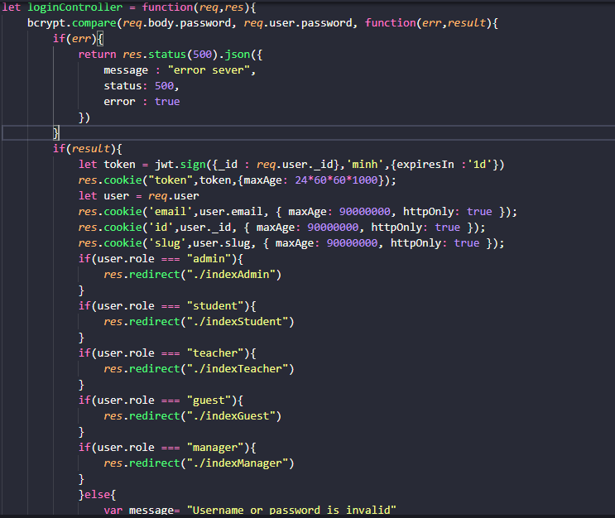

Figure 75: Authorize code

With the following logins, the server side will decode the token again to verify that it is them. To be able to decode the token, it is necessary to have the correct secret code generated in the server. After decoding the token, the server will check the role and direct the users to the home page depending on their role

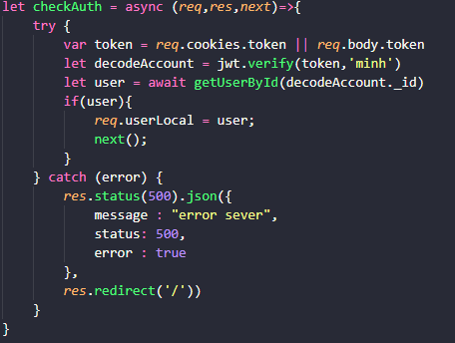

Figure 76: check Auth code

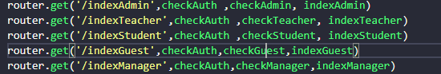

Figure 77: Home account

#### Upload file and images

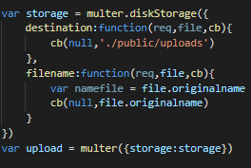

Figure 78: Upload file and images

First, the system will set a location to store the files that students upload to the system and their names when saved at that location. After that, the uploading of the student's file will have to go through the following tests with the condition: can upload only 1 word file and 1 image file (optional).

The system will check the number of files uploaded by the student. In case of uploading a file to the system, the system will force it to be a word file. After checking, if it is not a word file, the system will report an error and send a notice. If the test passes, the system will convert the file to PPF and start setting the file name and location (both docx and PDF) and save that information to the database.

* Case upload 1 file: Only docx is acceptable

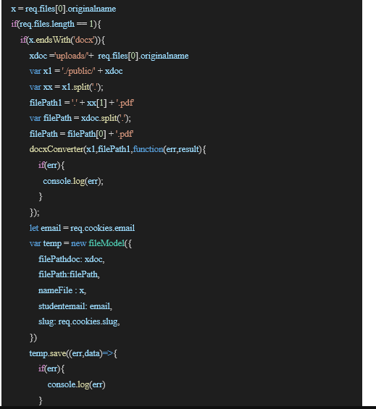

Figure 79:Case upload 1 file code

* Case upload 2 file: 1 docx and 1 images are acceptable

For the case of uploading 2 files to the system. First, the system will proceed to check the files. If a student uploads files other than word (docx), image (png, jpg, gif) files, the system will send an error message to the student with an uploadable file type. After the list is checked, the system will conduct to check whether the two files are word files or image files. If 2 files have the same properties, the system will send a notification. Otherwise, the system will convert the file to PPF and start setting the name, file location (both docx and PDF), image address and save that information in the database.

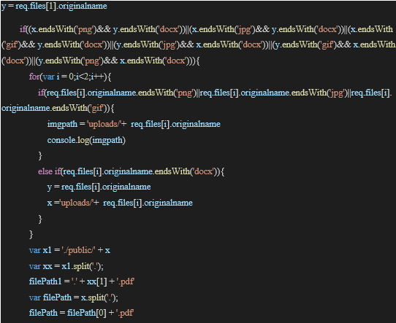

Figure 80:Case upload 2 file code

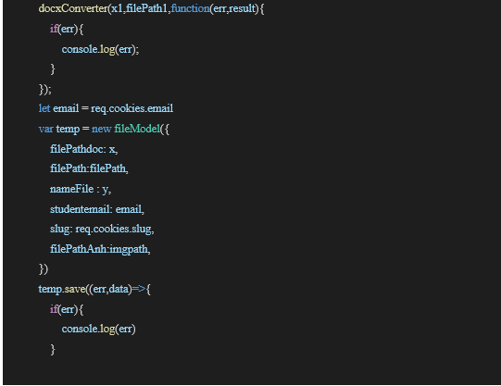

Figure 81:Case upload 2 file code

#### View the selected reports.

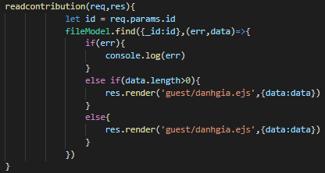

Figure 82: View the selected reports code.

From the front-end, the user will click and read the articles they are interested in, the back-end will get the information's id of that article and get the address of that article in the database through the id and display the post through the <iframe> tag on the front-end.

#### Receive email notification after student posting articles to the system.

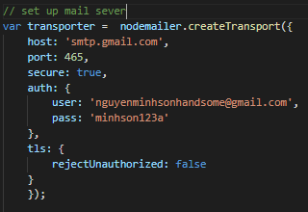

Figure 83: Set mail sever

First, we need to install mail for the server through the nodemailer library. Besides, the server's mail account also needs to set up some settings on google such as: allowing low security applications to access. . This will allow the server to access this mail without being intercepted by Google's security. In addition, you need to enable IMAP to retrieve email messages from the mail server over a TCP / IP connection.

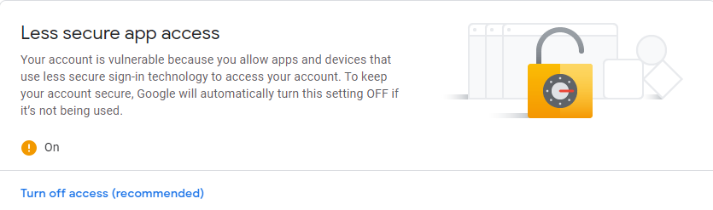

Figure 84: Turn on less secure app access

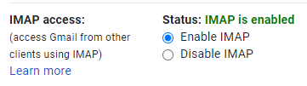

Figure 85:Enable IMAP

• Send email to student

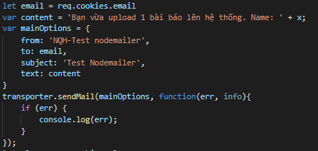

Figure 86: Send email to student code

To send mail to students every time they post to the system, the system will need to write the content of the mail. Then proceed to set up your mailing address and subject. After composing the mail, it will proceed to send the mail through the trasporter.sendMail function. This operation will happen after saving the file information to the datase.

* Send email to Marketing coordinator

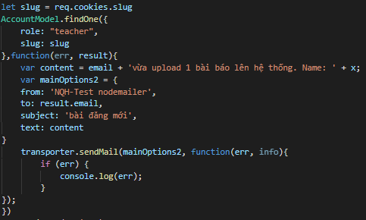

Figure 87: Send email to Marketing coordinator code

After students upload a post to the system, Marketing coordinator will also receive a notification about that post. Based on the student's scientific code (slug) and role as Marketing coordinator, the system will look in the database and retrieve the mail of that Marketing coordinator. After obtaining the Marketing coordinator's mail, compose the letter and send it to Marketing coordinator. This operation will happen after saving the file information to the datase.

#### Make a comment

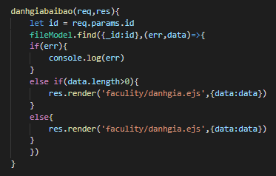

Figure 88: Make a comment code

First, the system will get the id of the selected article and from the id will get the information of that article and send it to the interface page for evaluation. All information (status, comment, etc) of that file will also be printed out in the interface page.

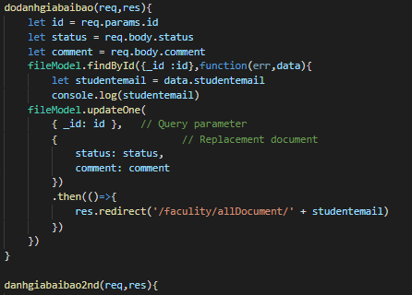

Figure 89: Make a comment code

After reading and giving comments and post status (Pass or Fail), the system will get the id and comment information, post status and save it to the database via the post id.

#### Download zip:

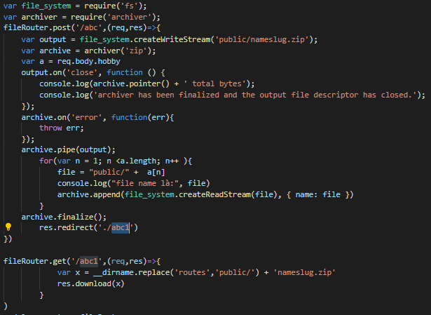

Figure 90: Download article as zip code

The system will use archiver library to compress docx files to zip. First, the system will create zip file: nameslug.zip and save it in public folder. After creating the zip file, the system will get the address of the article through the check box on the front-end and proceed to insert them into the zip file through the archive.append () function and then proceed to finish the compression process. Then the system will switch to the new router and download the file.

#### Chat box

The chat function will be in the details of the marketing coordinator or student depending on the user's role. If you are a student, there is only 1 coordinator, but if it is the coordinator, you can choose from a list of students.

If the coordinator and the student do not have any chat box before, the interface will have a button to add chat. When you click this button, the server side will create a collection of "chat" including the receiver and the sender. All conversation content will be saved in this collection. After adding chat, the next time, the user does not need to add a chat box anymore but can click the message button.

Server side will query in database according to sender and receiver email. New messages recorded by the user will be pushed into the collection

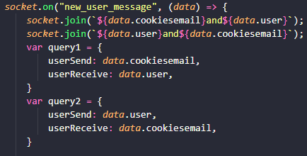

Figure 91: Chat box code

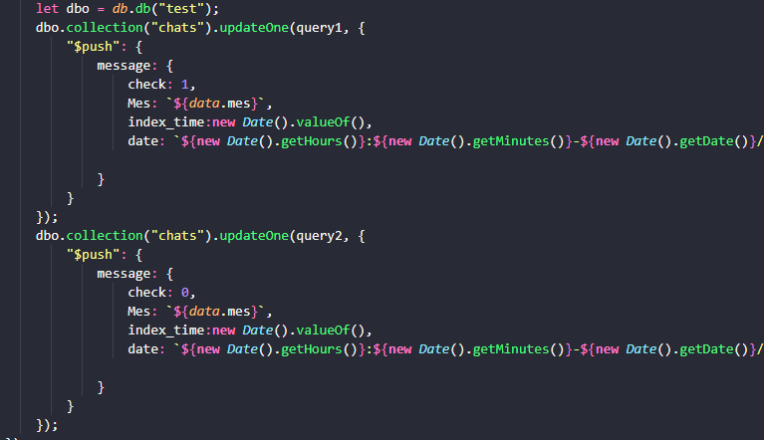

Figure 92: Chat box code

# Testing:

In order to make sure the project working properly, we need to make sure every function of it work as it should be. For that purpose, just like almost every other project, we decided to create a session which focus on testing the project. In this session, we will create a plan to test the service and after that we will show the test result in this report.

## Test plan

### Function requirement

* Front-end: Login, Download submission by ZIP format, Chat box, Statistic, report and submission, give and read comment on submission, accept or reject submission, see submit deadline and edit deadline.
* Back-end: Statistic management, notification email auto sending, exceptional report managing, comment management, chat box generator, account creator, setting deadline and maintaining system, password encode generator.

### Targeted users

Our system is created for a university magazine so our user is 99 percent university students and school’s staffs.

### Purpose of the test

Determine the results of how the system work, make sure the system work perfectly as it should be and help on the developing phase because the test start right after a function is finished coding.

* Environment requirement
* Server test: Heroku.
* Device: laptop
* Browser: Chrome, CocCoc, Microsoft Edge, Mozilla Firefox.
* Test plan: Microsoft word
* Test case: Microsoft word
* Image capture tool: Snipping tool, Window capture
* Set up test report: Microsoft Word
* Tool Support Test Interface: Chrome

### Testing implementation plan ( Test strategy )

* Strategy for building test case
* The test case must follow the interface of manuscript functions and all function of Front-end and Back-end must be included in the test case.
* Defining risk by risks then solve the problem that may occur
* Testing function as it finish before jump into the next function
* Testing tool
* Integration test: Testing using Google Chrome and Microsoft Edge on PC and laptop, Safari for phone
* System test: Test on PC and mobile phone.
* Project testing recourses
* Nguyen Trung Doan Khang: Responsible for Implementation of project test
* Bui Chi Huong: Tester
* Test order (Test sprint)
* **System test: 27/03/2021**
* Test Role Admin in sever: 27/03/2021
* Test Role Marketing Manager in sever: 27/03/2021
* Test Role Marketing Coordinator in sever: 28/03/2021
* Test Role student in sever: 28/03/2021
* Test Role Guest in sever: 29/03/2021
* Test chat box in sever: 29/03/2021
* **Test login/logout function: 25/03/2021**
* Login: 25/03/2021
* Logout: 25/03/2021
* **Test add/update/delete faculty and account: 02/03/2021**
* **Test upload file: 08/03/2021**
* Upload file by docx format: 07/03/2021
* Upload file by images: 08/03/2021
* **Marketing Coordinator function testing: 11/03/2021**
* Testing notification function: 10/03/2021
* Test function: Marketing Coordinator reviews the student's articles: 11/03/2021
* **Testing guest function: 13/03/2021**
* **Testing Marketing manager function: 20/03/2021**
* Test manager read the selected articles: 14/03/2021
* Test download selected report: 17/03/2021
* Test statistic data and displaying: 20/03/2021
* Test set time: 20/03/2021

### Potential risks

|  |  |
| --- | --- |
| Risk | Solution |
| inexperienced tester | This is one of the most potential risk, the solution is easy, we can hire a well recommended tester or let them train our staff for a greater course. |
| The infrastructure may not fulfill requirement to test | Continuously checking on the machines, do guarantee work on time. |
| Lacking interactions between tester, developer and users | This may lead the project to a dead-end because of misunderstood, we should create a daily or weekly meeting to get more information between each other |
| Everyone may get difficult in job because of time strict | We can get more people to directly or indirectly help us with the job.  Another solution is managing everyone work every day so we can make sure that they finish the job on time or sooner than we need |
| Test case may not include every error and may occur when we did not expect it | The only thing we can do is test every case that we can think of if their an error we may fix that in the future |

## Test case

1. Administrator

|  |  |  |  |  |  |
| --- | --- | --- | --- | --- | --- |
| Test case | Input | Expected result | Actual result | Test condition | Test log |
| 1 Create account for Marketing Manager | Create a marketing manager account with email: [manager1@gmail.com](mailto:manager1@gmail.com)  And password: 123 | Create successfully | Create successful and go to “All manager” page | Pass | 17:16-02/03/2021  Test on URL: https://localhost:3000/ |
| 1.2 Create account for Marketing Coordinator | Create a marketing Coordinator account with email: [teacher1@gmail.com](mailto:teacher1@gmail.com)  And password: 123 | Create successfully | Create successful and go to “All Teacher” page | Pass | 17:20-02/03/2021  Test on URL: https://localhost:3000/ |
| 1.3 Create account for Student | Create a Student account with email: [student1@gmail.com](mailto:student1@gmail.com)  And password: 123 | Create successfully | Create successful and go to “All Student” page | Pass | 17:33-02/03/2021  Test on URL: https://localhost:3000/ |
| 1.4 Create account for Guest | Create a Guest account with email: [guest1@gmail.com](mailto:guest1@gmail.com)  And password: 123 | Create successfully | Create successful and go to “All Guest” page | Pass | 17:36-02/03/2021  https://localhost:3000/ |
| 1.5 Create an account which contain a number or special characters | Create a Guest account with user name: guest1+ | Create fail | Create successful and go to “All Guest” page | Fail | 17:37-02/03/2021  User name can still contain number and special character  Test on URL: https://localhost:3000/ |
| 1.6 Create an account | Create a Marketing Manager account with email:  Manager2 | Create fail | Create successful and go to “All manager” page | Fail | 17:37-02/03/2021  Email can be create without @gmail.com  Test on URL: https://localhost:3000/ |
| 1.7 Create an account | Create a Guest account with password: +++ | Create fail | Create successful and go to “All guest” page | Fail | 17:37-02/03/2021  Password can contain special characters.  Test on URL: https://localhost:3000/ |
| 2 Update account for Marketing Manager | Click on Update and update information | Update successfully | Update successful and go to “All manager” page | Pass | 17:37-02/03/2021  Test on URL: https://localhost:3000/ |
| 2.1 Update  account for Marketing Coordinator | Click on Update and update information | Update successfully | Update successful and go to “All Teacher” page | Pass | 17:40-02/03/2021  Test on URL: https://localhost:3000/ |
| 2.2 Update account for Student | Click on Update and update information | Update successfully | Update  successful and go to “All Student” page | Pass | 17:42-02/03/2021  Test on URL: https://localhost:3000/ |
| 2.3 Update account for Guest | Click on Update and update information | Update successfully | Update  successful and go to “All Guest” page | Pass | 17:45-02/03/2021  Test on URL: https://localhost:3000/ |
| 3.1 Delete account for Marketing Manager | Click on Delete | Delete  successfully | Delete successful and go to “All manager” page | Pass | 17:47-02/03/2021  Test on URL: https://localhost:3000/ |
| 3.2 Delete account for Marketing Coordinator | Click on Delete | Delete  successfully | Delete successful and go to “All Teacher” page | Pass | 17:52-02/03/2021  Test on URL: https://localhost:3000/ |
| 3.3 Delete account for Student | Click on Delete | Delete  successfully | Delete  successful and go to “All Student” page | Pass | 17:58-02/03/2021  Test on URL: https://localhost:3000/ |
| 3.4 Delete account for Guest | Click on Delete | Delete  successfully | Delete  successful and go to “All Guest” page | Pass | 18:00-02/03/2021  Test on URL: https://localhost:3000/ |
| 4.1 Create a new Faculty | Create a new faculty with Faculty Name: Python | Create successfully | Create successful and go to “Faculty” page | Pass | 18:10-02/03/2021  Test on URL: https://localhost:3000/ |
| 4.2 Update a faculty | Click on detail then update on “Faculty page” | Update successfully | Update successful and go to “Faculty” page | Pass | 18:12-02/03/2021  Test on URL: https://localhost:3000/ |
| 4.3 Delete a faculty | Click on detail then Delete on “Faculty page” | Delete successfully | Delete successful and go to “Faculty” page | Pass | 18:13-02/03/2021  Test on URL: https://localhost:3000/ |
| 5 Search | Typing Java on search bar | Search success and only Java faculty appear | Only JAVA faculty appear on the screen | Pass | 18:13-02/03/2021  Test on URL: https://localhost:3000/ |
| 6.1 Login | Login as administrator with email: [admin@gmail.com](mailto:admin@gmail.com)  Password: 123 | Login successfully. | Login successful and Home page is admin’s Personal information | Pass | 17:05-25/03/2021  Test on URL: https://localhost:3000/ |
| 6.2 Login | Login as administrator with email: [admin@gmail.com](mailto:admin@gmail.com)  Password: 1 | Cannot login | Cannot login and inform Username or password is invalid | Pass | 17:08-25/02/2021  Wrong password  Test on URL: https://localhost:3000/ |
| 6.3 Logout | Press the X button on the interface | Return to Login screen | Return to Login screen | Pass | 17:11-25/02/2021  Test on URL: https://localhost:3000/ |

1. Marketing Manager

|  |  |  |  |  |  |
| --- | --- | --- | --- | --- | --- |
| Test case | Input | Expected result | Actual result | Test condition | Test log |
| 1.1 Login | Login as Marketing manager with email: [manager1@gmail.com](mailto:manager1@gmail.com)  Password: 123 | Login successfully. | Login successful and Home page is manager’s Personal information | Pass | 13:05-  25/02/2021  Test on URL: https://localhost:3000/ |
| 1.2 Login | Login as Marketing Manager  with email: [admin@gmail.com](mailto:admin@gmail.com)  Password: 1 | Cannot login | Cannot login and inform Username or password is invalid | Pass | 17:08-25/02/2021  Wrong password  Test on URL: https://localhost:3000/ |
| 2 View Statistic | Click on View contribution then view statistical | View successful | When click on, pie chart of that faculty showed up | Pass | 13:08-  20/03/2021  Test on URL: https://localhost:3000/ |
| 3 View all submission by faculty | Click on View contribution then view contributions again on a faculty | View successful | All contribution of that faculty showed up | Pass | 13:10-  14/03/2021  Test on URL: https://localhost:3000/ |
| 4 Download submission into ZIP | Click on download contribution | Download successful | Contribution was downloaded in ZIP format | Pass | 13:12-  17/03/2021  Test on URL: https://localhost:3000/ |
| 5 Set deadline for student | Click on “set time” | Time settled | Deadline was all set for student | Pass | 13:13-  20/03/2021  Test on URL: https://localhost:3000/ |

1. Marketing Coordinator

|  |  |  |  |  |  |
| --- | --- | --- | --- | --- | --- |
| Test case | Input | Expected result | Actual result | Test condition | Test log |
| 1.1 Login | Login as Marketing Coordinator with email: [teacher1@gmail.com](mailto:teacher1@gmail.com)  Password: 123 | Login successfully. | Login successful and Home page is teacher’s Personal information | Pass | 13:20-  25/02/2021  Test on URL: https://localhost:3000/ |
| 1.2 Login | Login as Marketing Manager  with email: [admin@gmail.com](mailto:admin@gmail.com)  Password: 1 | Cannot login | Cannot login and inform Username or password is invalid | Pass | 13:22-25/02/2021  Wrong password  Test on URL: https://localhost:3000/ |
| 2 View submissions by faculty | Click on view submissions | All submission showed up | All submission and students submitted showed up | Pass | 13:25-11/03/2021  Test on URL: https://localhost:3000/ |
| 3 Receive notification | An email automatically sent when a student submit | An email automatically sent when a student submit | An email automatically sent when a student submit | Pass | 13:28-10/03/2021  Test on URL: https://localhost:3000/ |
| 4 Give comment before due date | Give comment 14 days after submission | A timer will show around the comment box show that if it pass 14 days, the submission can not receive comment | Submission can be comment on anytime | Fail | 13:29-11/03/2021  Test on URL: https://localhost:3000/ |
| 5.1 Accept submission | Choose “Pass” in submission Status | Status of submission showed as Pass | Status of submission showed as Pass | Pass | 13:35-11/03/2021  Test on URL: https://localhost:3000/ |
| 5.2 Reject submission | Choose “Fail” in submission Status | Status of submission showed as Fail | Status of submission showed as Fail | Pass | 13:40-11/03/2021  Test on URL: https://localhost:3000/ |
| 6 Use chat box | Add student to box chat then use it to communicate | Student added and receive teacher message | Student added and receive teacher message | Pass | 14:00-29/03/2021  Test on URL: https://localhost:3000/ |

1. Student

|  |  |  |  |  |  |
| --- | --- | --- | --- | --- | --- |
| Test case | Input | Expected result | Actual result | Test condition | Test log |
| 1.1 Login | Login as Student with email: [student1@gmail.com](mailto:student1@gmail.com)  Password: 123 | Login successfully. | Login successful and Home page is student’s Personal information | Pass | 14:20-  25/02/2021  Test on URL: https://localhost:3000/ |
| 1.2 Login | Login as Student  with email: [admin@gmail.com](mailto:admin@gmail.com)  Password: 1 | Cannot login | Cannot login and inform Username or password is invalid | Pass | 14:22-25/02/2021  Wrong password  Test on URL: https://localhost:3000/ |
| 2.1 submit article as word or pdf | Click on Upload file, accept term then choose file to upload | File uploaded | File uploaded and returned to Summited file | Pass | 14:30-07/03/2021  Test on URL: https://localhost:3000/ |
| 2.2 submit article as images/photos | Click on Upload file, accept term then choose file to upload | File uploaded | File uploaded and returned to Summited file | Pass | 14:30-08/03/2021  Test on URL: https://localhost:3000/ |
| 2.3 Edit submission | Click on Update file | File updated | File updated then returned to Summited file | Pass | 14:36-29/03/2021  Test on URL: https://localhost:3000/ |
| 3 Read comment for own submission | Click on File submitted | View comment of submitted file | Comment showed on Submitted file page | Pass | 15:18-29/03/2021  Test on URL: https://localhost:3000/ |
| 4 Use chat box | Click on chat box | Chat box showed up | Chat box which student was added showed up and after clicked on one, the chat box between teacher and student showed up | Pass | 15:40-29/03/2021  Test on URL: https://localhost:3000/ |

1. Guest

|  |  |  |  |  |  |
| --- | --- | --- | --- | --- | --- |
| Test case | Input | Expected result | Actual result | Test condition | Test log |
| 1.1 Login | Login as Guest with email: [guest1@gmail.com](mailto:guest1@gmail.com)  Password: 123 | Login successfully. | Login successful and Home page is guest’s Personal information | Pass | 15:50-  25/03/2021  Test on URL: https://localhost:3000/ |
| 1.2 Login | Login as guest  with email: [admin@gmail.com](mailto:admin@gmail.com)  Password: 1 | Cannot login | Cannot login and inform Username or password is invalid | Pass | 15:56-25/02/2021  Wrong password  Test on URL: https://localhost:3000/ |
| 2 View accepted submission by faculty | Click on view button of each faculty | All accepted submission of that faculty showed | All accepted submission of that faculty showed | Pass | 16:00-13/03/2021  Test on URL: https://localhost:3000/ |

1. System

|  |  |  |  |  |  |
| --- | --- | --- | --- | --- | --- |
| Test case | Input | Expected result | Actual result | Test condition | Test log |
| 1 Test Role Admin in sever | Log in and test all admin function | Admin function work perfectly | Admin function work perfectly | Pass | 13:50-27/03/2021  Test on URL:  <https://asmmmtest1.herokuapp.com/> |
| 2 Test Role Marketing Manager in sever | Log in and test all Marketing Manager function | Marketing Manager function work perfectly | Marketing Manager function work perfectly | Pass | 16:03-27/03/2021  Test on URL:  <https://asmmmtest1.herokuapp.com/> |
| 3 Test Role Marketing Coordinator in sever | Log in and test all Marketing Coordinator function | Marketing Coordinator function work perfectly | Marketing Coordinator function work perfectly | Pass | 11:28-28/03/2021  Test on URL:  <https://asmmmtest1.herokuapp.com/> |
| 4 Test Role Student in sever | Log in and test all Student function | Student function work perfectly | Student function work perfectly | Pass | 11:28-28/03/2021  Test on URL:  <https://asmmmtest1.herokuapp.com/> |
| 5 Test Role Guest in sever | Log in and test all Guest function | Guest function work perfectly | Guest function work perfectly | Pass | 09:10-29/03/2021  Test on URL:  <https://asmmmtest1.herokuapp.com/> |
| 6 Test chat box in sever | Use Marketing Coordinator account to add Student to chat box and interact between 2 accounts | Chat box work perfectly | Only added student can interact in the chat box with the teacher who added him/her | Pass | 20:11-29/03/2021  Test on URL:  <https://asmmmtest1.herokuapp.com/> |

## Test evident

To increase the reliability of the test, we decided to create a section contain test evidence. In this section, we will present screenshot of testing process

1. Login/Logout

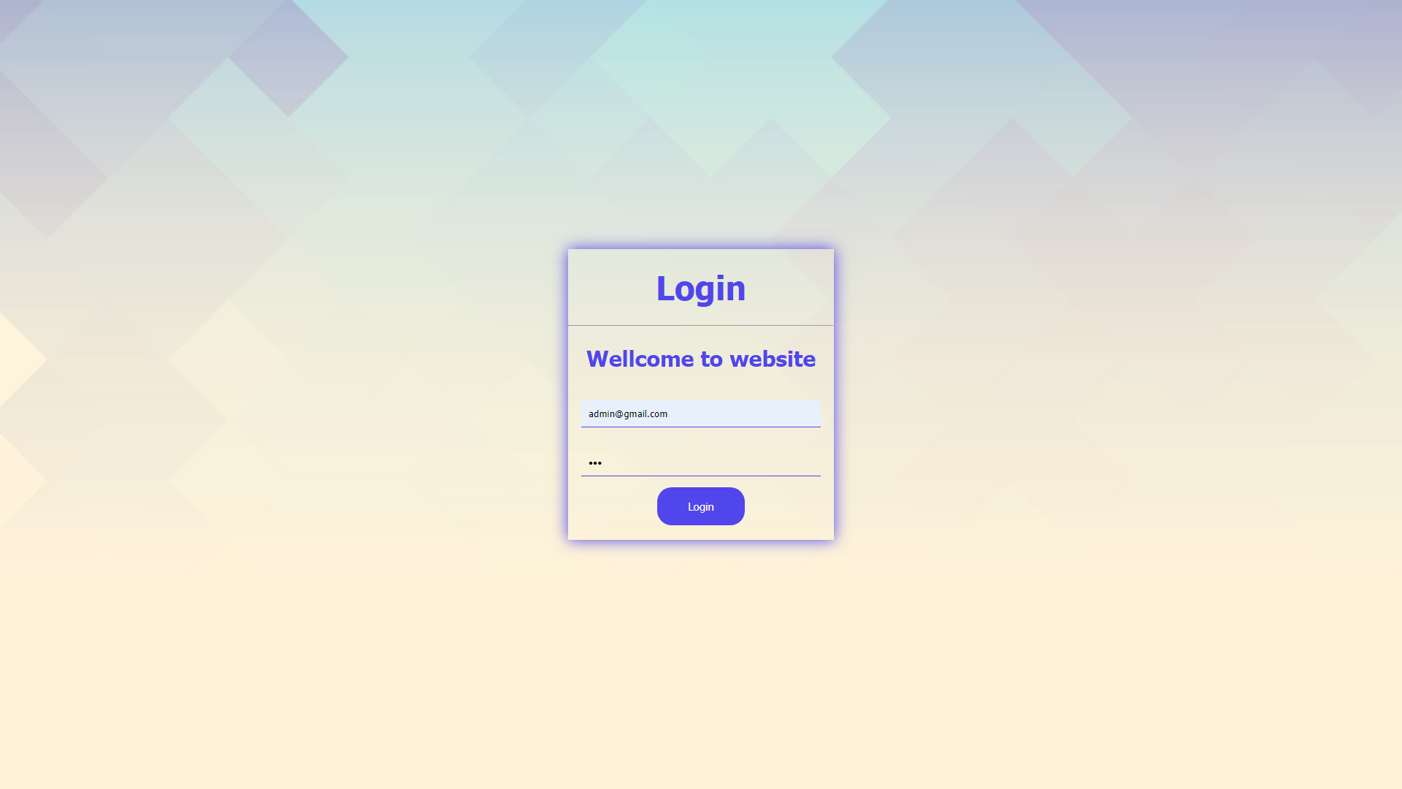

Figure 93:Login as admin

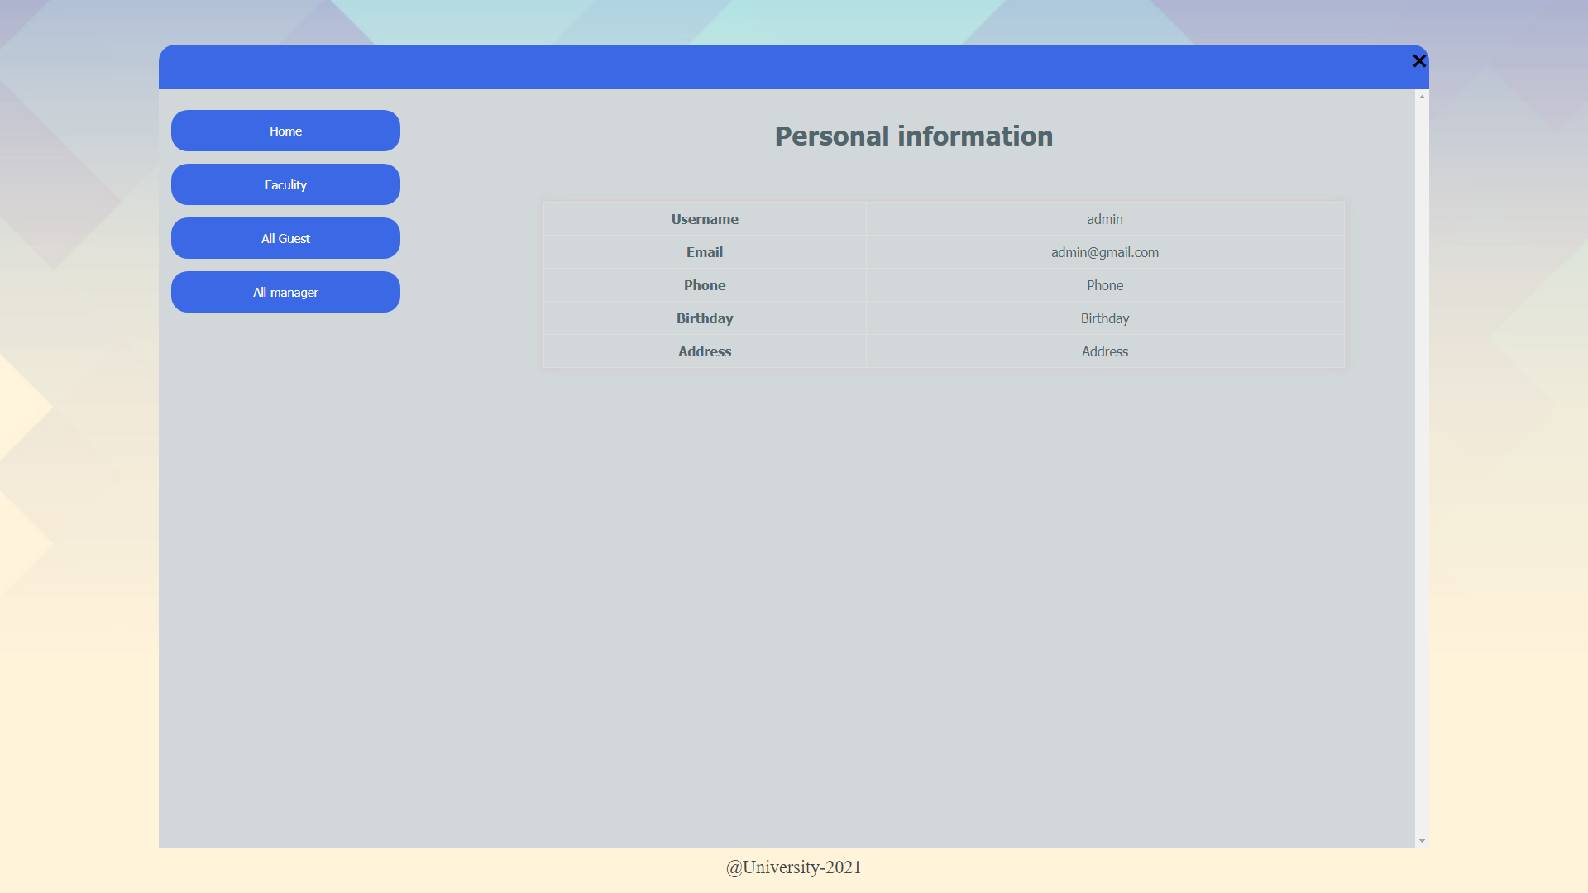

Figure 94: Log in successful

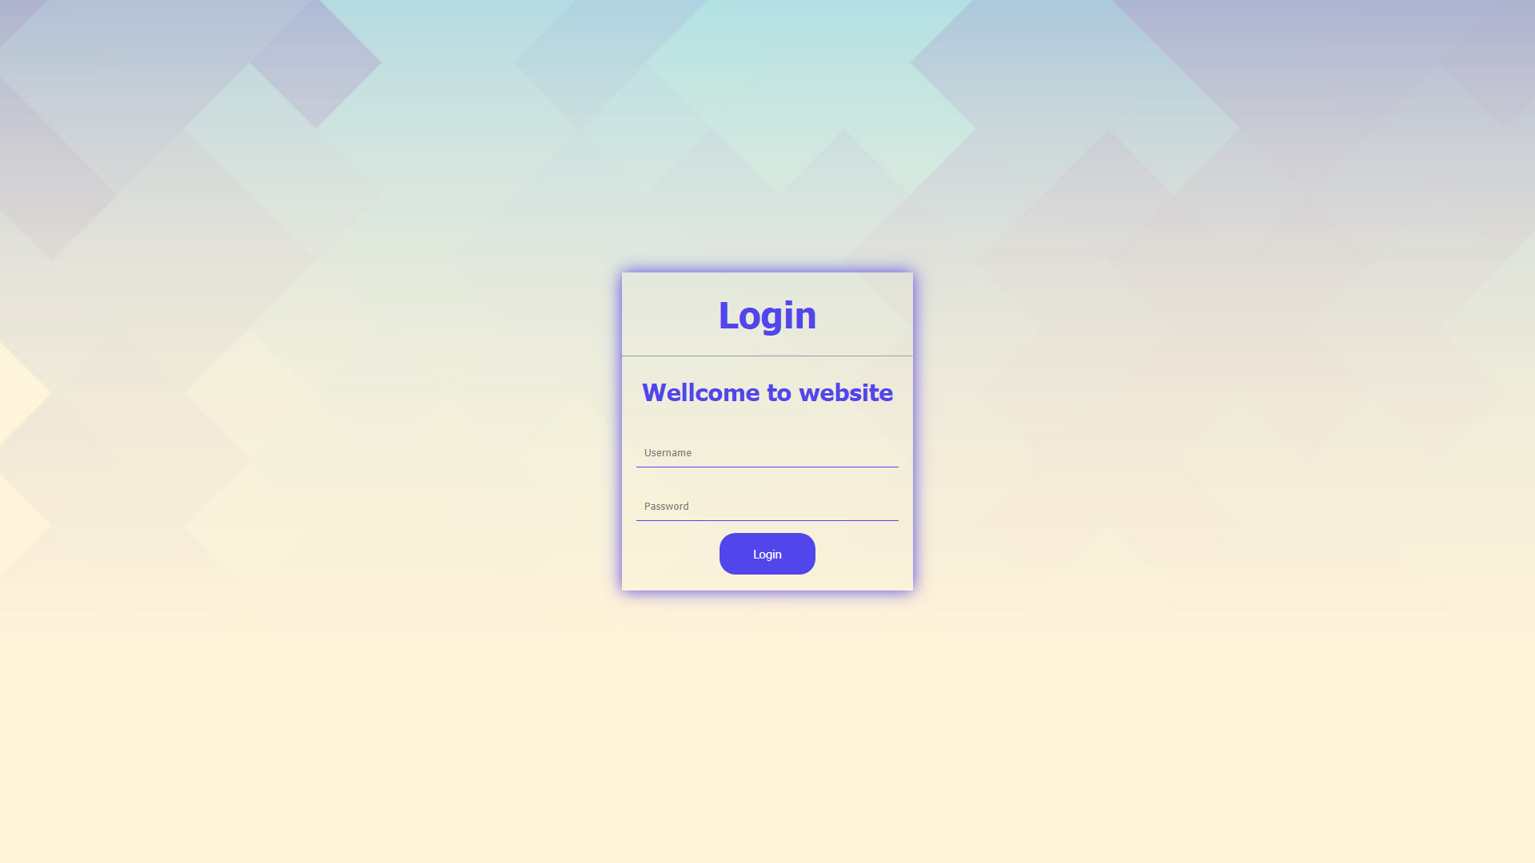

Figure 95:Logout by pressing the “X” button

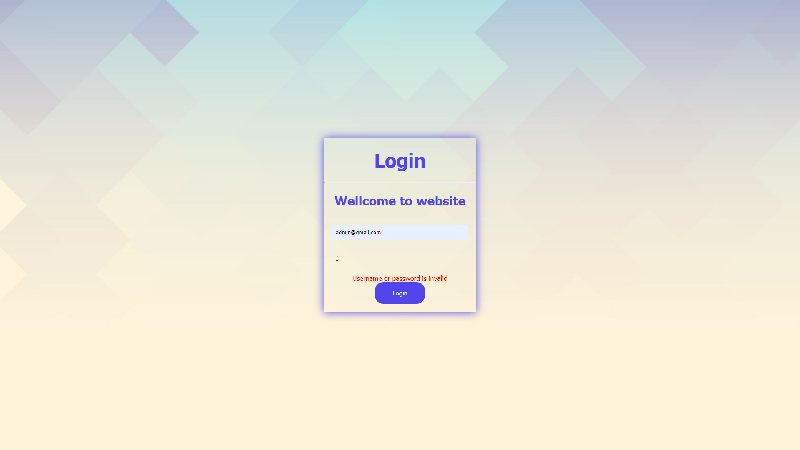

Figure 96:Login fail ( wrong password)

1. Create, Update and Delete faculty

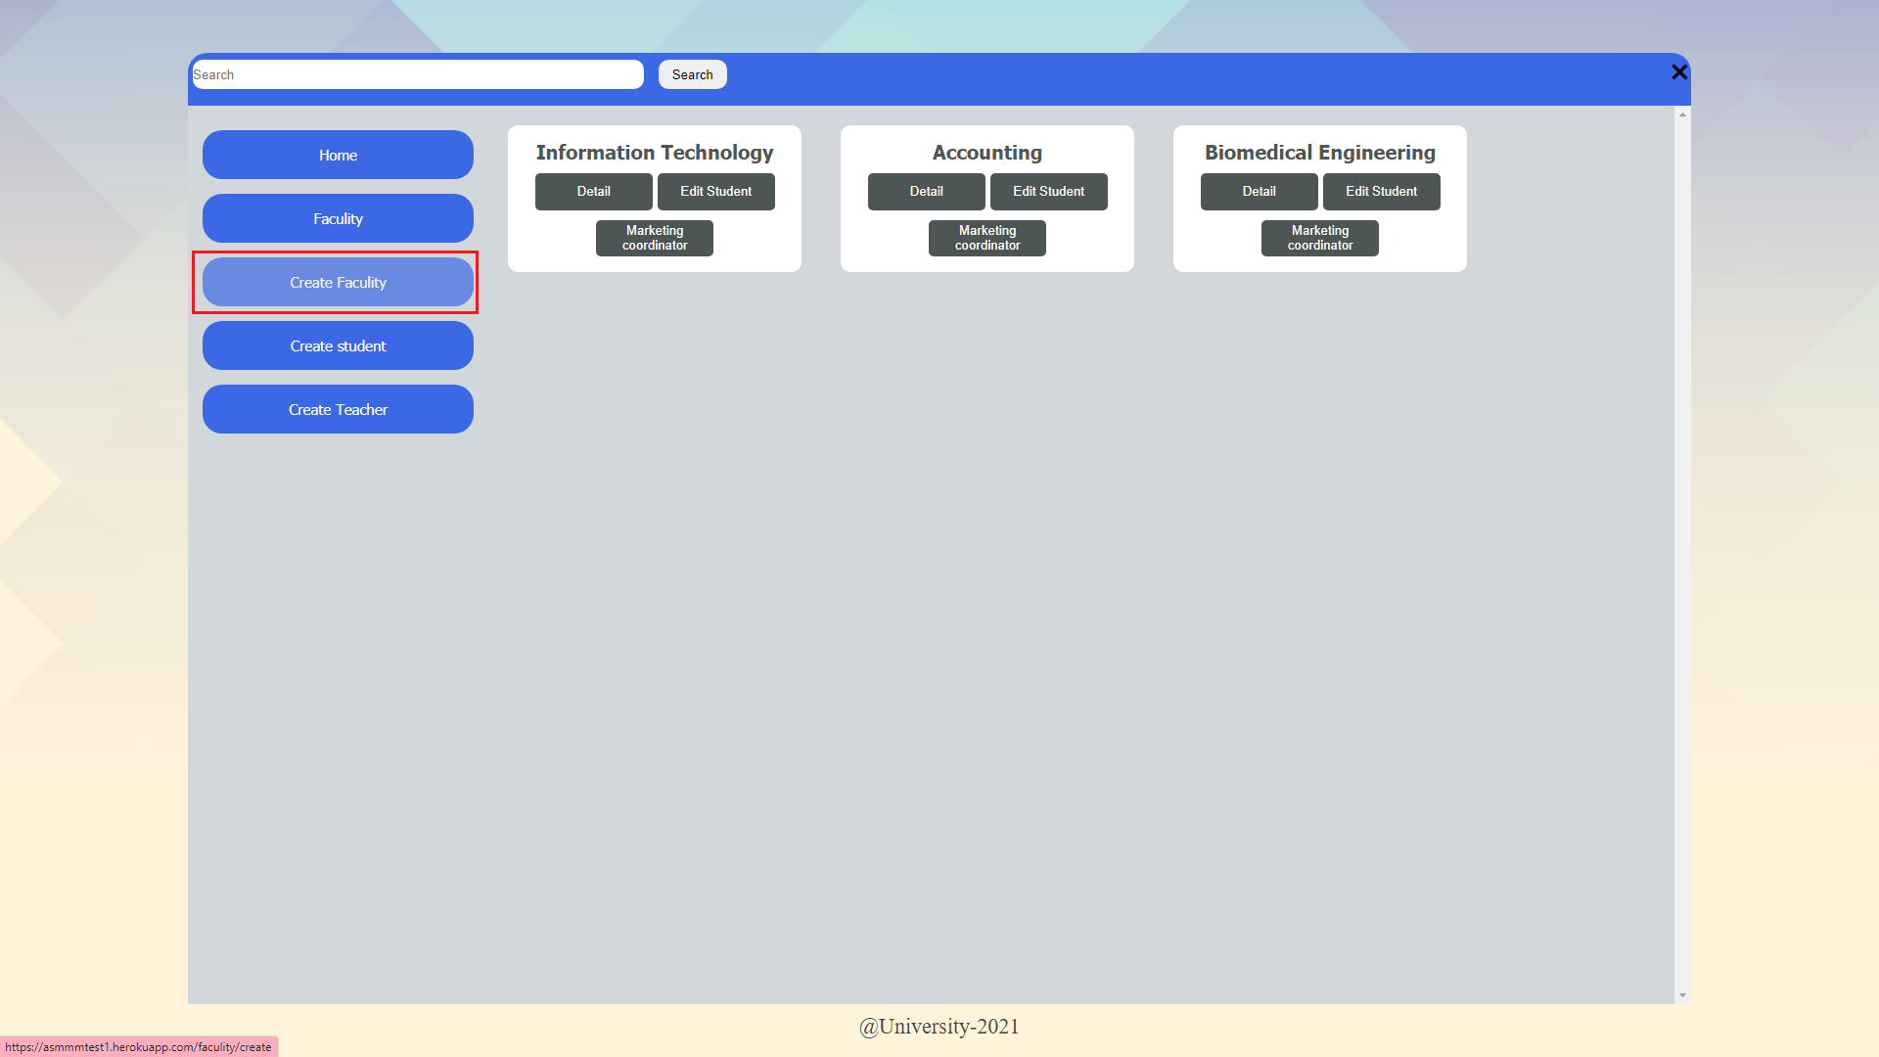

Figure 97:Faculty list before create a new one

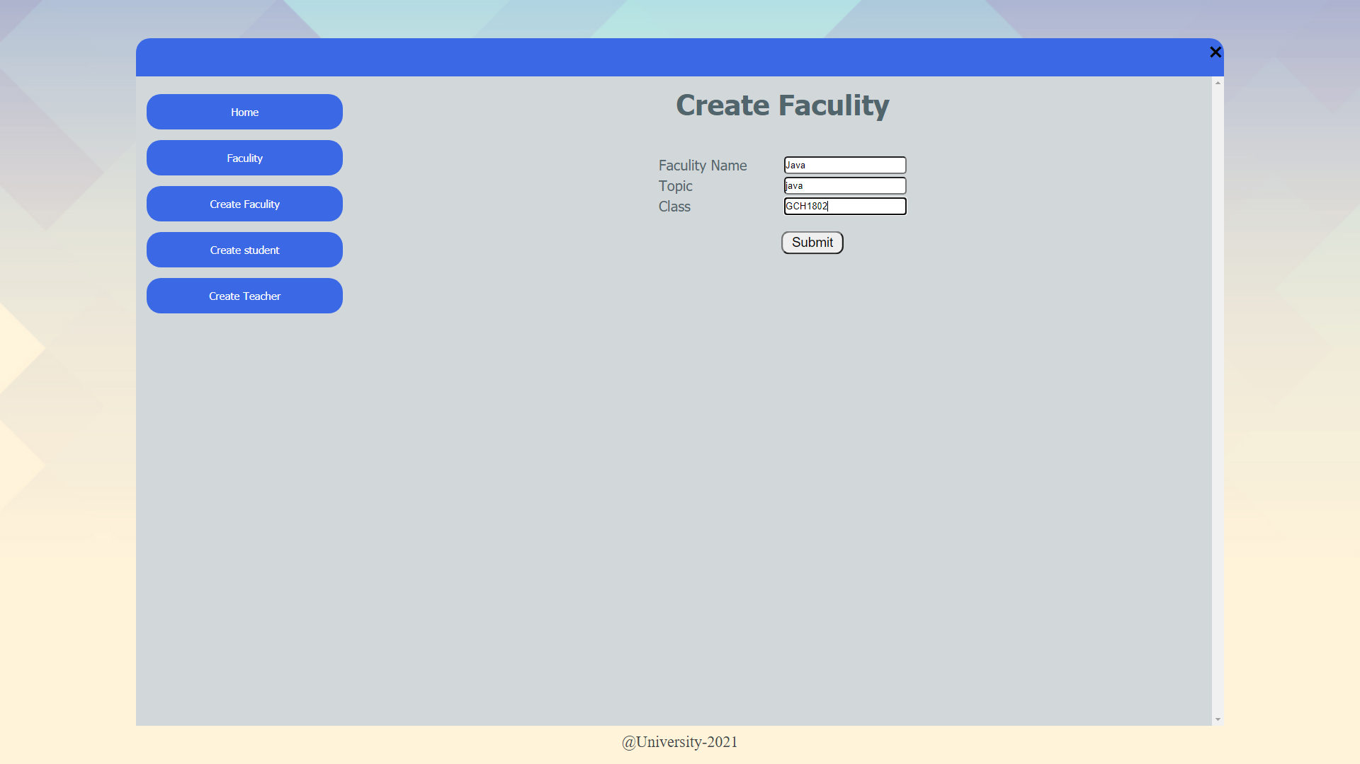

Figure 98: Creating a new faculty

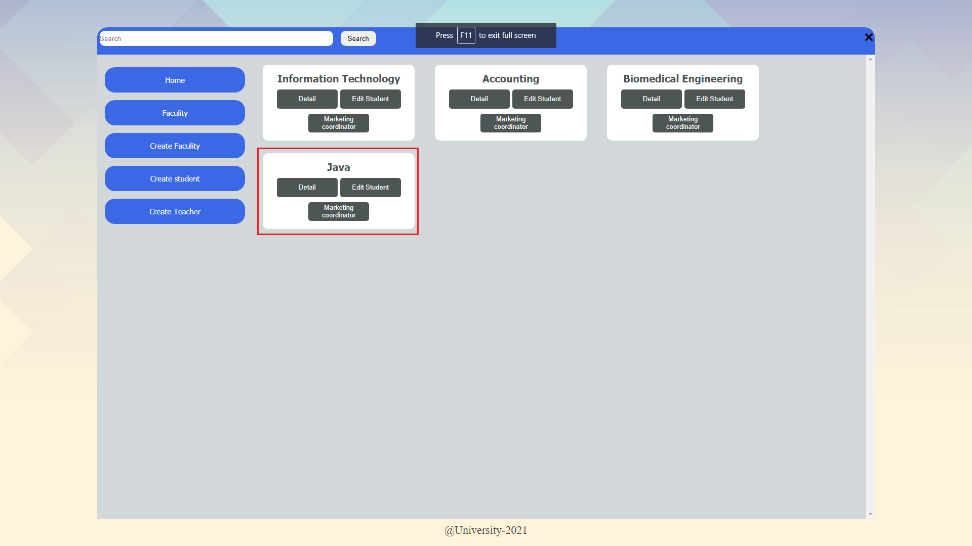

Figure 99: Create faculty successful

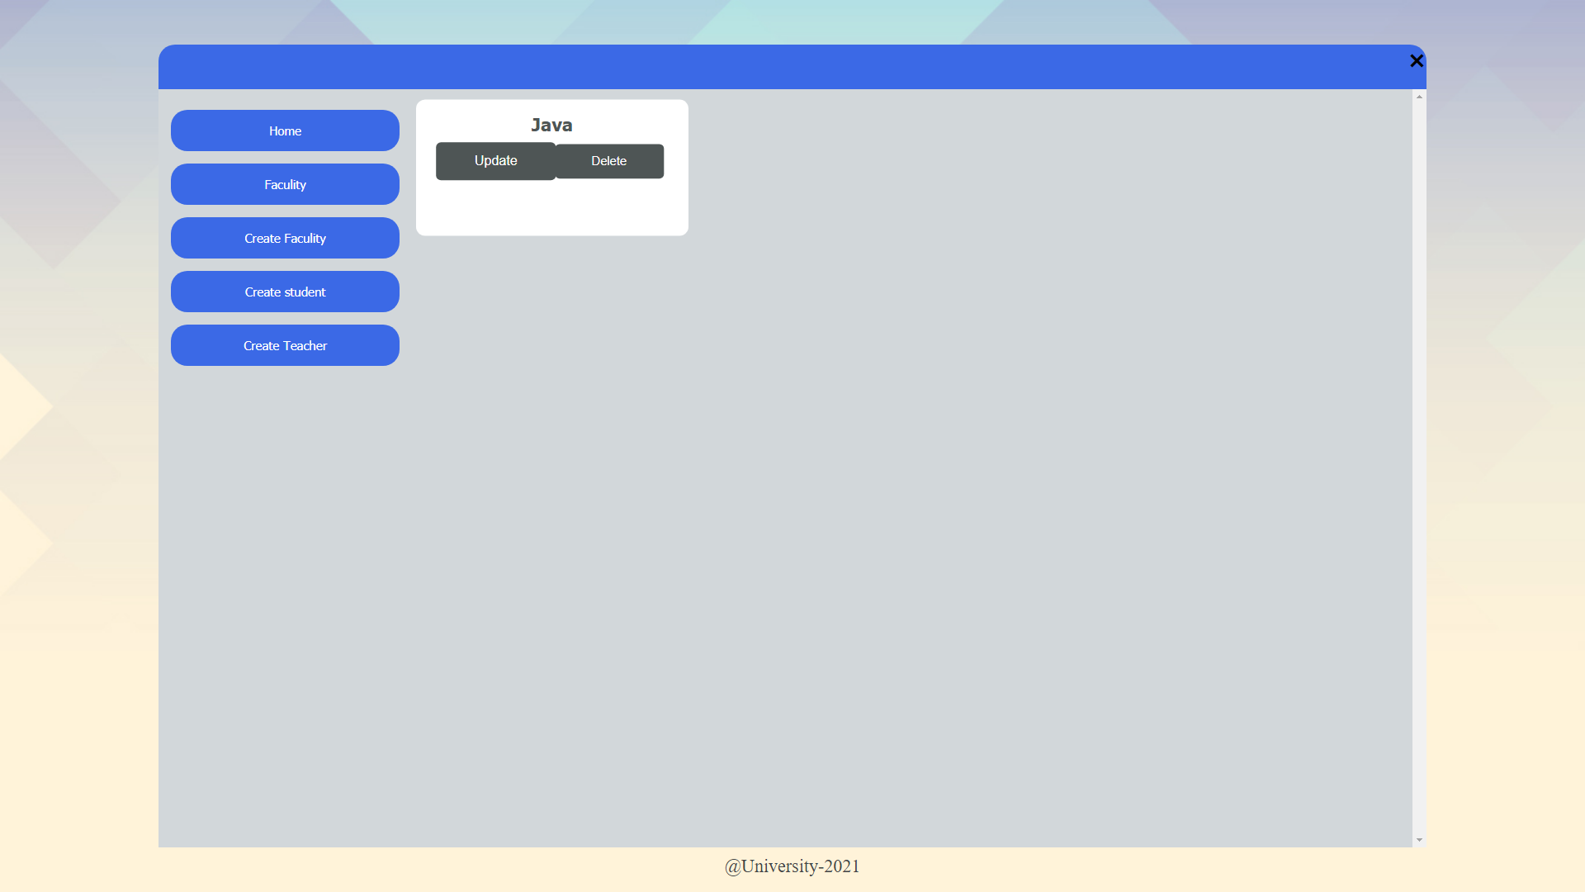

Figure 100: Update or delete button of faculty

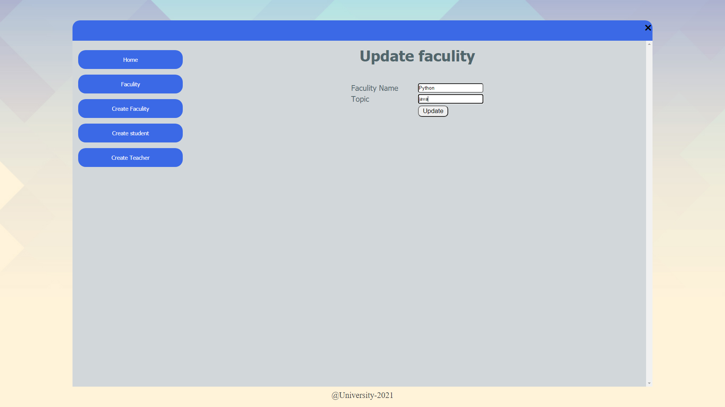

Figure 101: Changing subject name to Python

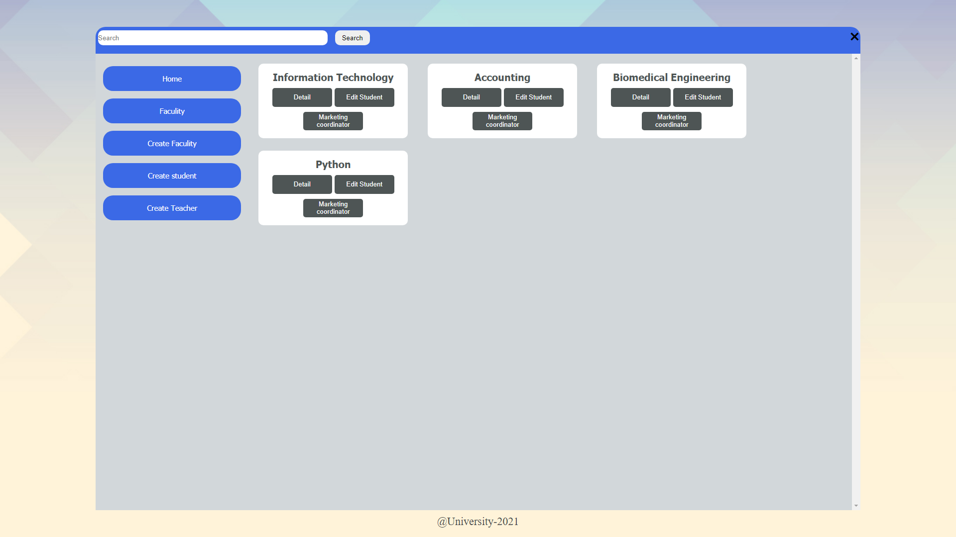

Figure 102:Faculty display after update

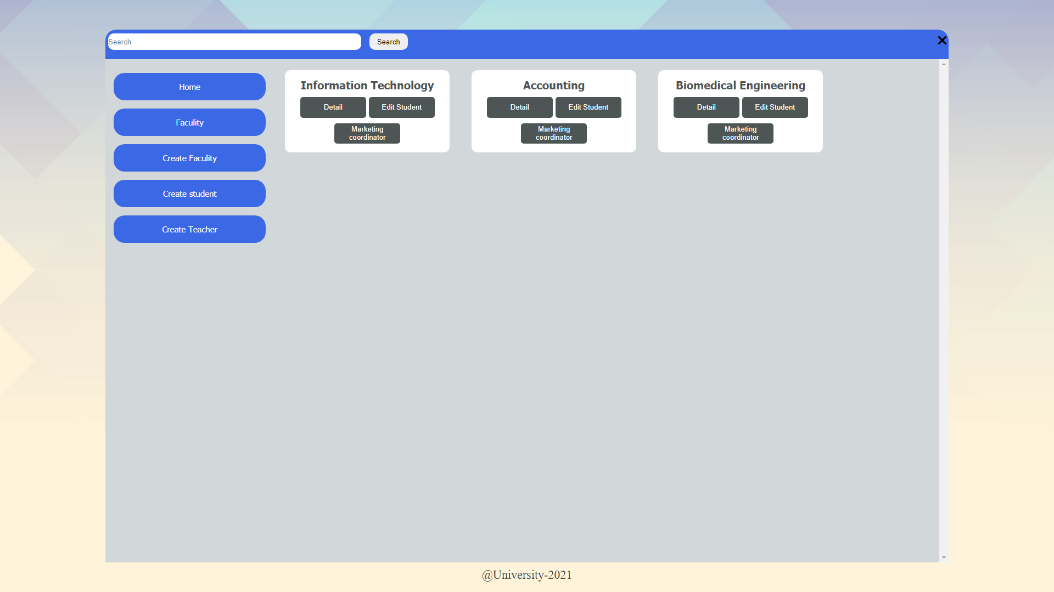

Figure 103: Faculty display after delete

1. Search

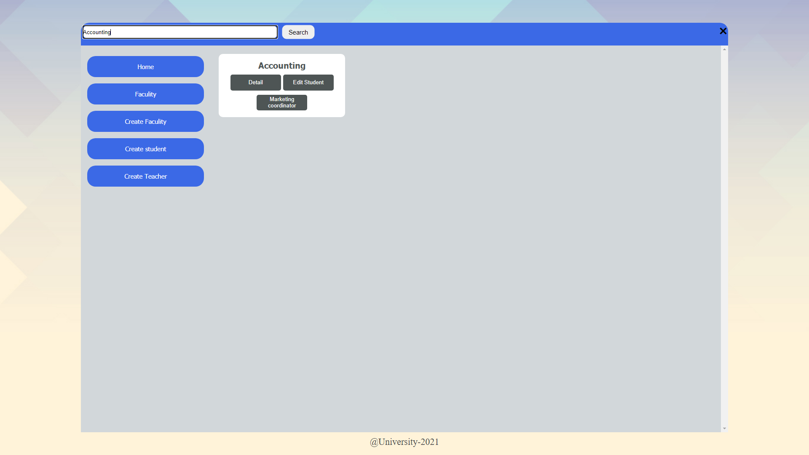

Figure 104: Search function of the system

1. Create, Update and Delete account

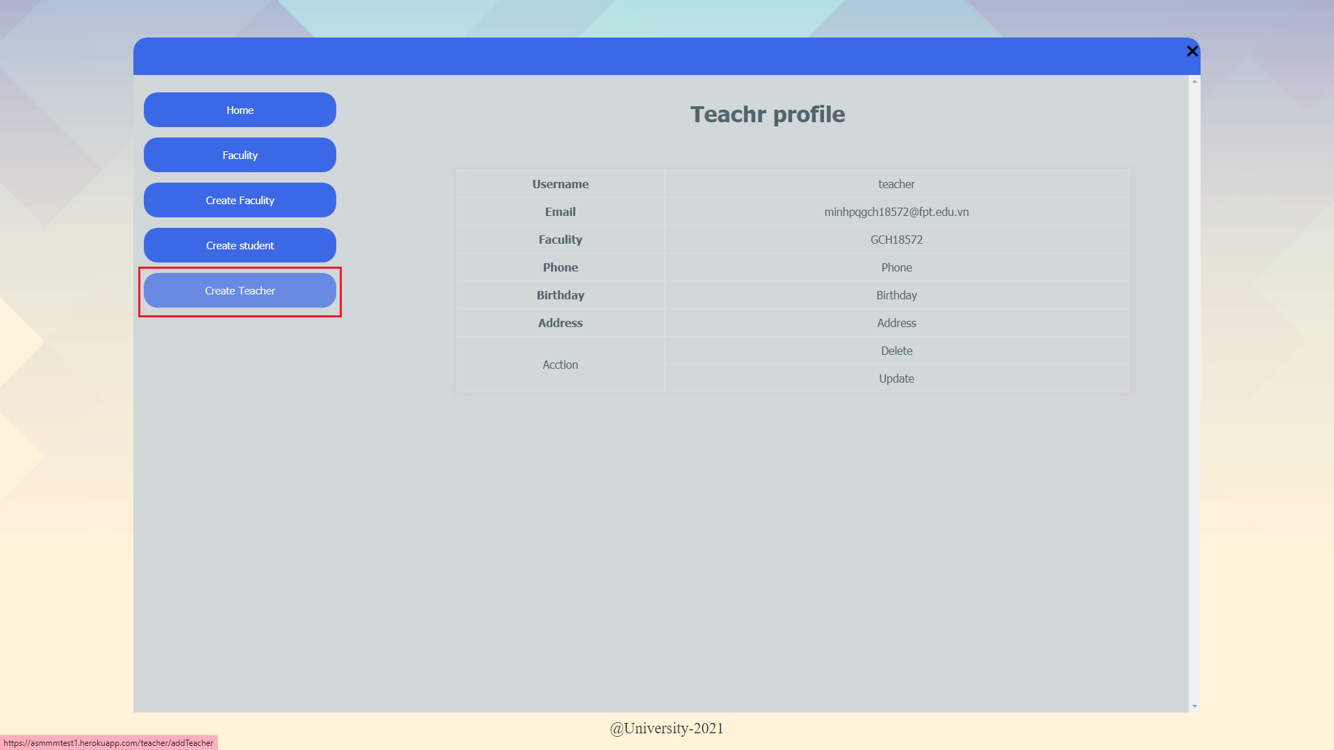

Figure 105: Marketing coordinator list before create a new one

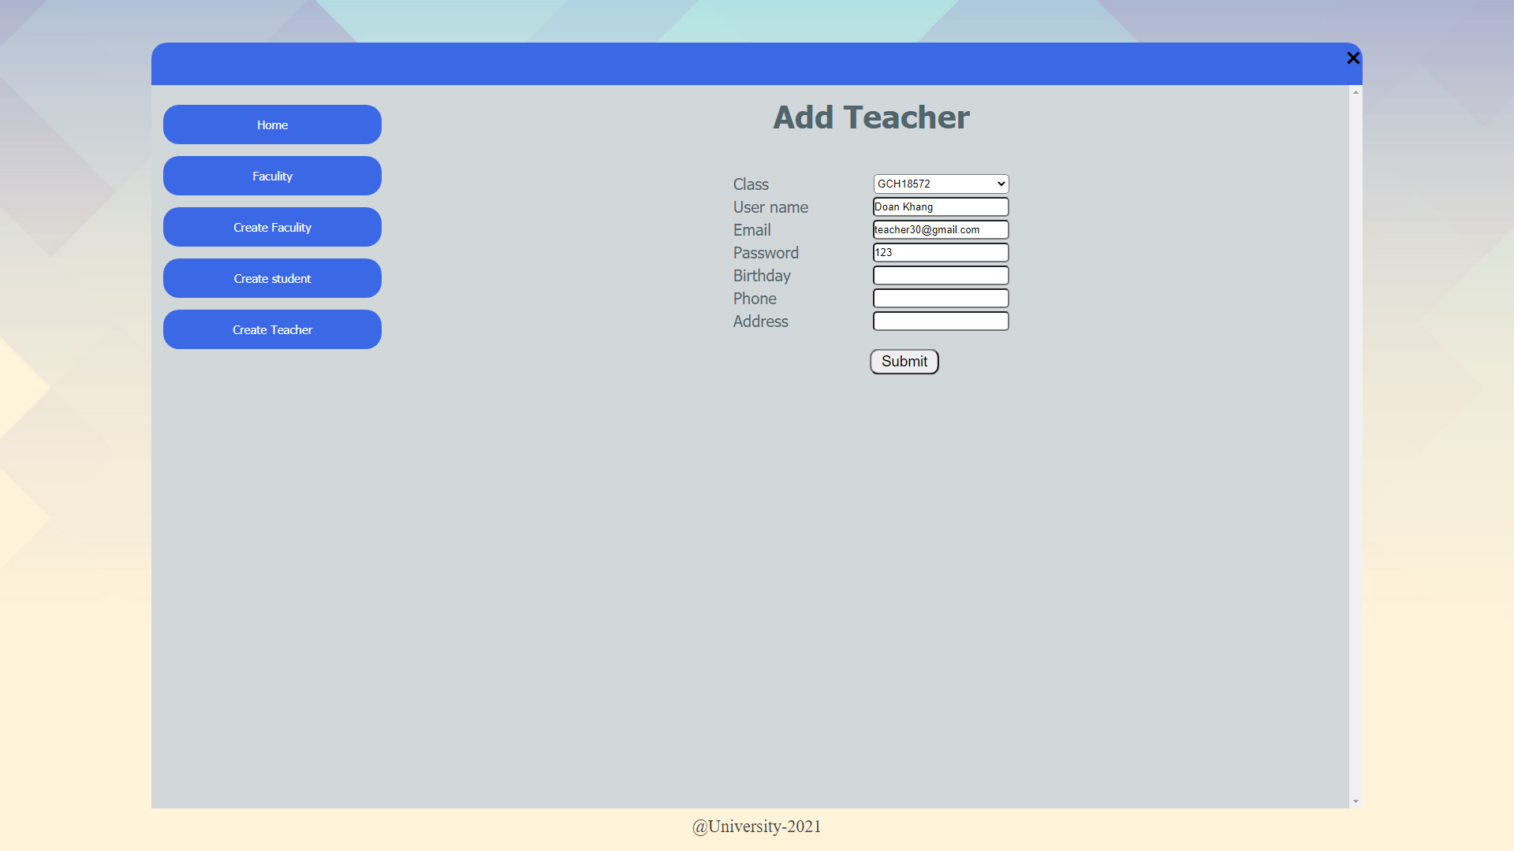

Figure 106: Creating a new Marketing coordinator

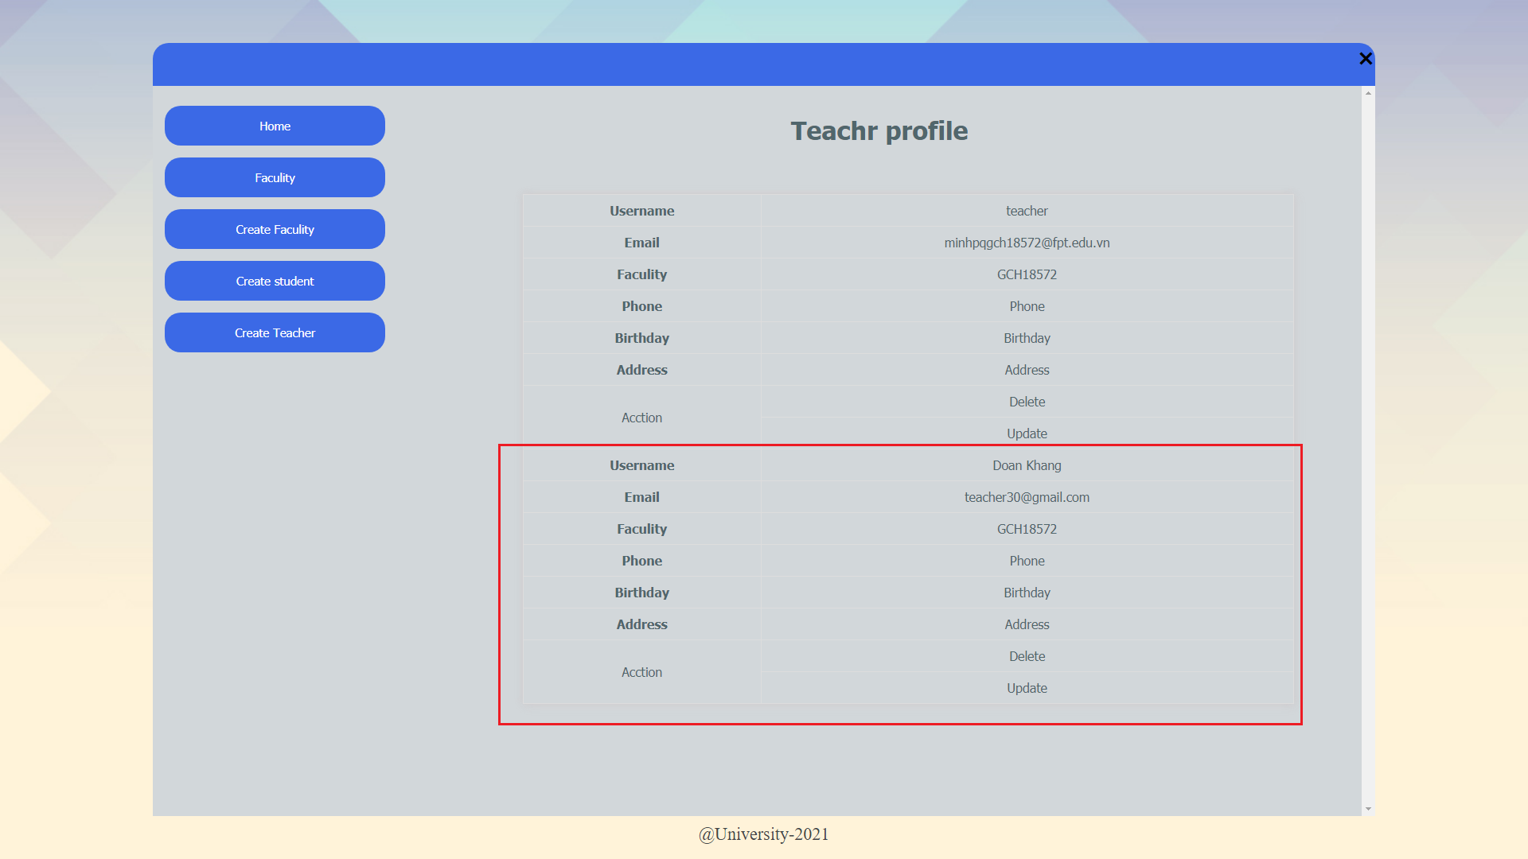

Figure 107: Create new marketing coordinator successful

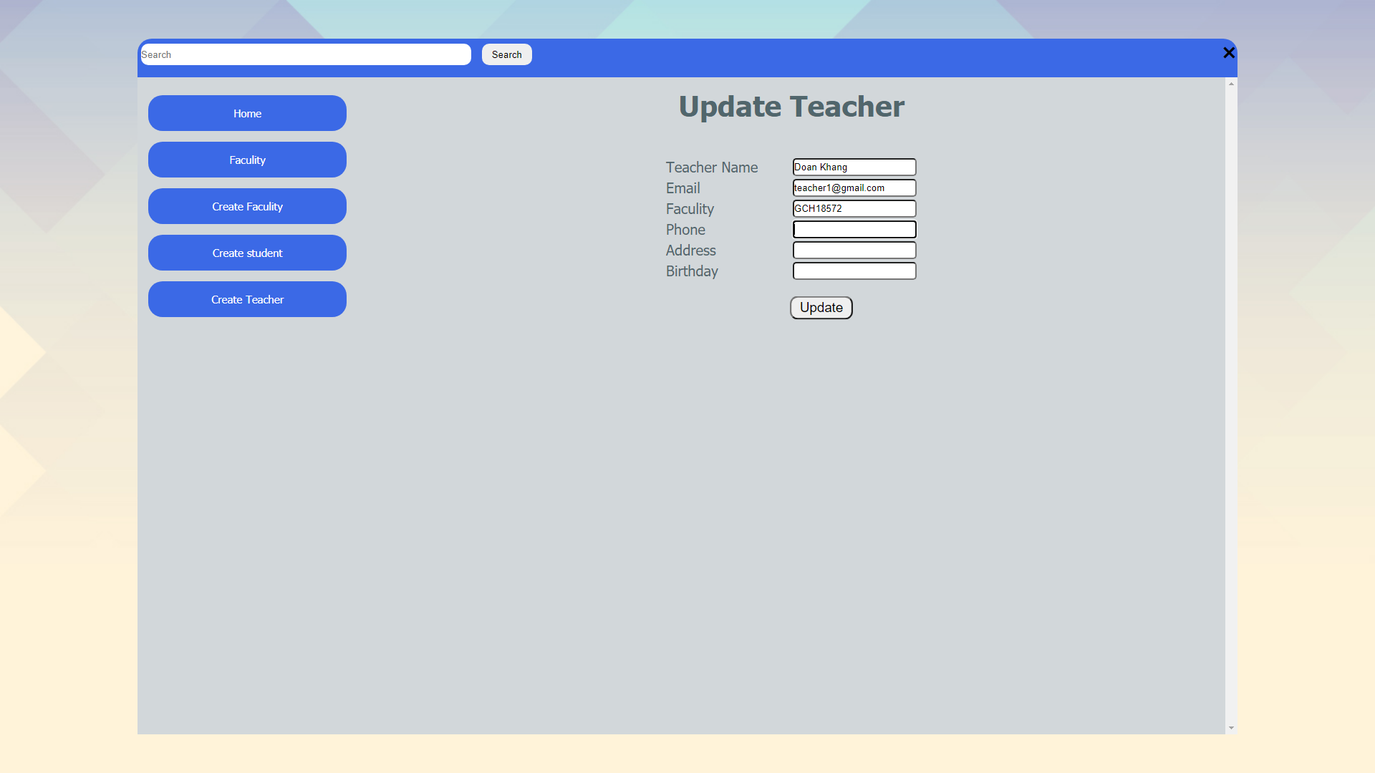

Figure 108: Update teacher email to teacher1@gmail.com

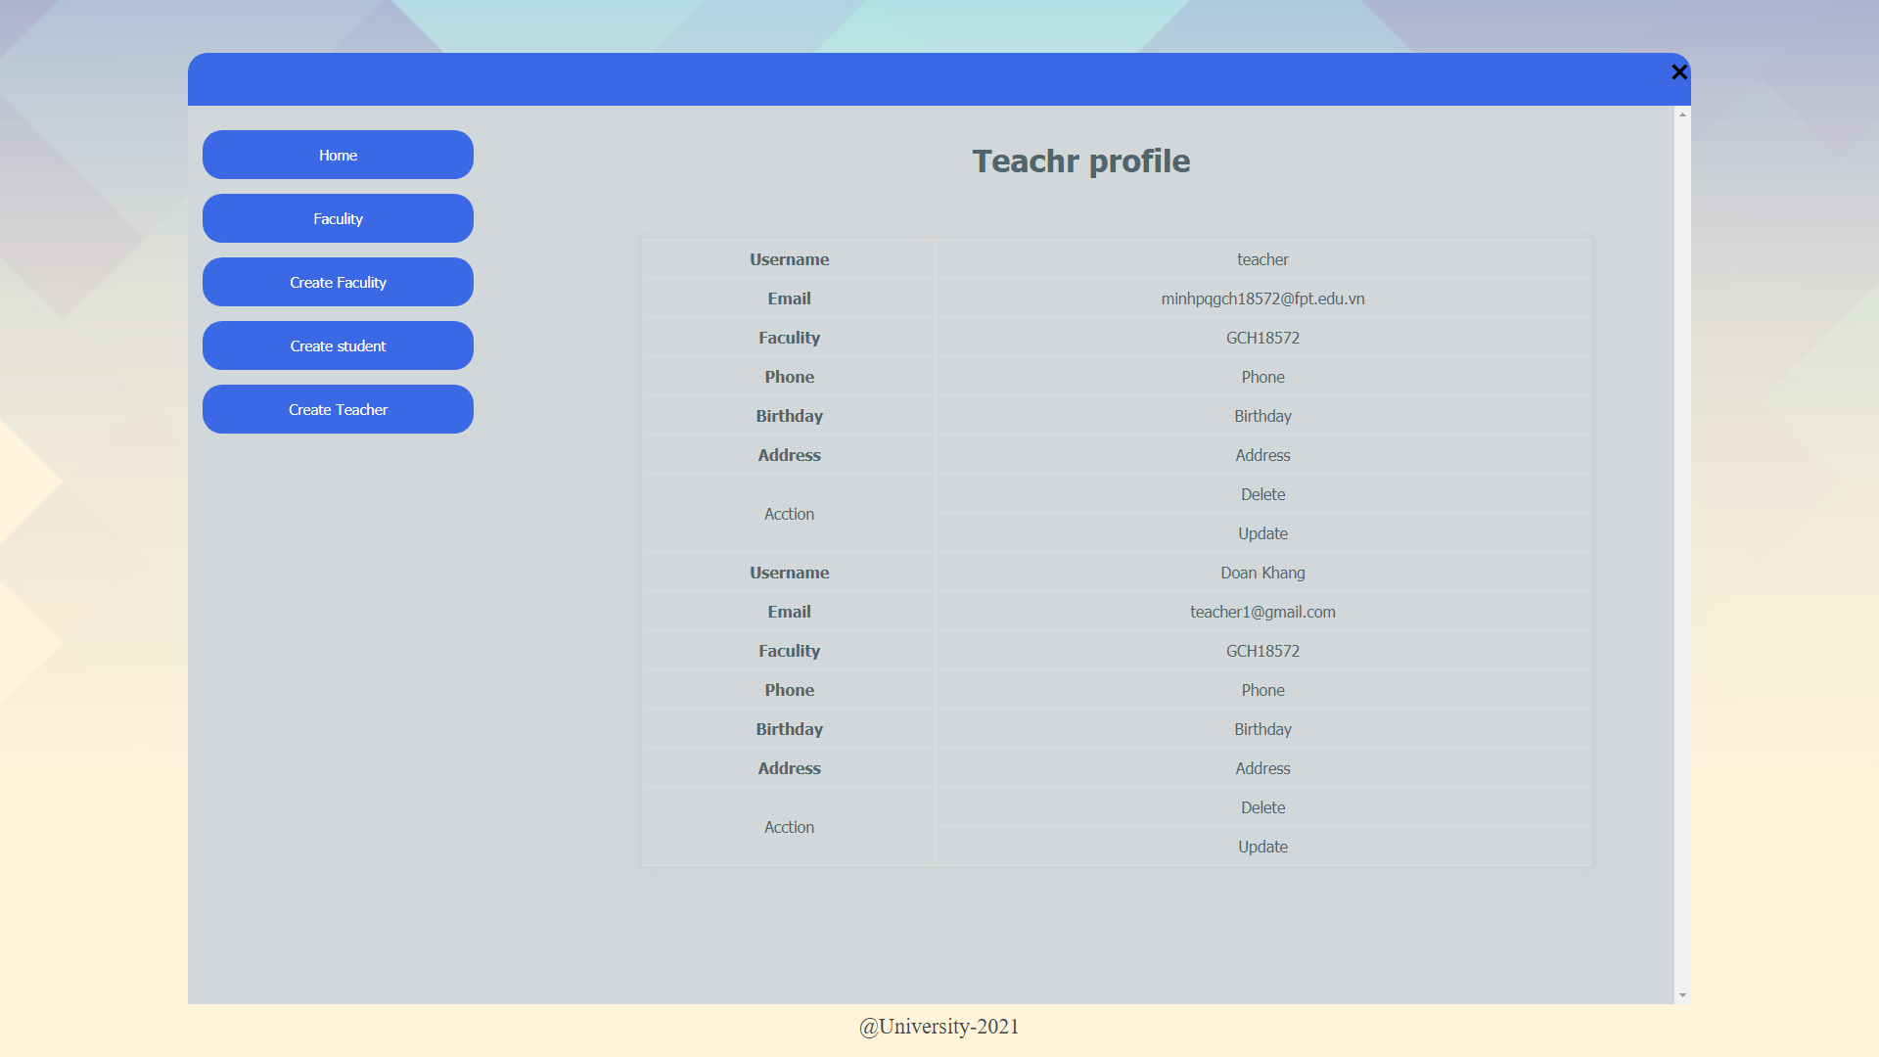

Figure 109: Update teacher successful

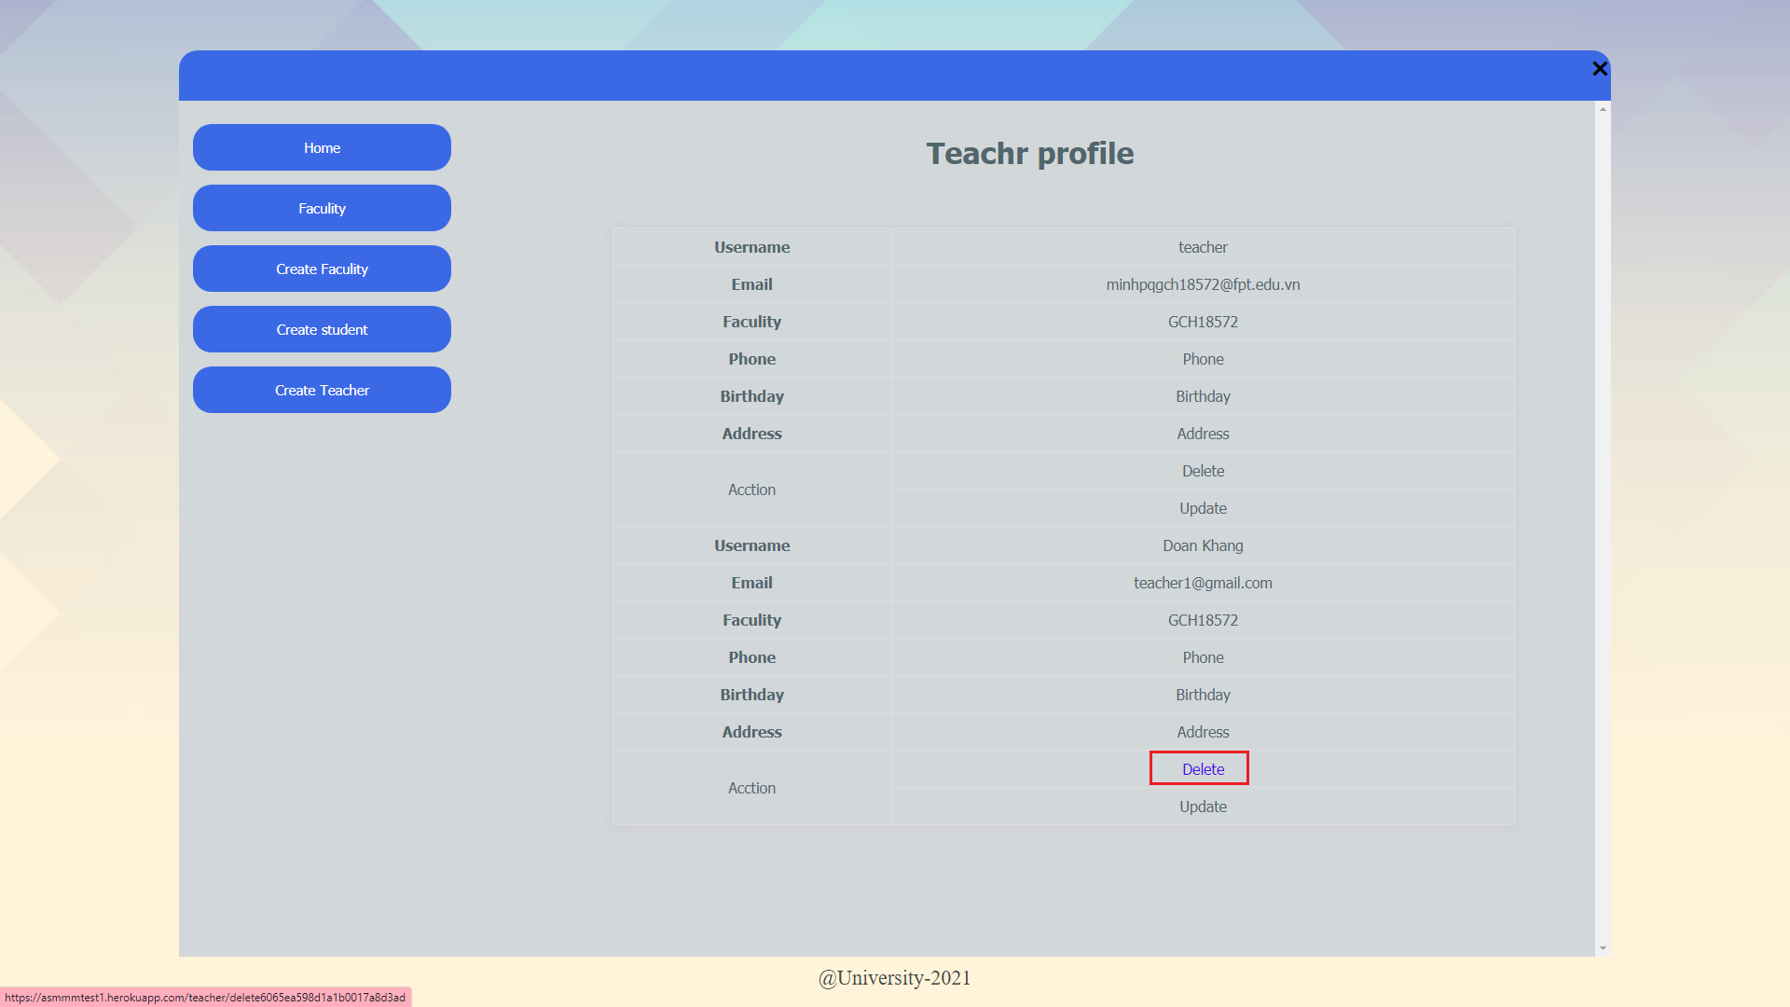

Figure 110: Delete marketing coordinator button

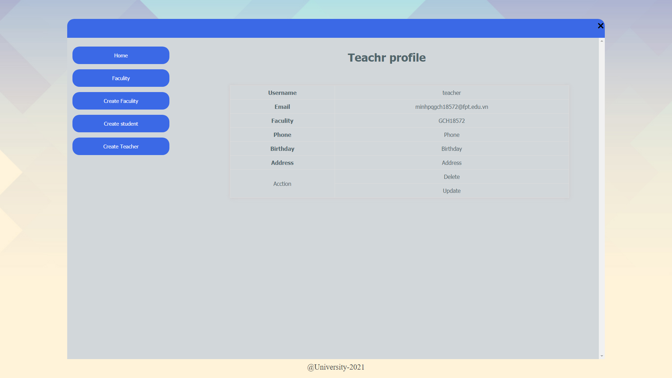

Figure 111: Delete successful

1. View statistical

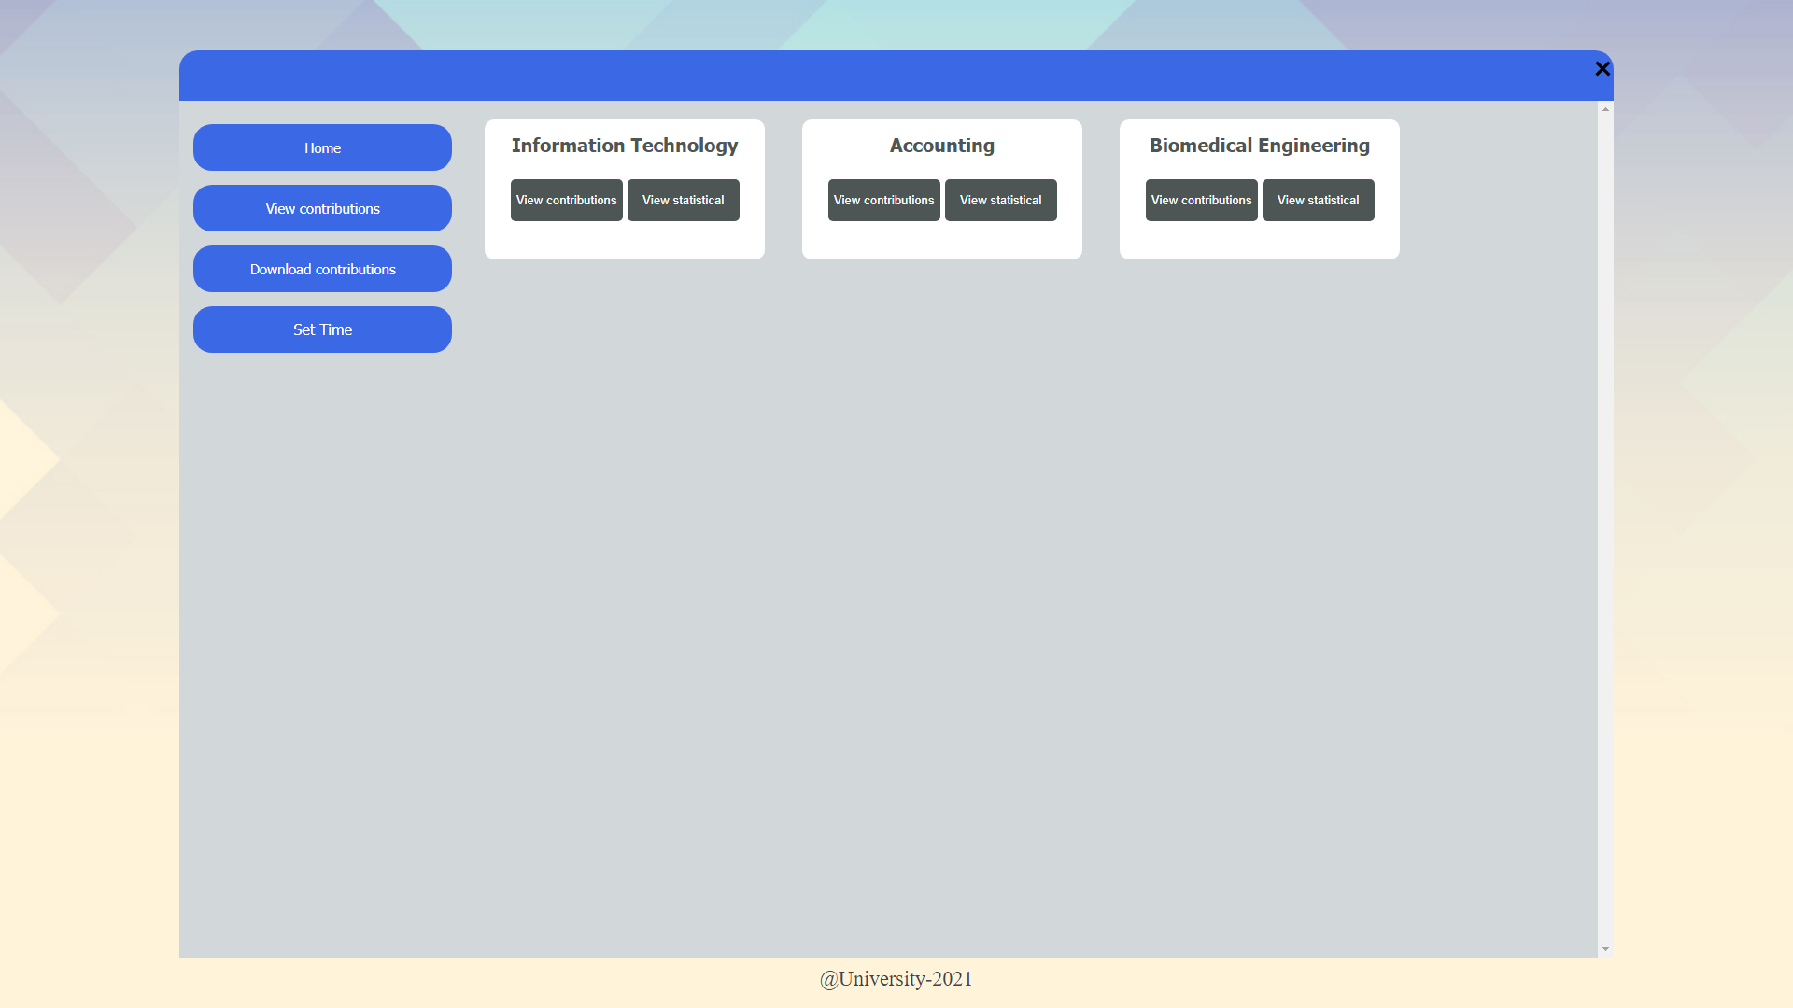

Figure 112: Display faculty list and view statistic button

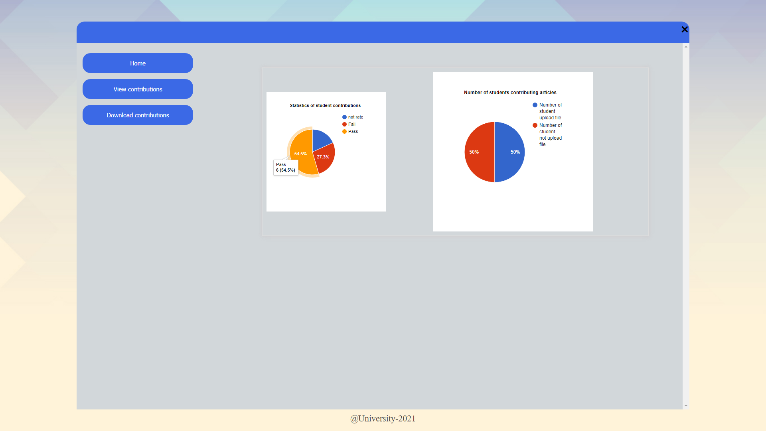

Figure 113: Statistic view and can see detail information when hover your cursor on the chart

1. View contribution



Figure 114: Display faculty list and view contribution button

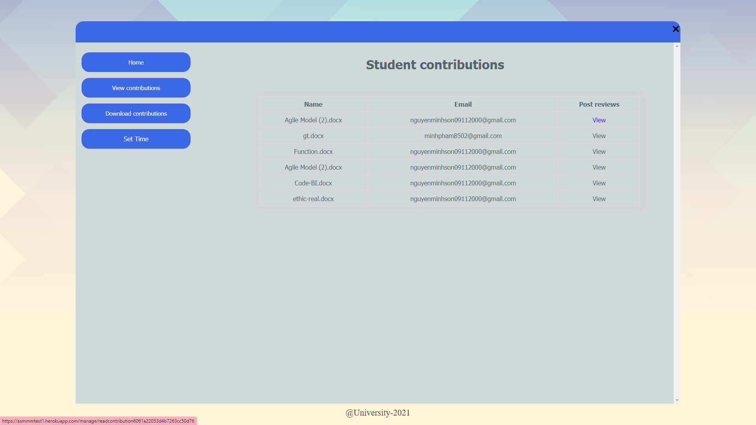

Figure 115: Submission list of that faculty

1. Notification email

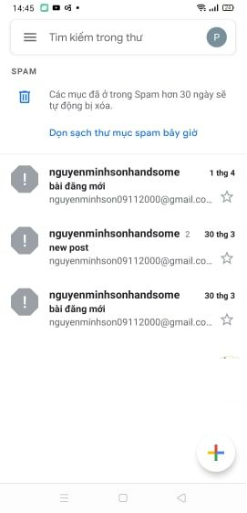

Xám áaaaaaaaaaaaaaaaaaaaaaaaaaaaaaaaaaaaa

1. Download contribution

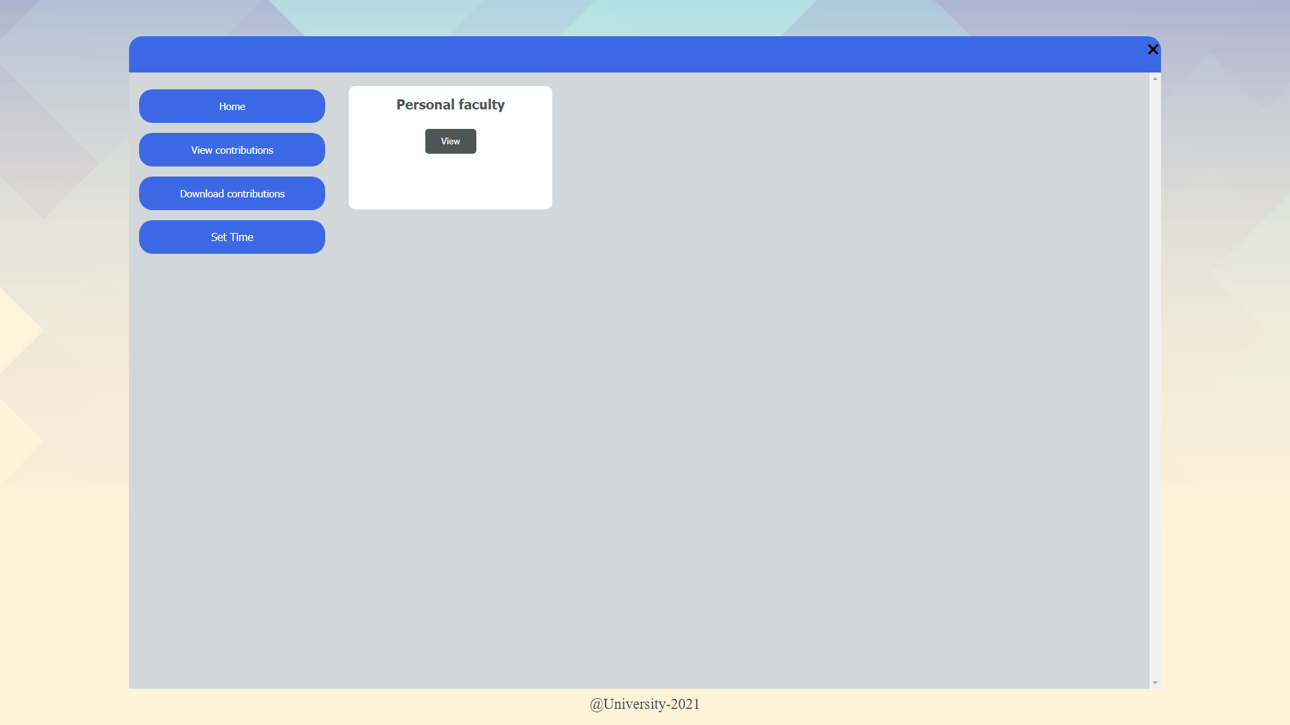

Figure 116: Click on download contribution and see the faculty list

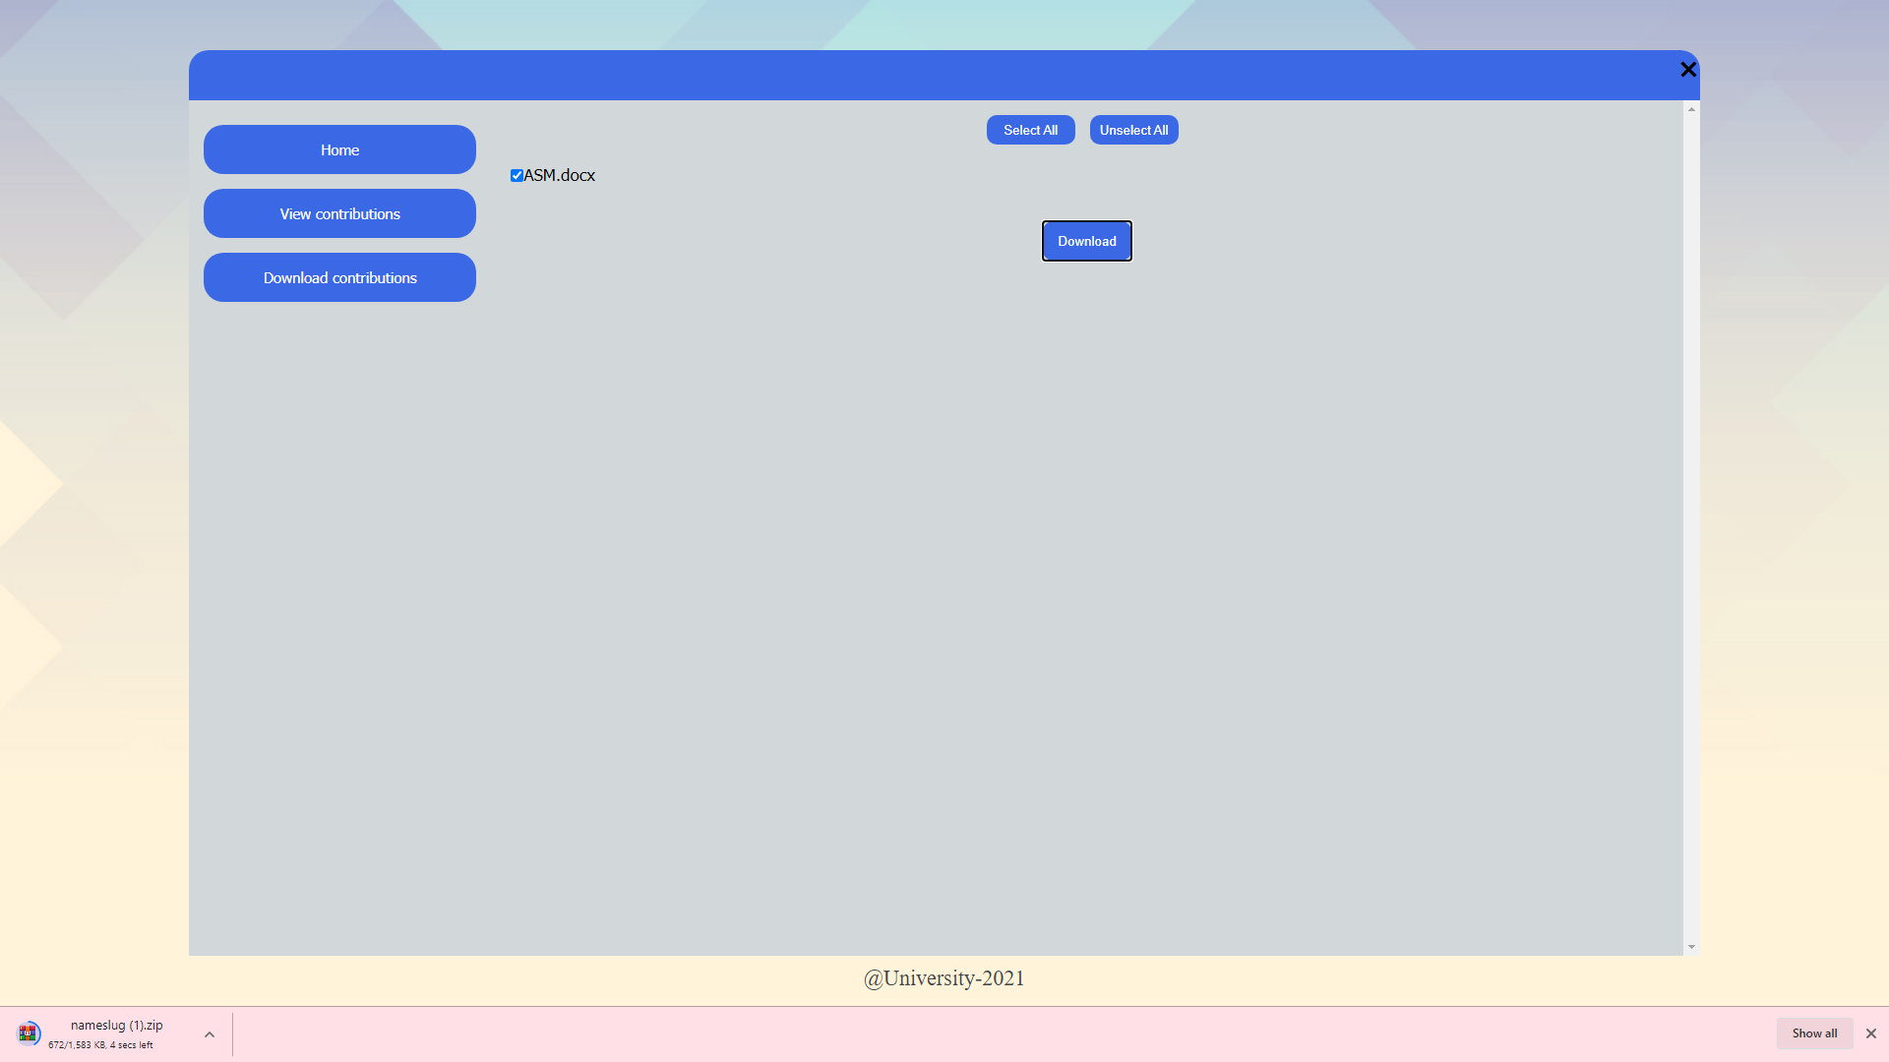

Figure 117: Select submission and download successful

1. Set deadline for student

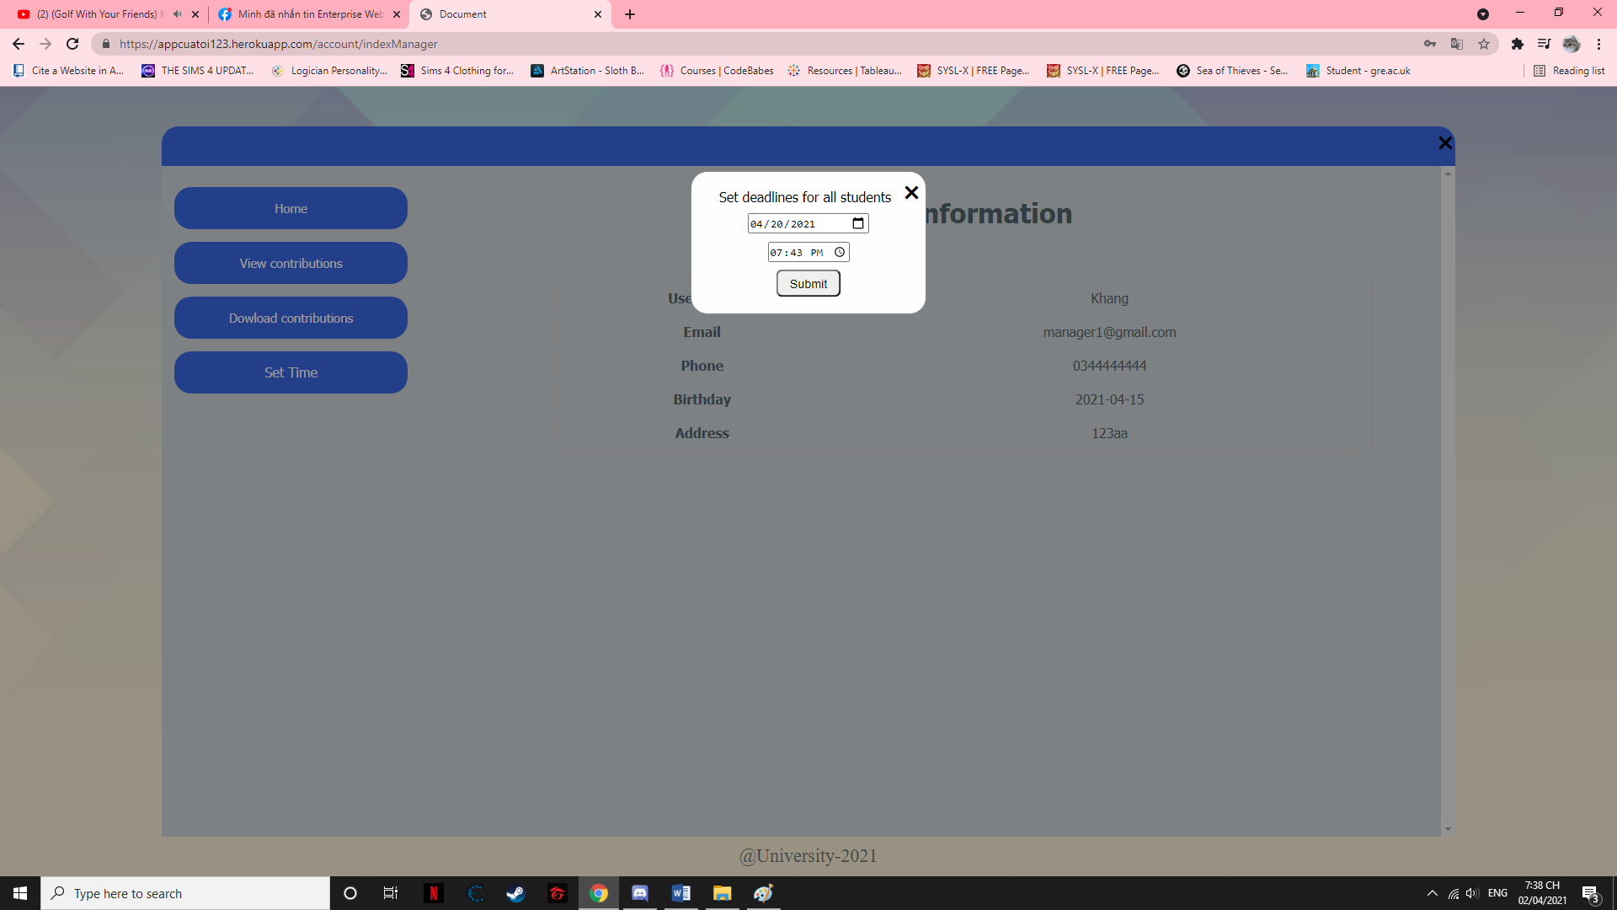

Figure 118: Click on set time button

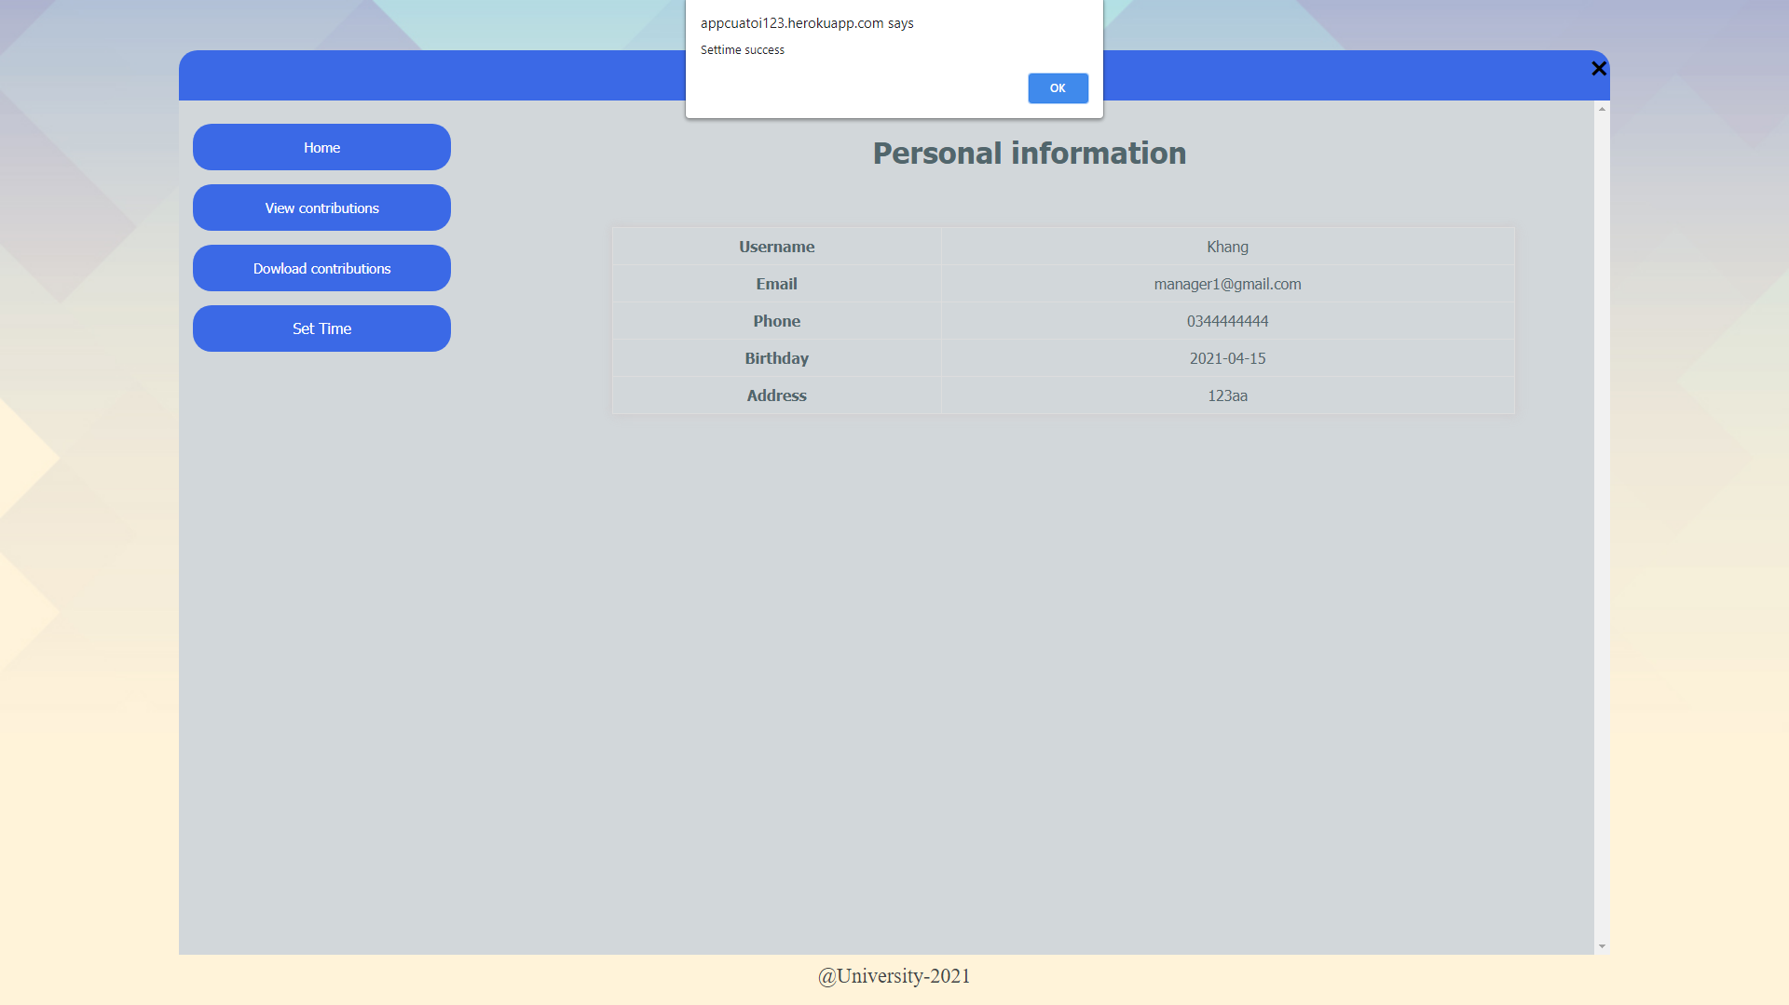

Figure 119: Set time successful

1. Comment and grading

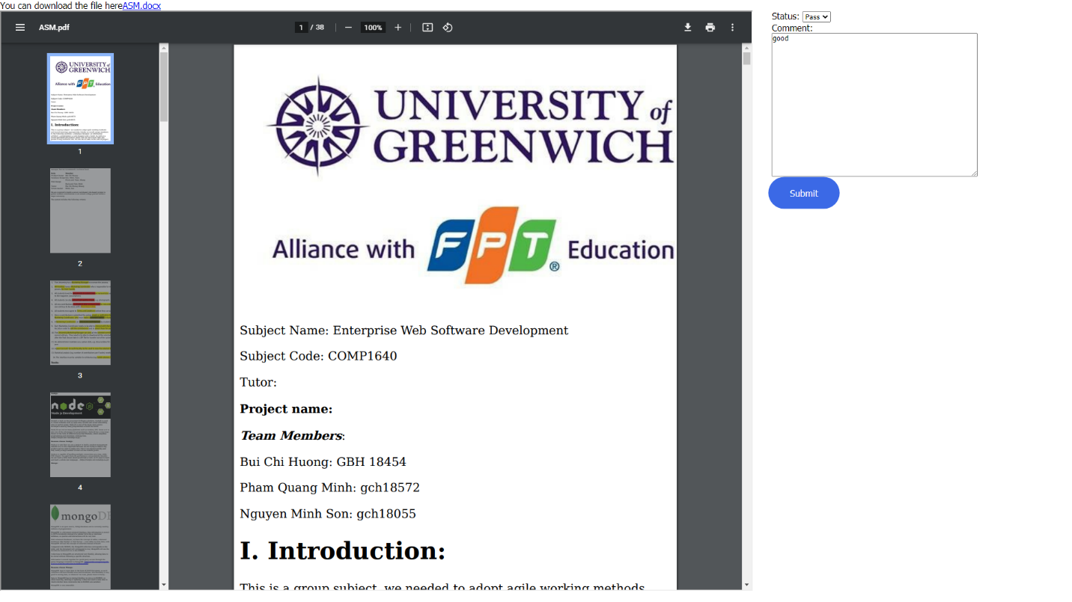

Figure 120: Grading and comment box after click on view submission

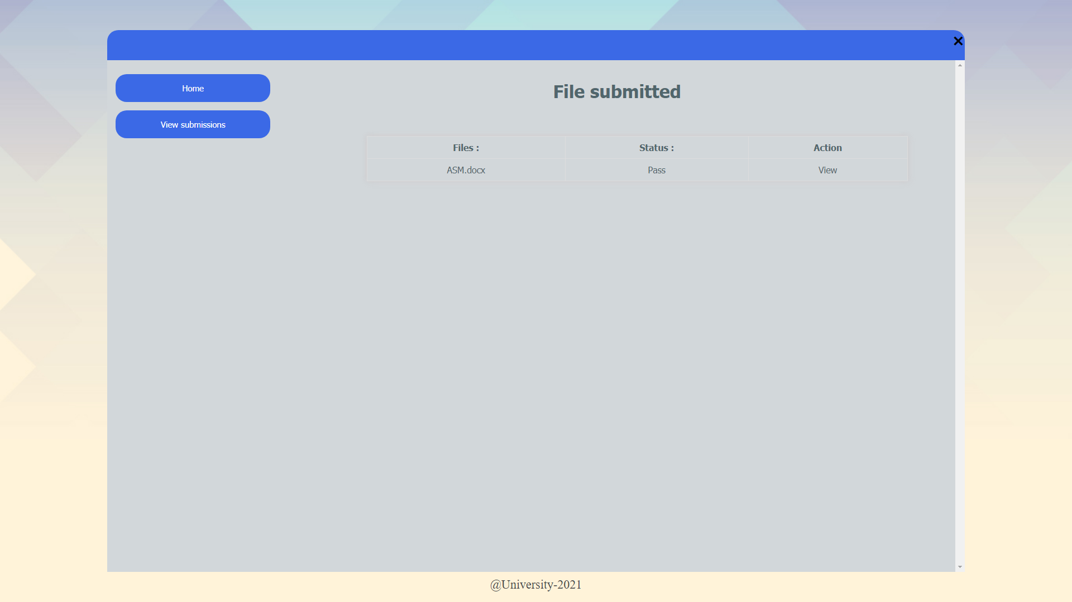

Figure 121: Grading successful

1. Chat box

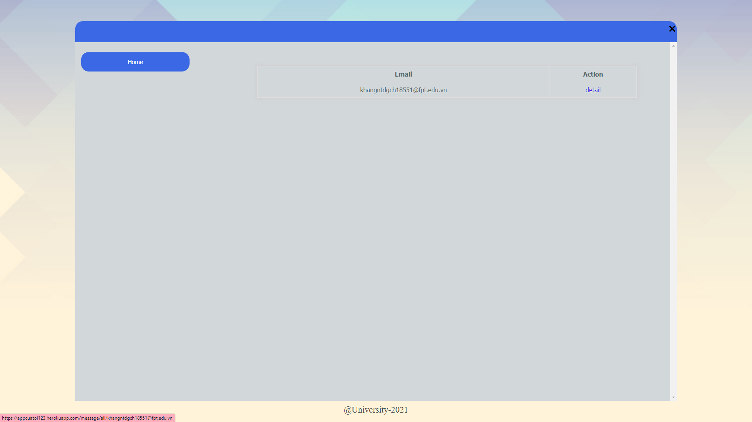

Figure 122: Adding people to chat box

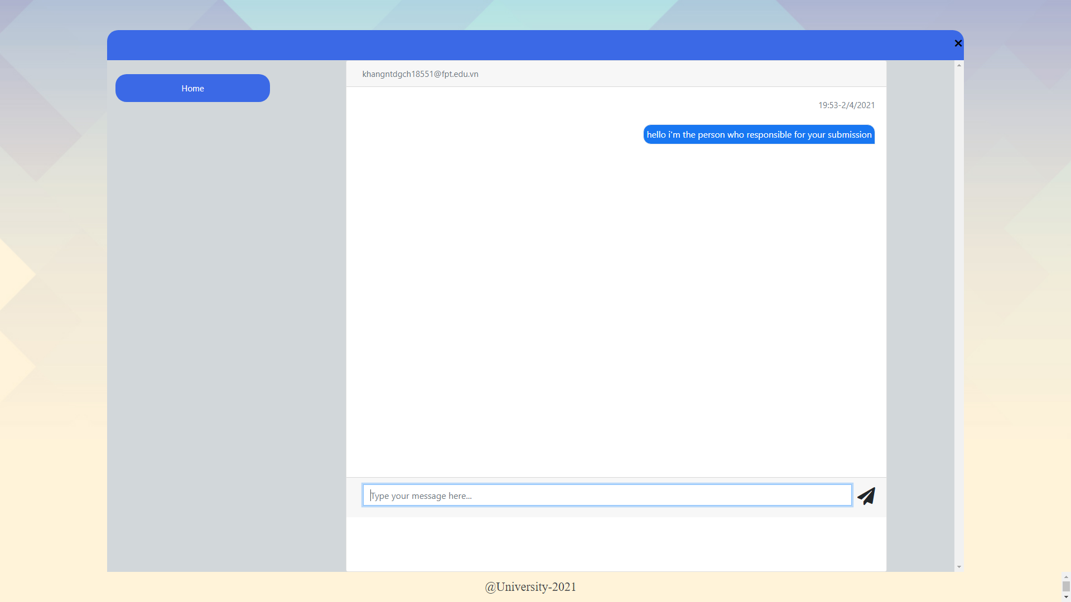

Figure 123: Using chat box

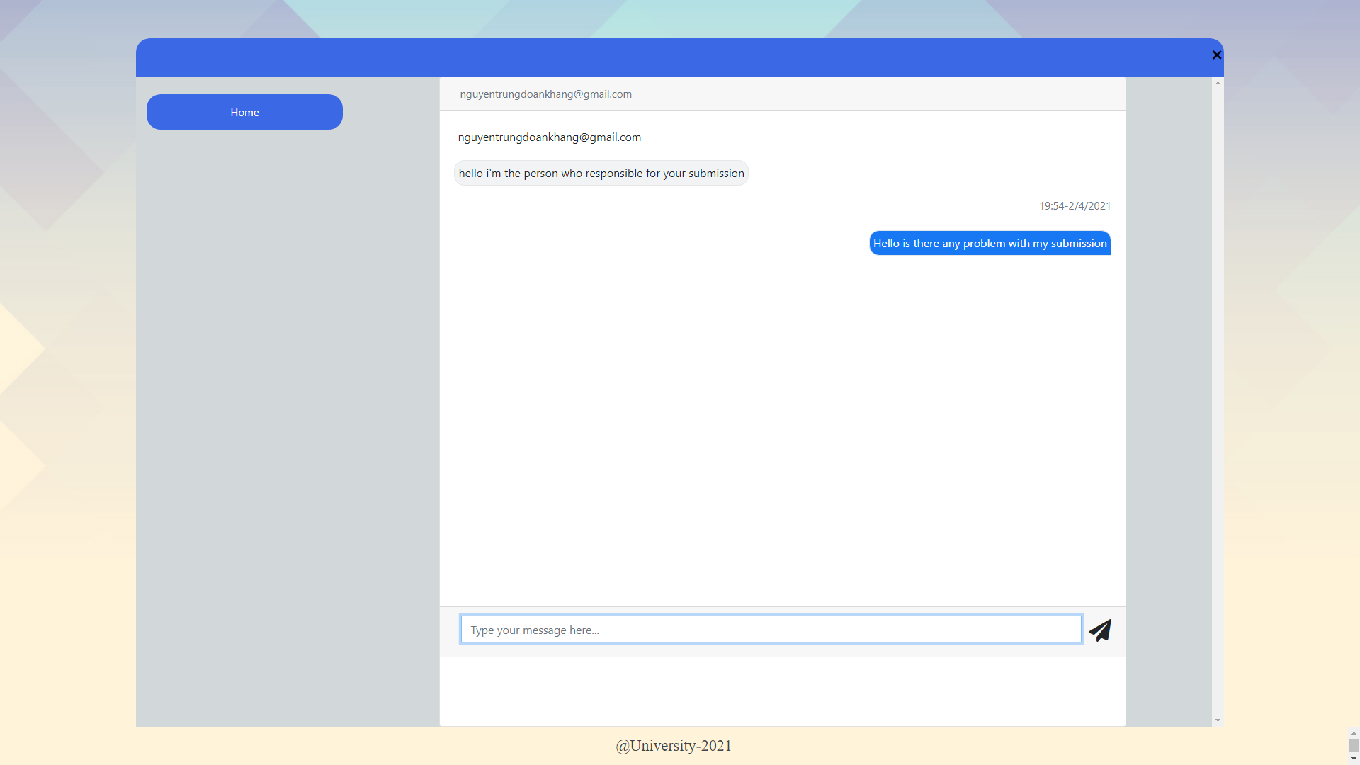

Figure 124: Interaction in chat box between Coordinator and Student

1. Upload/ Update and view comment

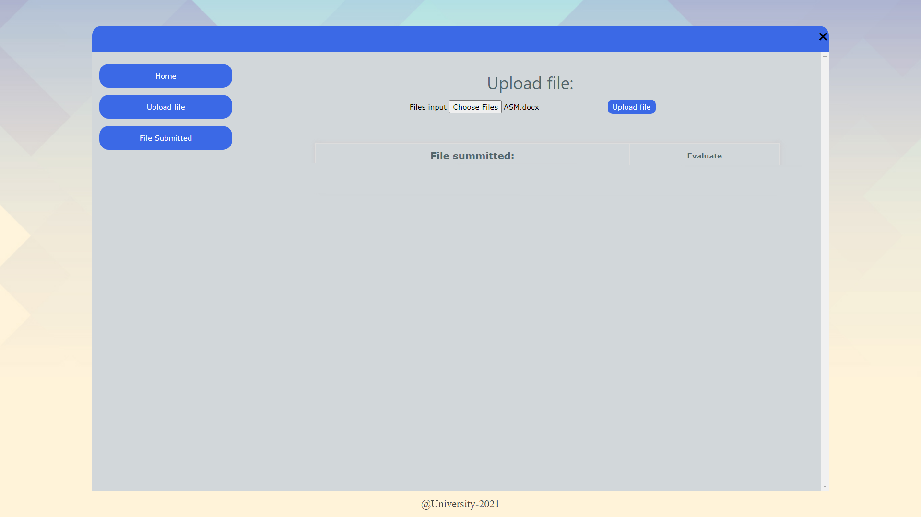

Figure 125: Uploading file

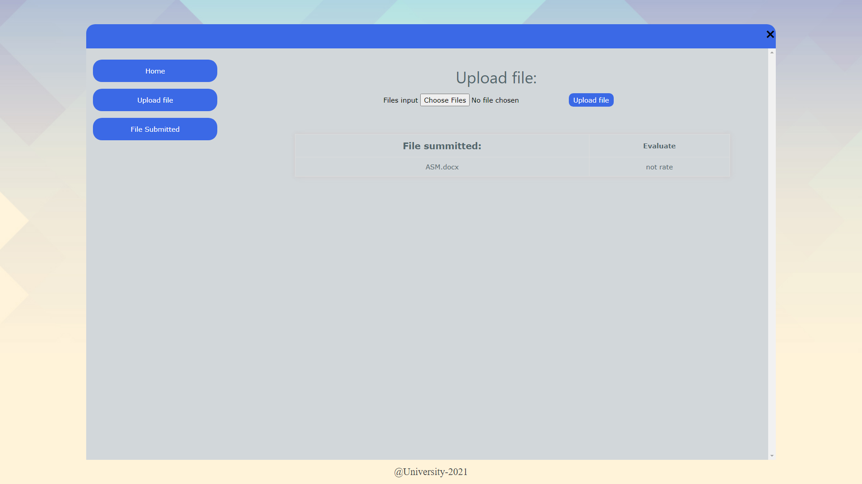

Figure 126: Uploading successful

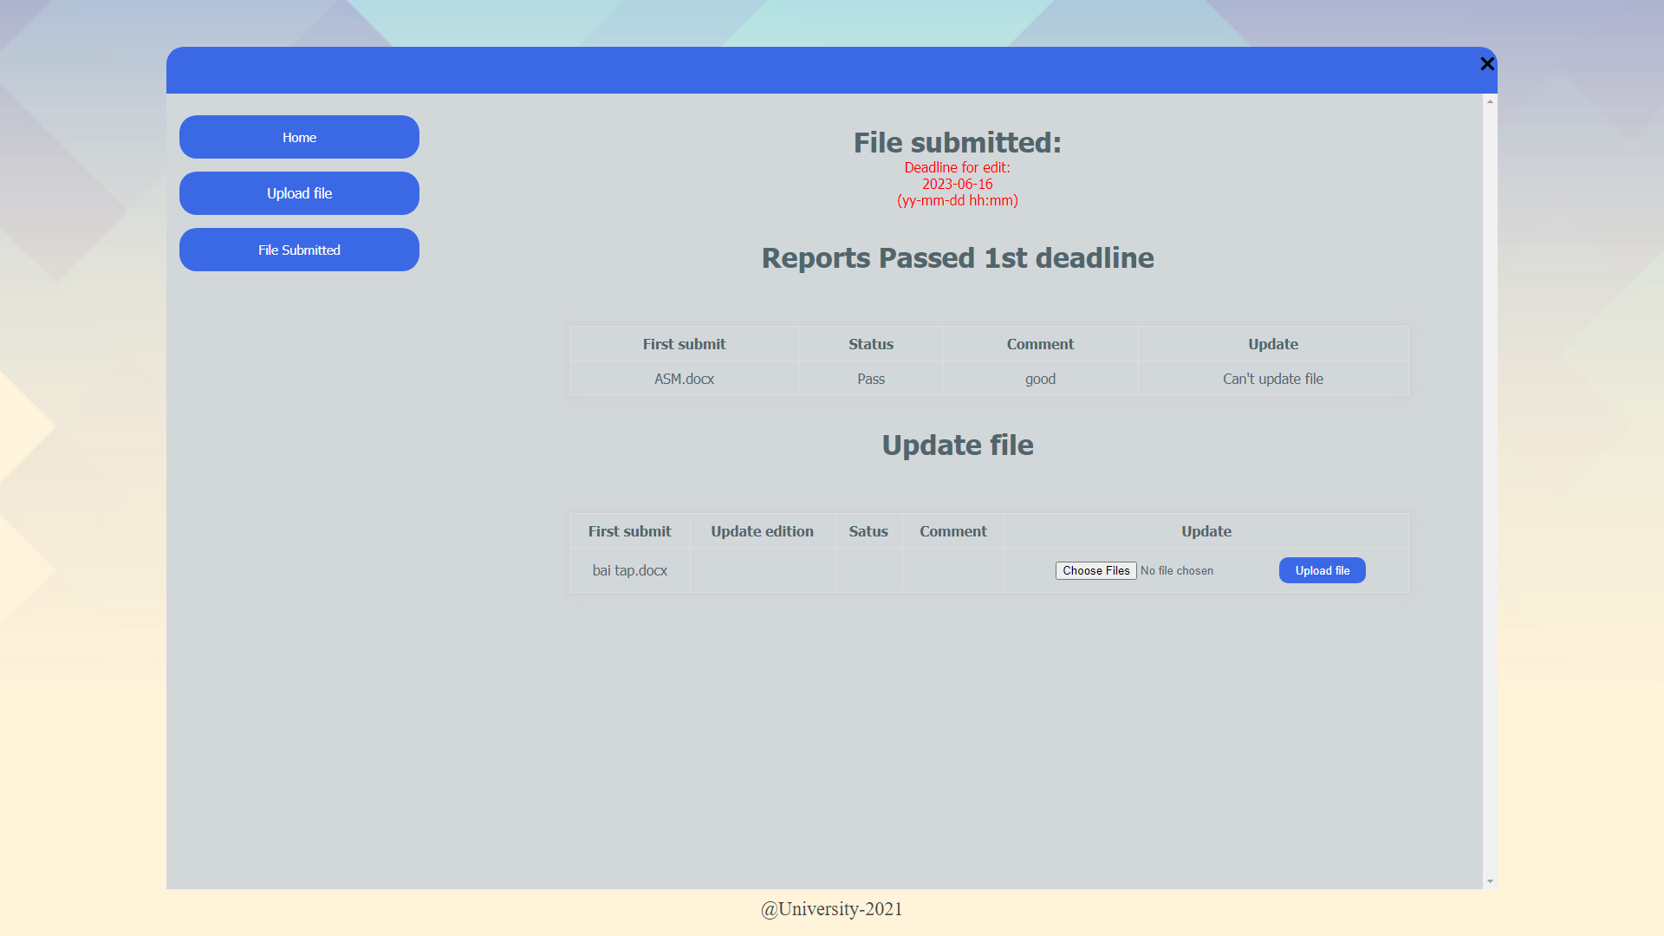

Figure 127: Display submission graded with comment

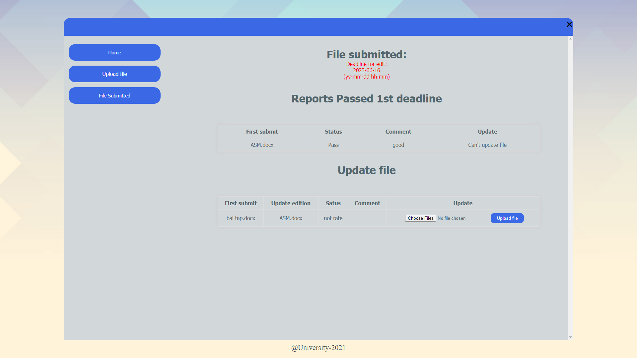

Figure 128: Update file success

1. View submission

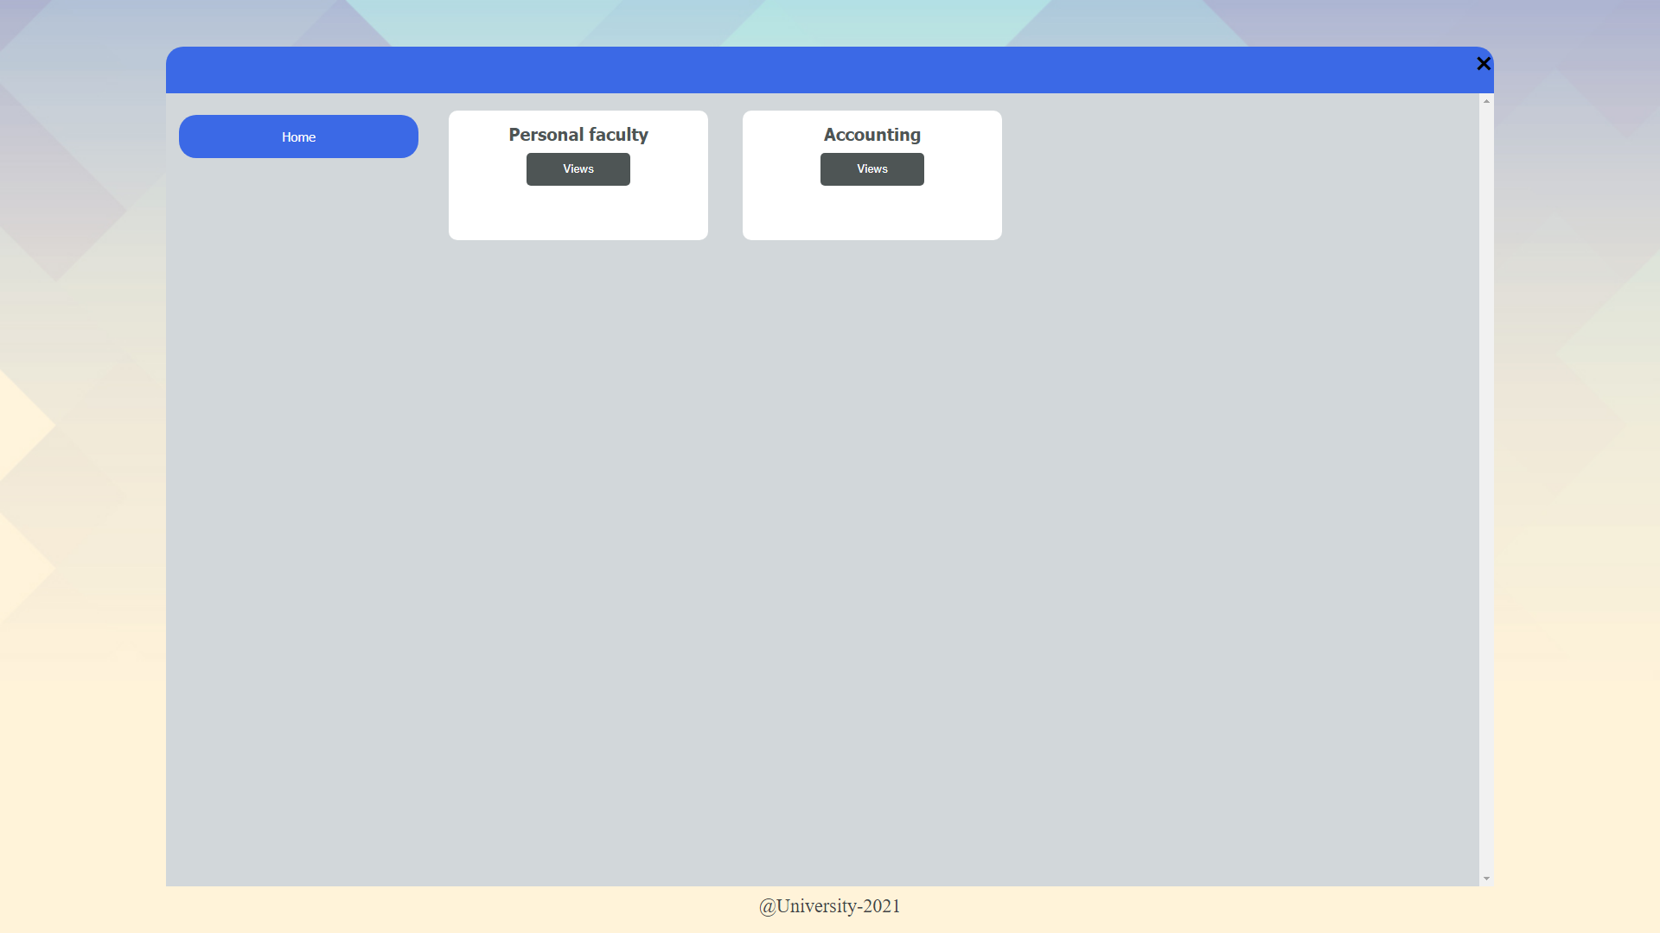

Figure 129:All faculty as guest perspective

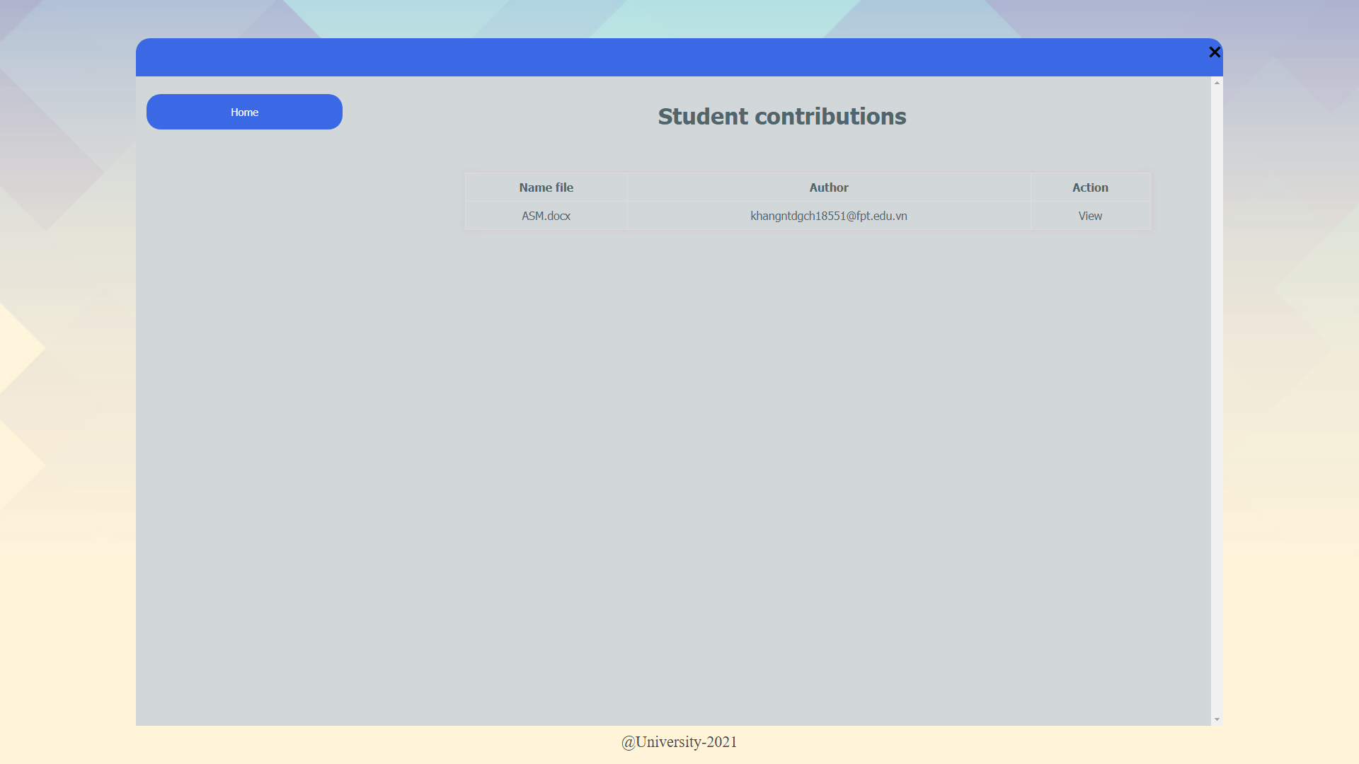

Figure 130: All submission in selected faculty



Figure 131: Submission being viewed by guest

# Agile:

The first meeting at the start of the project was held on 21/2/2021 at 2:00 pm to 5:00 p.m.

The meeting was held to discuss the following issues:

* Discuss each person's competencies according to strengths and weaknesses and then assign work to roles (Scrum master, product owner, coder, design, etc) in project development.
* Discuss and make a decision about the technology to be used for the project development.
* Analyze project requirements and evaluate how important they are to the project and how difficult it is to carry out those requirements (creating a product backlog).
* Divide the work by weeks based on how important the project is and how difficult it is to do it.

Technical:

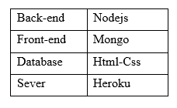

Figure 132:Technical

## Product backlog

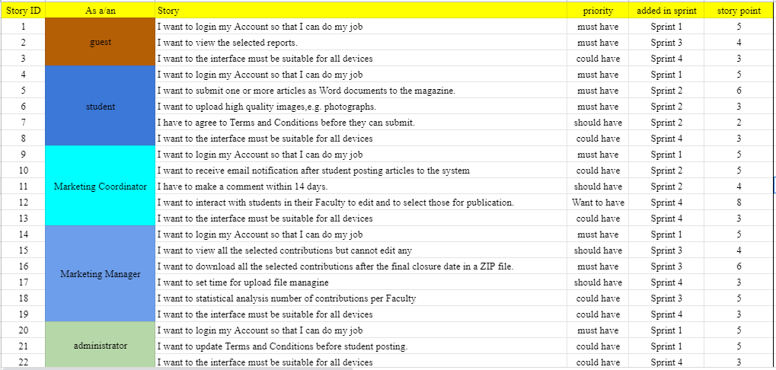

Figure 133:Product backlog

## Sprints, burndown chart, meeting

### Sprint 1 (22/2/2021- 2/3/2021)

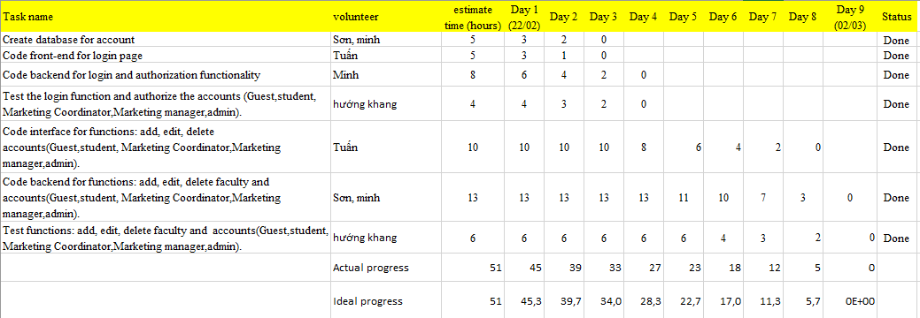

Figure 134: Sprint 1

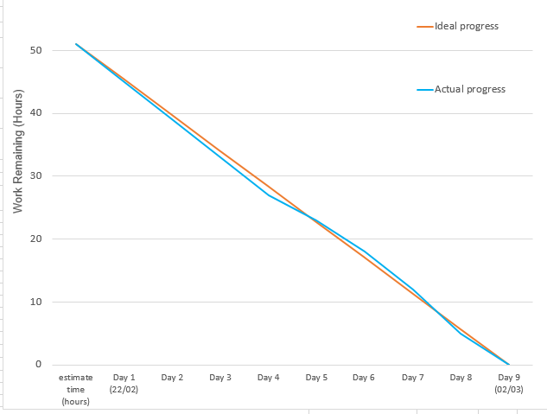

Figure 135: Burndown chart Sprint 1

The work schedule of spirnt 1 is completed according to the set plan. Since Son and Minh are familiar with the technology, the implementation and construction of the functions took place as planned.

**The first timeline of sprint 1 is on February 25, 2021:**

Because Son and Minh have researched and practiced with technologies from previous courses, database manipulation and decentralization are implemented quickly. In the first half of sprint 1, we accomplished the following:

* Sơn, Minh: Dabase has been created to store account information.
* Tuan: The user interface has been designed for the login.
* Minh: Decentralized the accounts based on roles.
* Hướng,Khang: The decentralization test has been completed and there is no risk.

Next work to be completed when Sprint 1 ends (March 02, 2021): Complete functions for Admin:

• Add, delete and update guest account

• Add,edit and delete student account

• Add, delete and update marketing coordinator account

• Add, edit and delete marketing manager account

• Add, editing and deleting faculties

**The second timeline of sprint 1 is on March 02, 2021 (the end of Sprint 1):**

The work has been completed

* Son, Minh: 2 coders agreed to divide the work of the back-end code for the work of implementing the functions of the admin and completed the job on time and in a timely manner, assigned to the direction and testing.
* Tuan: The functions have the same interface structure so the design doesn't take too much time, Tuan has finished designing the interface for the functions to add and delete the accounts (4 roles) and for faculty.
* Khang, Huong: During the test, the direction and direction did not detect errors in adding and deleting accounts, but there are some validate problems that need to be solved when creating accounts such as: Name can enter numbers, electricity phone may enter text, enter wrong email, etc.

Remaining work: The account information validation will be move to sprint 4.

### Sprint 2 (3/3/2021- 11/3/2021)

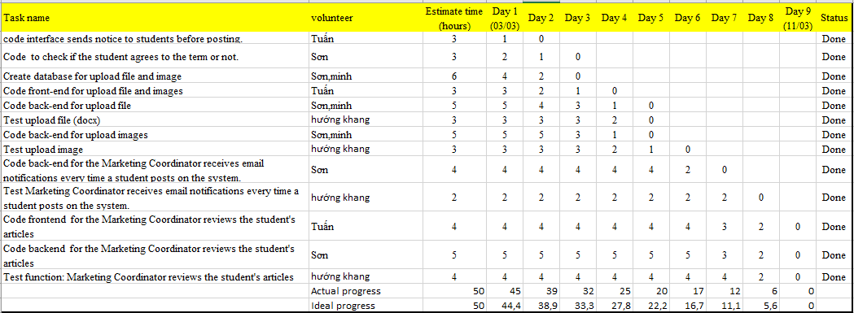

Figure 136: Sprint 2

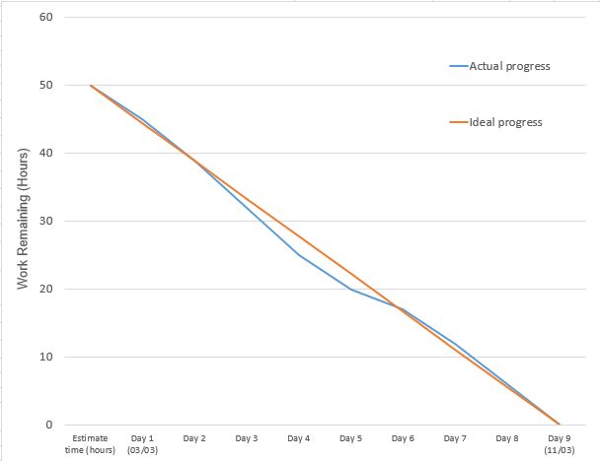

Figure 137: Burndown chart Sprint 2

In sprint 2, we also got the job done on time and was a bit over-schedule in the midst of spirnt. In the middle of sprint 2, due to the work being similar in nature and functionality, the implementation took place faster than intended. (upload file, upload image, student and marketing coordinator receive mail).

In sprint 1, the team completed the admin functions. In sprint 2, the whole team will practice building functions for students and some functions for Marketing Coordinator. In sprint 2, we set 2 timelines for sprint 2 to monitor the situation.

**The first timeline of sprint 2 is on March 6, 2021**

During the first half of sprint 2, we completed the following work in the plan:

* Tuan: The interface has been designed for the display of the school's terms when students decide to post their articles on the system.
* Son: Code work completed to check if the student agrees with the term. To do this, Tuan has helped paint better understand Pop-up in the interface. From there, Sơn learned to use the <script> tag in Html to test it right at the front-end.
* Sơn, Minh: Both of them carried out to find out about the necessary attributes of the file to the database and have since completed the database creation.
* Tuan: After designing and displaying the terms, Tuan continues to design the interface for students who upload their articles to the system and have finished.

The next work to be completed when Sprint 2 ends (March 11, 2021): Complete functions for students and some functions of marketing coordinator.

* Student: Upload file (docx), img, receive mail when uploading an article to the system.
* Marketing coordinator: receives an email when a student of the department posts an article on the system, evaluates the student's articles.

**The second timeline of sprint 2 is on March 11, 2021 (the end of Sprint 2)**

The work has been completed

* Sơn, Minh: After completing the design of the interface for uploading files and images, I painted and I learned together about Nodejs libraries to save files to the system. Through many options I decided to use the multer library and perform the file and images work successfully.
* Hướng, Khang: During the file upload test, the system crashes when there are cases such as uploading files in incorrect format docx, png, jpg.
* Sơn: After performing the file saving function, Sơn learned about the library to help the system send mail and found the nodemailer library. Through the manuals, Son has completed 2 functions of receiving mail for teachers and students.
* Hướng, Khang: During the test of receiving mail, no errors are detected
* Tuan: After designing the page to upload files for students, Tuan has finished designing the interface to display the articles and the interface that helps Marketing coordinator evaluate the students' articles.
* Sơn: After discussing with Tuấn, the two of you decided to display the post with the <iframe> tag in PDF format. After closing, Son has completed the back-end coding for the article evaluation.
* Hướng, Khang: Hướng and Khang have checked the article reviews and no errors have occurred.

Remaining work: None. The sprint 2 work has ended as planned.

### Sprint 3 (12/3/2021- 20/3/2021)

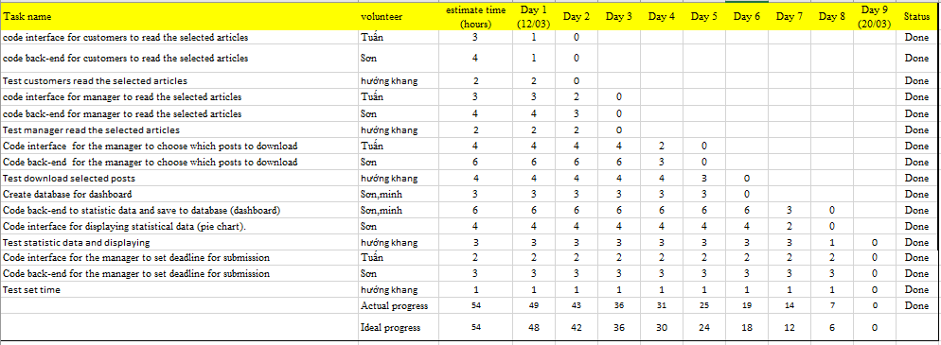

Figure 138: Sprint 3

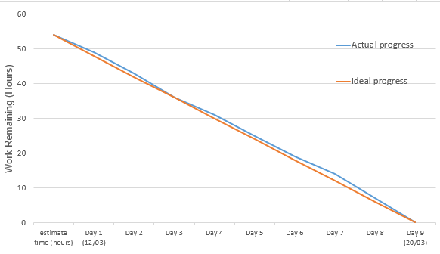

Figure 139: Burndown chart Sprint 3

In sprint 3, functionality is assessed to a moderate level (3-6). Therefore, the construction implementation is quite accurate time estimate. In addition, the statistical viewing function is quite new, but also quickly and completely explored. Therefore, the work was also completed as planned.

In Sprint 2, the student functions and Marketing coordinator have been completed. Following sprint 3, the job will be to build the Client and Marketing Manager functions.

**The first timeline on March 15, 2021**

In the first 4 days of sprint 3, the team has completed 2 functions of the Customer and Marketing Manager, which is the function of reading articles that has been evaluated and approved by Marketing coordinator.

* Tuan: Create an interface for reading articles for Guest and Marketing Manager.
* Sơn : Write back-end code to perform the process of getting post information and displaying the post on the front-end. And learn how to perform the function of downloading articles as zip files of Marketing Manager.
* Hướng, Khang: Do the test and there is no problem during the test.
* Minh: Researching charts to perform statistical functions for Marketing Manager.

Remaining work:

* Function of marketing manager: Set deadline for upload file, download selected article as zip, view statistic chart.

**The second timeline on March 20, 2021** **(the end of Sprint 3)**

The work has been completed

* Tuan: Design the interface for Marketing Manager to choose the articles to download and the interface for Marketing Manager to set a deadline for the student's article loading.
* Sơn, Minh: Created database for statistical graphs and wrote back-end code to statistic data from database.
* Sơn: The back-end code for the selection process, uploading students' articles to Marketing Manager and setting deadlines for students to submit. Create an interface to display statistics graphs.
* Hướng, Khang: Test the above functions and no errors occur.

Remaining work: None. The sprint 3 work has ended as planned.

### Sprint 4 (21/3/2021- 29/3/2021)

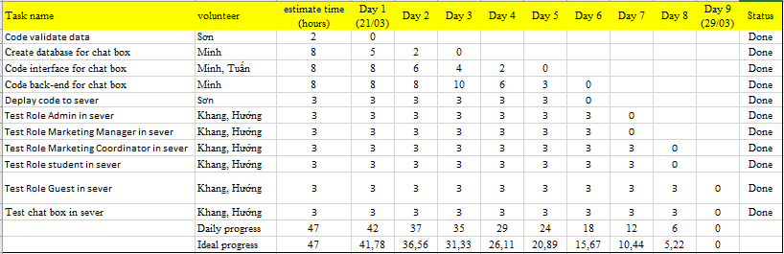

Figure 140: Sprint 4

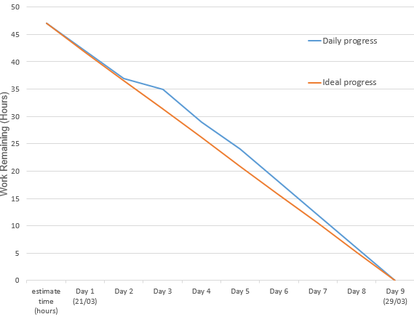

Figure 141: Burndown chart Sprint 4

At spirnt 4, the implementation of building chat functions for students and the marketing coordinator took longer than expected. We have evaluated this functionality as difficult compared to the power of the coder (8/10 points) and the implementation of this function has slowed the project forward. In addition, we have to validate the account information left by spirnt 1.When we finished the chat function, we quickly started pushing the project and testing it on the server and there was no risk incurred. The project has also ended as scheduled.

After completing the functions of for Guest and Marketing Manager in Sprint 3. At Sprint 4, we will proceed to handle the problems in the previous sprints and push the project to the server to progress to test the project. run on server.

**The first timeline on March 24, 2021**

During the first 4 days of spirnt 4, we completed the following tasks:

* Sơn: Execute code completion for account information validation (work needs to be done from sprint 1)
* Minh: Designing database for student chat and Marketing Coordinator and researching back-end code for chat. Since the chat is considered to be the most difficult part, the database design takes a lot of time

Remaining work: Complete the student chat and Marketing Coordinator and test the project running on heroku.

**The second timeline on March 28, 2021**

* Sơn: Pushes the project onto heroku. During the push of the code, there were some errors such as: Node version not specified in package.json, Node_modules checked into source control and promptly processed.
* Minh, Tuan: Research and design interfaces for student chat functions and Marketing Coordinator.
* Minh: Doing the back-end coding for the chat.
* Khang, Huớng: Test the project running on heroku and the result runs as if running localhost and did not detect any new errors.

# Conclusion

Through the process of studying and working, we have had interesting experiences, accumulated new knowledge and walked through difficulties together. There have been a lot of problems happening during the project being built, but thanks to teamwork, we bring a complete software with extremely high practicality. Our program is not considered to be excellent yet but we will improve the management program in the future and help it grow further. More suitable with the vision of life.